SCANNING SELECTION STATUS FOR BHL

This paper is a first step toward creating a process for selecting which books to scan, in what priority and at which institution for the Biodiversity Heritage Library. Currently there is minimal coordination or documentation of the process in operation for selection. There is no systematic or coordinated consulting with the scientific community about what is needed. BHL must find a way to respond to the questions: "What are you planning to digitize, when, and where?” “How will you minimize duplication among yourselves and other scanning projects?" As yet there is no easy response. This is a large, distributed project and better coordination is needed within the members and across other projects.
The BHL must also be able to respond quickly to the needs of EOL, the Encyclopedia of Life, and ensure that BHL content supports EOL as much as possible. As the EOL Secretariat establishes thematic areas of emphasis for the EOL, the BHL libraries intend to select texts that best support the thematic area. The costs of scanning, while low per-page, are high over the course of the entire project. Thus it is essential to identify ways to minimize duplication of scanning and to ensure that the most inaccessible, needed or important literature is selected and scanned quickly.
The BHL involves ten separate institutions with different collection strengths. Selection of materials to scan needs to be multi-dimensional including thematic areas, date of publication, condition of material, completeness of items and quantity. The BHL project requires moving books to specific scanning locations and this impacts the selection of materials. In the summer of 2007, BHL Directors organized a “BHL Collections Working Group,” to refine and articulate the thematic areas. Initially, scanning selections will either be in the public domain or have copyright permission. The EOL Secretariat encouraged BHL to begin scanning marine biology-related materials. Additionally, the BHL plans to analyze such major indexes as Index Kewensis, Sherbourne’s Index Animalium, and Neave’s Nomenclator Zoologicus to develop a priority list of journals and monographs. Scanning from a prioritized list created through citation analysis will help to ensure that the BHL contains the most critical works for our audience of scientists and scholars. BHL will also remain flexible enough to take timely advantage of offers from significant learned society journals to digitize back holdings in an open access manner. Other ideas to develop additional thematic focus include applying taxonomic intelligence so that a filter can be applied to other indexes to identify important journals and monographs.
The MBL and Harvard MCZ initially prioritized marine literature and expect to digitize 70% of the pre-1923 marine literature. The Smithsonian initially prioritized entomological literature and expects to complete 40% of the pre-1923 literature. The Missouri Botanical Garden, the New York Botanical Gardens, Harvard Botany Libraries, and the Royal Botanic Gardens, Kew, are in discussions as to which areas of botany each institution can best cover and expect to digitize 70% of the pre-1923 literature.
Tools have been developed by BHL to help with selection including a serials bidding database, and a monographic deduplication tool, both discussed in more detail below. Other tools and indexes including Taxatoy and Index Animalium may produce rankings but no systematic tests have occurred. Digitization selection was done by MOBOT using TROPICOS name records to prioritize titles containing the highest number of original plant descriptions, but this methodology is not necessarily extensible to all institutions or organisms. The OCLC Collection Analysis Tool was purchased by the Smithsonian Institution Libraries for the BHL and can illustrate general areas of strength within the BHL libraries.

1. CURRENTLY AVAILABLE SELECTION TOOLS
OCLC COLLECTION ANALYSIS TOOL
On behalf of the BHL, the Smithsonian Institution Libraries purchased the OCLC Collection Analysis Program and added all member library records. It took more than a year to get this tool running, partly because not all libraries were members of OCLC, and, in the case of Harvard University, the records of the botany and zoology libraries could not be separated from those of other Harvard libraries not participating in BHL scanning. The OCLC Collection Analysis tool enabled a broad look at institutional collection strengths and allowed the group to estimate the numbers of public domain pages that could be scanned more or less immediately and to identify Library of Congress subjects with unique titles in the member libraries.
A sample calculation from the OCLC Collection Analysis Tool indicates that the total number of BHL bib records equals 1,804,900. This describes “titles” or “bibrecords”, not “volumes” There is no way to get volume counts since most libraries do not have complete item level control. Based on MOBOT numbers, one assumption is that there are about 2 volumes per bib record or 3.6 million volumes in the 10 BHL libraries. MOBOT submitted 89,863 titles (bib records) to the Analysis and total item (volume) count is about 180,000. This is about a 2:1 ratio.
Because there is a European initiative underway to scan German language material, the OCLC tool was used to see how much of this material is found within BHL collections. Filtering by “German Language” only, leaves a total of 137,434 titles in all BHL libraries. This is about 7.6% of the 1.8 million BHL total. Using a pre-1923 and German filter there are 72,663 titles in BHL. Without the German filter (meaning all pre-1923 titles), there are 471,079 titles. The average percentage of pre-1923 items in the BHL collections is a simple average of the percentage for each library. Based on some analysis from SIL and MOBOT an average of 20 volumes per serial is a reasonable guesstimate. All the estimates will go up as additional records from NHM, Kew and FMNH are processed. See figures 1-4 below.

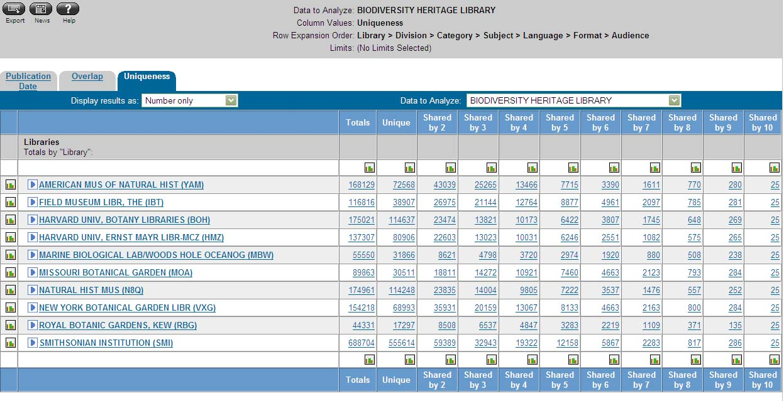
Figure 1: “Uniqueness” of all titles per institution in BHL.

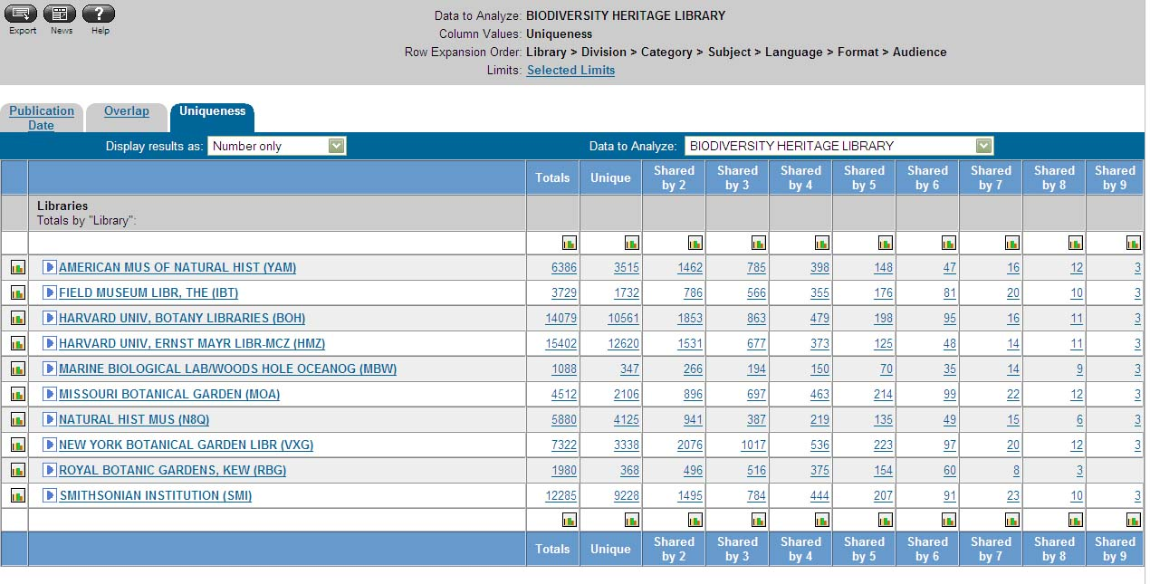
Figure 2: “Uniqueness” per BHL library filtered for German language and pre-1923.

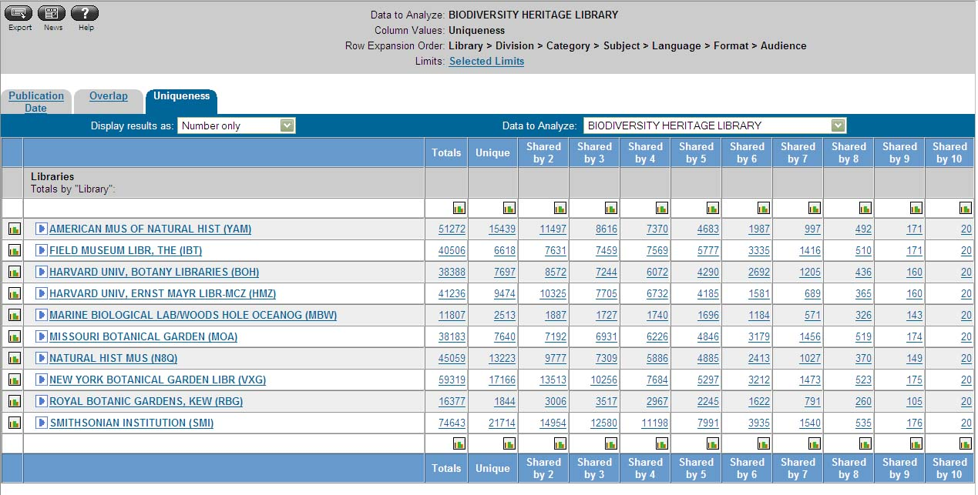
Figure 3: “Uniqueness” filtered by “biological sciences”

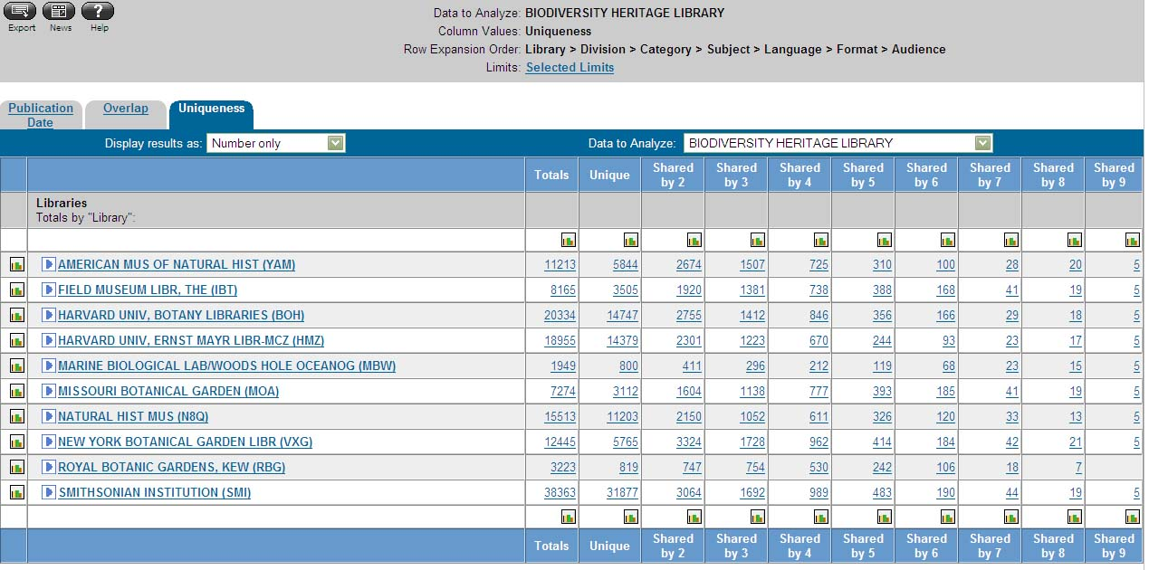
Figure 4: “Uniqueness” per BHL library filtered by German language.

Unfortunately, the data in OCLC are only as good as the data in the library catalogs and records are not always clean. For instance, lists of “unique” items for a library appear to be wildly inflated. This is due to the inability of the tool to match bibliographic records that vary slightly from one another, but describe the same item. Additionally, there is no de-duplication of the records in OCLC beyond matching up OCLC record numbers. However, the OCLC Collections Analysis tool still may have some potential to help with selection for digitization. Doug Holland and Connie Rinaldo have requested a training session from OCLC to ensure that we get the most out of this tool once the NHM and Kew records are loaded.

SERIALS BID LIST
http://obsidian.nhm.ac.uk/test/library/bhlseriallist/bids/
With input from the EOL Steering Committee, BHL members chose serial publications as a priority because the serial literature is critical to the scientists who make up the primary audience for the first release of the BHL. The systems office of the Natural History Museum of London developed a tool to avoid scanning duplication among the member institutions: the Serials Union Catalog. This catalog allows users to browse and search titles held by BHL member institutions using advanced filtering. The database includes online catalog records of all the serials in all the member institutions with a checkbox for selection. The serials bid list tool allows an institution to select part or all of a serials run for scanning. As titles are identified for scanning, an institution accesses this database to make sure no one else has bid on the item. If there are no bids, or bids cover only part of a serials run, the institution is free to claim the title, or at least the parts of the title that have not been bid, for scanning. Once logged into the serials bid database, bids can be filtered by institution. See figure 5 below.

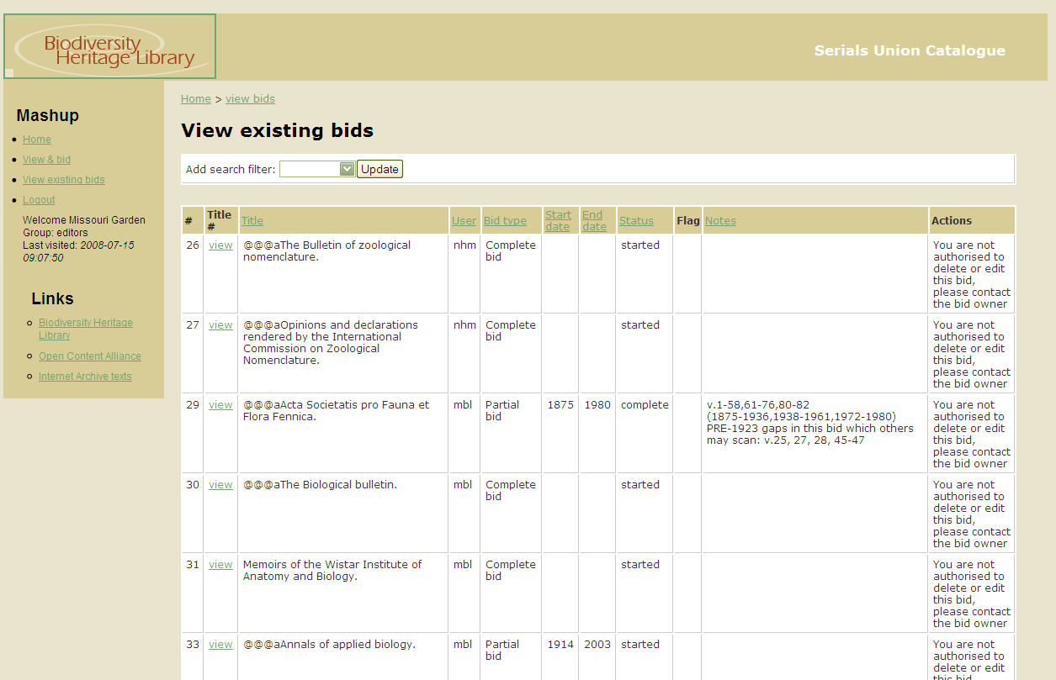
Figure 5: Serials Bid List

MONOGRAPH DE-DUPING TOOL
(http://nstage.mbl.edu)
The MBLWHOI Library has developed a tool that assists with avoiding duplication of the monographs sent by BHL members to IA for scanning. While still in an early stage, the application is being used and its development will benefit from usage and feedback.
The application is entirely web-based, requiring no client or user configuration. There are separate accounts for each institution. The tool is designed to ingest picklists in excel (.xls) format. The tool can track an institution’s picklist upload activity. If duplicates are found, the tool will show which institution scanned it, and when, so that it can be removed from the newly submitted picklist. Some problems have surfaced with the identification of duplicates because of punctuation differences in records but these issues are being resolved. See figures 6-8 below.

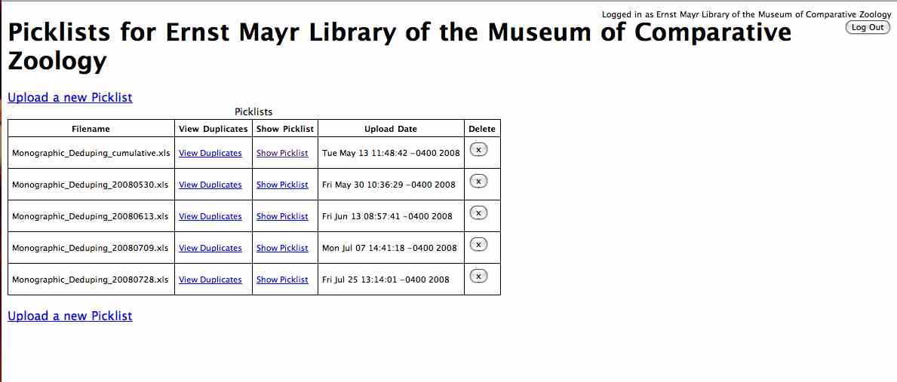
Figure 6: Ernst Mayr Library picklists in Monograph de-duping Tool.

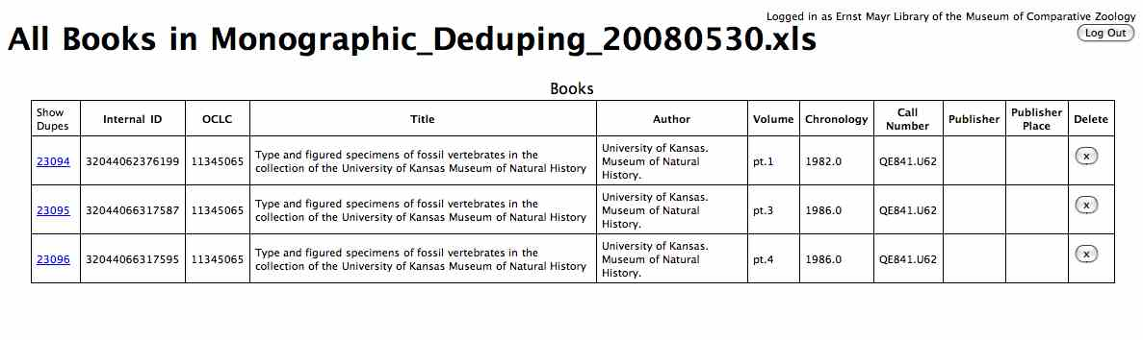
Figure 7: One picklist in the Monograph de-duping tool.

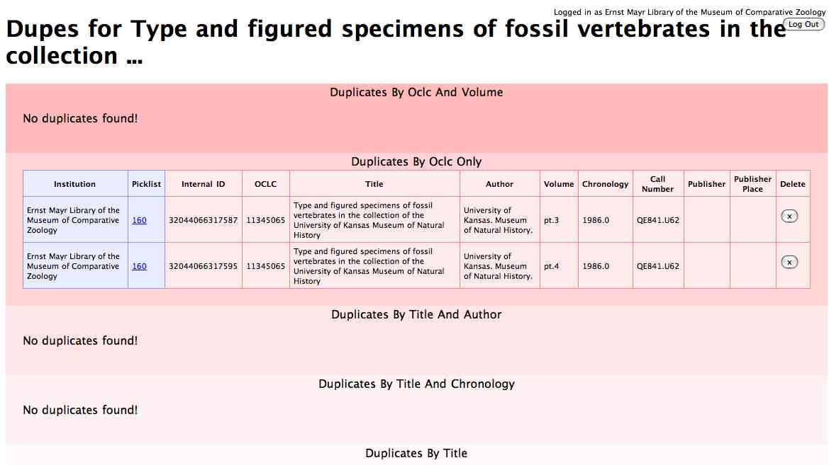

Figure 8: Duplicate display in the Monograph de-duping tool.

TAXA TOY
(https://bhl.wikispaces.com/TaxaToy) (http://taxatoy.ubio.org/)
Taxa Toy is a tool developed by Neil Sarkar at MBL/WHOI to analyze the data in NameBank. It can be used to explore historical trends associated with taxonomic names and may help identify the quantity and likely publication years of species descriptions. TaxaToy contains a list of taxonomic groups, and how many species were discovered per year in that group. Groups that are predominantly described in public domain period publications can be identified. This tool also displays the top five years with the highest number of descriptions for each group. This could also help to pinpoint the “low hanging fruit” for a group whose literature needs to be prioritized for EOL or a similar organization. See figure 9 below.

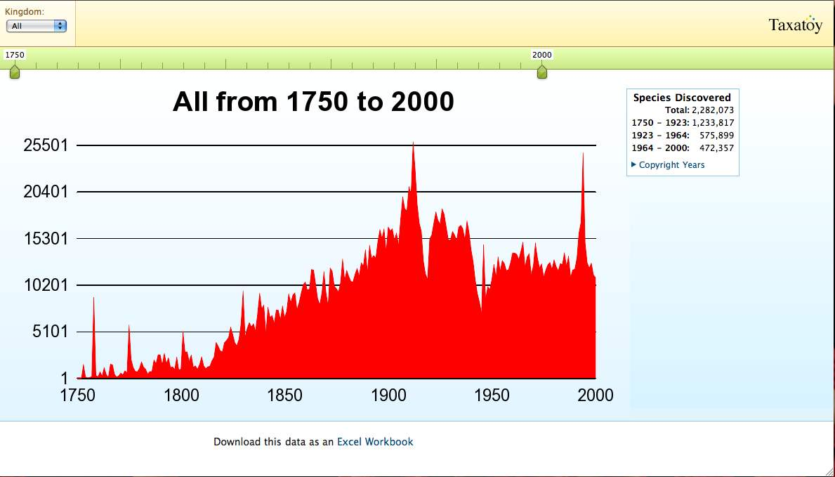
Figure 9: Species discovered from 1750-2000 as displayed in TaxaToy.

2. PRELIMINARY AGREEMENTS ON WHICH INSTITUTIONS ARE SCANNING WHAT SUBJECT AREAS

UIUC/FIELD MUSEUM
The University of Illinois at Urbana-Champaign is scanning some items from the Field Museum of Natural History including Fieldiana and other selected titles. They will also be scanning UIUC holdings, selected by the Missouri Botanical Garden

NHM
The Natural History Museum, London is scanning major serial run publications of their own (NHM publications) and also pre-1860 serials starting in the Zoology library, then into the General library so a variety of subjects will be covered. NHM has been bidding as they select.

AMNH
The American Museum of Natural History will start with ornithology and then progress to mammalogy.

BOTANY: Kew, MOBOT, NYBG, Harvard Botany Libraries
The Botany Libraries (Kew, MOBOT, NYBG, Harvard Botany Libraries) are working to develop a coordinated plan for scanning. The New York Botanical Garden will scan mainly Brazilian and Caribbean material and Floras. MOBOT has been scanning from a prioritized list based on protologue density as derived from the TROPICOS database.

SMITHSONIAN
The Smithsonian Institution Libraries (SIL)will begin scanning entomology and Smithsonian published materials (US National Museum). SIL may do some paleontology works with a non-grant funded scribe.

ERNST MAYR LIBRARY/MCZ/HARVARD
The Ernst Mayr Library of the Museum of Comparative Zoology, Harvard will focus on MCZ publications, Herpetology, Ichthyology and marine biology as well as general science serial titles. Marine Biology monographs and serials will be pulled from the following MCZ collections: Coelenterates, Crustaceans, Echinoderms, Invertebrates, Mollusks, Porifera, Protozoa and Oceanography. The Ernst Mayr Library has also responded to specific requests and serial runs for societies and museums for which permissions have been granted. The Ernst Mayr Library will also scan Palaeontographica Americana and Bulletins of American Paleontology once permissions have been resolved.

MBL/WHOI LIBRARY
The MBLWHOI Library is scanning pre-1923 monographs and US government publications (regardless of year) in the following call number ranges: Q, QE, QH, QK, QL, QP, QR, SH. The collection is primarily, although not exclusively, marine focused. MBL also checks Stanford’s Copyright Database for books in the 1923-1963 range that have not had copyright renewed. If copyright has not been renewed, the books are scanned. For serials, MBL is making a physical A-Z pass through the stacks identifying pre-1923 titles within our thematic areas: Marine Biology, and Natural History titles with significant marine related content, including Oceanography, Fisheries, Malacology and special faculty specific request areas such as embryology. Titles bid upon, which are being bar-coded and placed in the queue for scanning may be viewed at the BHL Serials Union Catalog bidding pages:
The MBLWHOI Library has a website (http://cecelia.whoi.edu/BHL/) where call number, title, author, and URL are posted for scanned items.

3. ISSUES: COORDINATION & SELECTION

Tom Garnett has been negotiating with a variety of publishers to get permission to scan in-copyright material. A complete list of copyright cleared titles can be found at:
http://www.sil.si.edu/BHL/BHL_permissions.cfm.
Non-BHL mass scanning projects have some overlap with the BHL. Other digitization projects should be investigated to avoid duplication or to find content to ingest into BHL and thus save some scanning funds and effort. In some cases, BHL members may alter scanning plans based on the identification of alternative sources of specific content. If discovered content is open access, meets BHL standards, including being easy to ingest, then we suggest that BHL libraries should not scan those items and alert the technical team to ingest the copy found. There is currently no workflow in place to ingest from other sources, thus for now the library can choose to scan the item anyway or flag it for notification and later scanning if ingestion is not possible. It is particularly important that scanning funded by EOL/BHL have minimal duplication.
BHL content is openly available as either public domain or with a Creative Commons license; individuals may download and reuse the content without first seeking permission; commercial use requires permission (http://www.biodiversitylibrary.org/Copyright.aspx). Other projects (GoogleBooks http://books.google.com/, Microsoft scanning for Internet Archive http://www.archive.org/, and Animalbase http://www.animalbase.de/) may not be open access thus duplication may be necessary to ensure unfettered access to content.
The University of Toronto and the University of California already have rich biodiversity content in the Internet Archive. Their scanning was done with Microsoft funding and the original agreements had restrictions that did not match the open access goals of the Biodiversity Heritage Library. Since Microsoft has decided to end their book scanning operations, they have also apparently ended the restrictions on content. . If the restrictions are removed, BHL potentially could ingest the biodiversity-related content easily. Tom Garnett is investigating the removal of restrictions and as a courtesy, will request permission from the University of Toronto and the University of California to ingest any non-restricted content. There may be considerable duplication with already scanned BHL material (early reports suggested up to 10%). Chris Freeland posted a search on IA by selecting the most frequently used subjects in BHL and comparing them against the books scanned with MSN as the sponsor. The result was a total of approximately 18,379 biodiversity items in IA from non-BHL scanning.
AnimalBase http://www.animalbase.de/ has requested the BHL "intent to scan" list to ensure that that their scanning does not duplicate BHL scanning. Currently, this request does not fit the workflow of most BHL libraries. It is not feasible for us to spend the time and funds to analyze our collections to the detail needed to answer the request. BHL libraries are working in batches of immediate plans to scan. Plans are separated into monographs and serials understanding that the separation is not always clear, since series may be viewed as both monographic and serial in nature. It may be possible to share the serials bidding tool and the monograph deduping tool spreadsheet with Animalbase administrators. However, these tools are tightly coordinated with rapid scanning workflow so it may not provide enough lead time for AnimalBase. AnimalBase might fit into our flow as long as they understand that we are working with immediate scanning and full “cover to cover” scanning not “article level” scanning. A title placed in the monographic list by Animalbase that would not be available until 12 months later does not fit the workflow for most BHL institutions.
Another issue is how to respond to requests for specific items. Requests may be sent to the BHL mail from any user browsing the site, they come in a variety of ways directly from faculty and researchers at the BHL institutions or other institutions, and even from publishers interested in having the BHL digitize their publications. There is no agreed workflow or procedure to address requests. Currently if the institution that received the request does not have the requested item, they may check OCLC or email other BHL libraries to see who has the requested items and pass the request on. Requests have not been overwhelming yet so informal channels are working. Permissions for post 1923 titles are verified through Tom Garnett and his staff and then titles are bid using the serials bid list.
There have also been questions about the suitability some of the already scanned content and how carefully we need to monitor or prefilter content. For instance, some works may be controversial such as these subject tagged examples:

http://www.biodiversitylibrary.org/subject/Animal+worship
http://www.biodiversitylibrary.org/subject/Religion+and+science
http://www.biodiversitylibrary.org/subject/Controversial+literature
http://www.biodiversitylibrary.org/subject/Poisonous+plants

Another potentially controversial title: Useful plants and drugs of Iran and Iraq
http://www.biodiversitylibrary.org/bibliography/2281.

The MacArthur money must be used for core taxonomic publications, not just all items in a library. Libraries scanning without the MacArthur money can be more liberal in their view of biodiversity topics. One suggestion is to review items based on library classification. For example, the Library of Congress system has clear science categories such as items classed in the Q’s. QL is the label for zoology and QK is the label for botany. Other areas of “Q” might have a mix of relevancy, as would areas labeled “S” (animal husbandry, agriculture and forestry). A decision should be made as to how finely selection should be viewed. Selectors could skip obvious non-science ranges such as “B” or “P” and review more closely ranges that might include relevant items such as “G” which might include gazetteers but also books about the environment (“GE”). Some of the libraries have their own classification systems and it may not be efficient to analyze each library’s unique system.

4. RECOMMENDATIONS

- Doug Holland and Connie Rinaldo should be thoroughly trained on the OCLC Analysis Tool. They can assess the value of the tool to BHL more accurately and make a recommendation as to the value of the subscription and if more individuals in multiple institutions should be trained.
- Money should be spent on improving the de-duping tools, including how to add material from other projects (such as University of Toronto and University of California).
- A decision needs to be made ASAP about whether or not BHL will incorporate scanned items from the Microsoft projects on Internet Archive. If these items are incorporated, BHL libraries should check picklists against these items until they are incorporated in de-duping tools. If these items are to become part of BHL, they should be incorporated into the serials bid list and the monograph de-duping tool as soon as possible.
- General workflow should include checking items on picklists against other BHL accepted scanning projects, identifying likely items for ingest from other digital libraries and a process for delaying or stopping scanning of duplicate items with notification to the appropriate member of the technical team for ingesting already scanned items.
- EOL-granted monies must be used only for scanning core biodiversity literature.
- An analysis should be completed to identify the library classifications (particularly in Library of Congress) that constitute the core biodiversity literature and how carefully mixed classifications should be screened.
- All BHL sites should use the serials bid list and monograph de-duping tool.
- All BHL sites should be sure that information about broad subject areas for which they are responsible are refreshed regularly on the wiki.
- Other projects that are potential contributors to BHL should be identified and monitored. Does Atlas of Australia have material to contribute? We must also be aware of what will be contributed by BHL Europe.
- A protocol for responding to special requests should be developed.

