**Global BHL Quarterly Reports**

**BHL US/UK Q1, FY12 (October-December 2011)**

* Introduction:

The Biodiversity Heritage Library started fiscal year 2012 with a multitude of exciting events, including a global BHL meeting, the Life and Literature Conference, the first in-person meeting of BHL staff members since the 2009 meeting in Washington, and a JRS-funded meeting focused on literature digitization in Africa. Furthermore, this quarter saw the addition of two new member libraries to the consortium: Cornell University and the United States Geological Survey.

This quarter, the Albert R. Mann Library of Cornell University joined the BHL consortium. Collection strengths include agriculture, human ecology, and life sciences. With the inclusion of Cornell to the team, BHL ingested 4,098 previously-scanned Cornell volumes from the Internet Archive, bringing BHL US/UK’s total volume count to over 100,000. Cornell plans to explore digitization options both in-house and with Internet Archive so that they may continue to contribute content to BHL.

The United States Geological Survey Library in Reston, VA, also joined the BHL ranks this quarter. The library, dedicated to earth and natural sciences, contains more than 2,000,000 volumes, 1,500,000 maps, and 800 current serial titles. The USGS has already digitized some of their collection and intend to upload that content to BHL via the Macaw system developed at Smithsonian Institution Libraries. They will also implement a scanning workflow through the Internet Archive to scan additional volumes from their collection.

On 13 November, 2011, BHL hosted the second global BHL planning meeting at the Field Museum in Chicago, IL. Representatives from all BHL nodes (with the exception of Bibliotheca Alexandrina) attended and presented project updates. Updates for the BHL-US/UK node included a new logo, the implementation of the BHL Flickr project, and the election of a new Executive Committee in keeping with the new governance structure reported on in the last report. Updates for the Australian node included the launch of the new Australian portal, which received very positive feedback from the user community. BHL-China, members of which visited SIL in early November to discuss project status and future collaborations and development, has continued digitization of Chinese materials, which have been presented through the BHL-US/UK portal. BHL-Europe is on target to release their portal, which will aggregate content from the multiple European library members, by the end of this year. Finally, SciELO-Brazil continues to contribute content to BHL via Citebank. As a whole, the group decided to form a Coordinating Committee to establish bi-laws and improve global project coordination, integration, and communication in the future.

The BHL Life and Literature conference, also hosted at the Field Museum in Chicago, IL, occurred following the global meeting, on 14-15 November, 2011. The conference, conducted with the express purpose of generating conversations about the priorities for biodiversity literature digitization, particularly as it pertains to BHL, for the next 4-5 years, brought together interested parties in a variety of disciplines, including science, education, informatics, and the humanities. The conference was divided into four panel discussions, followed on the second day by break-out sessions that allowed attendees to delve deeply into the various topics discussed during panel sessions, ultimately leading to an outline of the various areas deemed most important for BHL to focus on in the next 4-5 years. The winner of the Life and Literature Code Challenge, Ryan Schenk, was also presented at the conference. His winning application, “Synynyms”, works as a taxonomic name aggregator, finding all of the different names given to a species over the years and displaying the frequency of each name variety throughout history.

On Wednesday, 16 November, the BHL Staff Member and the JRS African meetings occurred. The BHL staff meeting was an opportunity for librarian staff at BHL member institutions to gather to discuss collective workflow issues. BHL Staff discussed the new ideas resulting from the Life and Literature conference as well as issues related to governance, social media, scanning workflow and technical development. The JRS African meeting , sponsored by the JRS Foundation, which funded the attendance of 11 colleagues from Africa, was an opportunity to bring together African librarians, biologists, computer scientists, publishers and students to discuss and decide on African needs and objectives for Biodiversity Literature Digitization.

As BHL staff look towards the next quarter of fiscal year 2012, we plan to continue governance discussions at the annual Institutional Council meeting in March and promote BHL at a variety of events, including the ALA Midwinter conference and the Catholic University of American Digital Library Symposium. Further staffing and consortium developments are also anticipated for the New Year. We have no doubt that future quarters will be as successful as this past quarter.

* Content Statistics:

**Quarterly Statistics:**

Items Added: 3,033

Pages Added: 1,054,835

Names Added: 2,762,629

PDFs Generated: 10,061

Feedback Issues Received: 303

Feedback Issues Closed: 164

Requests Received: 149

Rare Requests Received: 8

Requests Closed: 48

Rare Requests Closed: 2

**Cumulative Statistics:**

Total Items Added: 102,569

Total Pages Added: 37,890,320

Total Names Added: 131,894,689

Total PDFs Generated: 94,693

Total Feedback Issues Received: 3,840

Total Feedback Issues Closed: 2,802

Total Requests Received: 1,439

Total Rare Requests Received: 343

Total Requests Closed: 740

Total Rare Requests Closed: 136

* New software and functional development

Contribution to the BHL Flickr account continues, with 23,323 images currently added to the collection. The Flickr account pulls out the amazing natural history illustrations from BHL books and serves them up to users in an easy, approachable manner. It continues to be one of the most popular services offered by BHL, and has instigated a great deal of discussion about providing better access to BHL illustrations and inspired several grant proposals to support continued BHL-illustration related development. In January, 2012, a new application was added to the BHL administration dashboard that allows direct upload of images from BHL to Flickr, with embedded metadata and page links included. More information on this development in the next quarterly report.

At the beginning of this quarter, staff conducted a usability test with BHL users in the US and Australia. The usability test compared the functionality of the U.S./U.K. portal to that of the Australian portal. The final report indicated the need to improve item navigation in the U.S./U.K. portal (allowing for thumbnail view of images), improving pagination display and site navigation on the Australian portal, improve pagination for both portals, and the development a more robust, user-friendly mechanism for finding and displaying images in both portals. The insights gleaned from these usability studies will be used to improve user interface design, and have reflected in technical development milestones for the project.

As part of the Life and Literature Conference, BHL staff gathered a set of developmental priorities that our users would like us to focus on for BHL for the next 4-5 years. These priorities will help guide tools design and future BHL development. See attached “Life and Literature Breakout Session Visual.”

Also as part of the Life and Literature Conference, BHL staff were asked to study those priorities identified by conference attendees and further prioritize them for BHL technical staff. This information will help guide immediate development. See attached “Staff Reactions to Life and Literature Report.”

* Website Statistics

Visits: 288,287

Unique Visitors: 148,054

Page Views: 1,376,584

Unique Page Views: 983,635

Average Time on Page: 00:01:37

Average Time on Site: 00:06:05

Bounce Rate: 46.33%

New Visits: 134,675 (46.72% new visitors)

Returning Visits: 153,612 (53.28% returning visitors)

Most Visited Pages:

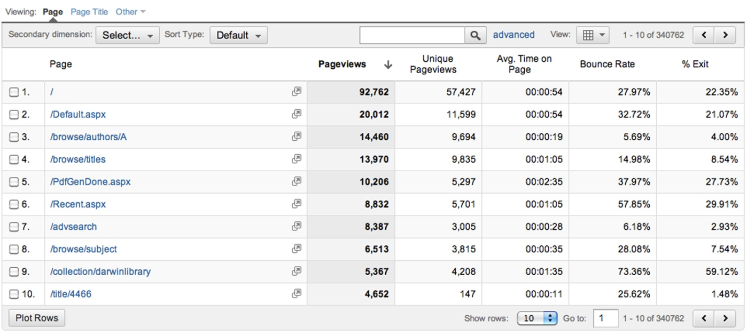

Traffic sources:

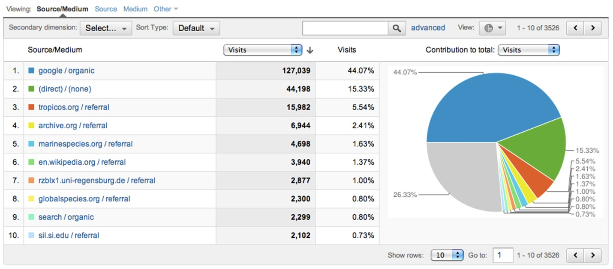

Previous Quarter Comparison:

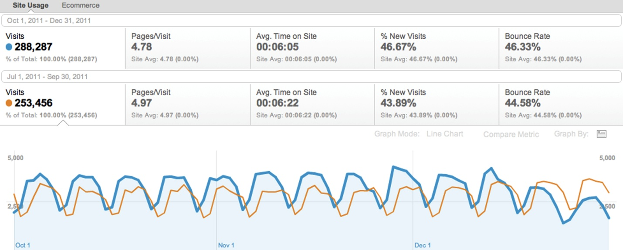

See attached Google Analytics Report for full statistics.

* Social Media Statistics

This section articulates goals and metrics for the social media platforms used, for example: Facebook[1] , Flickr[2], Twitter[3], Blog [4] and others.

**Facebook:**

Total Post Views: 245,095

Conversation Reach (Total Post Interactions/# of people who like our page): .95 or 95%

Audience Growth (Total new people who like our page): 338

Audience Engagement (Total post interactions): 1,620

Total Monthly active Users by End of Q1, FY12: 1,273

Total Page Likes: 1,871

**Twitter:**

Clicks on Links in Tweets: 1,164

Audience Engagement (@mentions + RTs): 380

Total Followers: 1,306

Audience Growth (new followers): 181

Conversation Reach (audience engagement/followers): .33 or 33%

Mentions by Influencers: 221

**Flickr:**

Total Views: 386,744

Total Followers: 365

New Images Added: 8,904

Audience Engagement (total comments, favorites, notes & tags, and added to galleries): 1,382

**Blog:**

Total Visits: 4,868

Unique Visitors: 3,540

* Anecdotes and Testimonials

***Via Email and Gemini:***

**Friday, December 16, 2011**

From Colin Jones, [colinjones18@hotmail.com](mailto:colinjones18@hotmail.com)

Dear Sirs, I must thank you for dealing with my request a couple of weeks ago re. Mag.Zool. I now see vol.1-8 are online. I have only checked 1 vol. so far but it will mean that 2 citations will need changing. As I think I said in my previous e-mail what you are doing is so helpful in being able to check things out and change them where that is needed.I pass on my findings and they go around the world so hopefully the correct citation will be used in the future. Just to give you some idea of how helpful you have been some lots of incorrect bird species names have now been corrected and also lots year dates have been corrected and some citations have changed where an earlier publication has been found. As I do this for fun in my spare time after work getting to museums etc. is nearly impossible. Your contribution to zoology should not be under estimated. colin jones

**Monday, December 12, 2011**

From Pat Knobloch, via gmail [mailto: huarpa@cox.net]

Dear Grace,

now that vol.2 is available I sent a message to our Andeanist list (via Dan Sandweiss). Hope you get some more feedback.

Thank you and staff for all your hard work to make this series available. I, too, am a librarian (retired), so I can appreciate the technical and cataloguing services that go into this endeavor.

Good luck,

Pat

**Monday, November 28th, 2011**

From: Peter Gregg, via Gemini [no email given]

What an absolutely wonderful site. It is a treasure trove of information. Thank you!

**Wednesday, November 23, 2011**

**From:** Elizabeth Whitcombe, via Gemini [mailto: ewhitcombe@xtra.co.nz]

May I compliment you on this splendid service? The Library's invaluable for my work on seasonal variability of climate and vector-borne disease in British India, 1875-1940.

**Tuesday, November 22, 2011**

From: Aaron Sims, via gmail [mailto: asims@cnps.org]

Grace,

Thank you so much for the prompt reply. I was able to get a colleague in a separate office to download the PDF fine, so it must have been an issue with the internet server at my office.

I really appreciate your work. The Biodiversity Heritage Library is an excellent resource that regularly helps my assistant and I obtain original descriptions for plants during their review and assessment for inclusion/change/deletion in the California Native Plant Society's Inventory of Rare and Endangered Plants ([www.rareplants.cnps.org](http://www.rareplants.cnps.org/)). I feel so privileged to be working in a day in age when such resources are so readily available and easy to obtain.

Kind regards,

Aaron

**Monday, November 14, 2011**

From: Dennis Meritt, via Gemini [mailto: dmeritt@depaul.edu]

I am most grateful for the ability to obtain a hard copy of an obscure article from The Nautilus (Volume 37 January 1924, No.3 pages 73-77). This reference is most useful to work that I am currently undertaking in the Chaco of Paraguay with apple snails and snail kites. Thank you most sincerely for your work in making the early issues of Nautilus available to researchers. With personal best wishes and regards. Dennis Meritt

**Friday, November 4, 2011**

From: no name given, via Gemini [mailto: tsguan@ibcas.ac.cn]

I received the pdf article so quickly. Many Thanks to all of you !

**Wednesday, October 19, 2011**

From:Michael Hinton, via Gemini {mail to: mhinton@iattc.org]

I created a bibliographic link for the journal article at <http://www.biodiversitylibrary.org/item/72534#page/55/mode/1up>. My apologies, but I missed including the name of the second author, which is Yoshio Ishizuka. Thank you for your help in correcting this. Also, I was very happy to find BHL - you have no idea how wonderful it is to [even] find California Fish and Game on line with such excellent access interface.

**Wednesday, October 12, 2011**

From: Annemarie OHLER, via Gemini [mailto: ohler@mnhn.fr]

Thank you very much for this service! Very useful!

***Via Twitter/Facebook/Blog/Flickr:***

**Twitter, from @SILibraries**

[Dec 01, 2011, 3:00pm via HootSuite](http://twitter.com/SILibraries/status/142332337869434880)

two vivid, colorful plates of mushrooms can now be viewed on @BioDivLibrary flickr stream. lovely! [ow.ly/7Lt1t](http://t.co/OQWHM2wf)

**Twitter, from @Endoxocrinus**

[Dec 02, 2011, 12:06pm via Web](http://twitter.com/Endoxocrinus/status/142650878904639488)

#FF @BioDivLibrary @eol @anatotitan @Mhorridus @labroides the best biotwits on the whole web! and lots of fun!

**Twitter from @eol**

[Dec 07, 2011, 8:51am via HootSuite](http://twitter.com/eol/status/144413694112169985)

Loving these gorgeous illustrations in Kunstformen der Natur, part of the @BioDivLibrary Book of the Week series [ow.ly/7Rvbe](http://t.co/K36xjwF0) #bhlib

**Twitter, from @ruthbleakley**

[Dec 07, 2011, 3:40pm via Web](http://twitter.com/ruthbleakley/status/144516634135109632)

WOOOW Love the latest BHL illustrations! @cheesivore @eol @BioDivLibrary

**Twitter, from @MagicMushShop**

[Dec 09, 2011, 1:08pm via Web](http://twitter.com/MagicMushShop/status/145203119582752768)

@BioDivLibrary Thanks for these beautiful illustrations, great source for inspiration and old cultivation methods.

**Twitter, from @OceanPortal**

[Dec 09, 2011, 5:10pm via HootSuite](http://twitter.com/OceanPortal/status/145263975758692352)

Stunning shells, beautifully illustrated. Thanks @BioDivLibrary for sharing them. [ow.ly/7U4ZG](http://t.co/uy6KywEZ)

**Twitter, from @Endoxocrinus**

[Dec 16, 2011, 12:28pm via Web](http://twitter.com/Endoxocrinus/status/147729712083505152)

#FF to @eol @BioDivLibrary @holoturio @anatotitan @Mhorridus the best sources of biodiversity (now and before) ever!

**Twitter, from @MycoFun**

[Dec 21, 2011, 9:37am via Web](http://twitter.com/MycoFun/status/149498735729197056)

A beautiful Champignon! Boletus with drawings of the basidia. [biodiversitylibrary.org/page/19539111#…](http://t.co/8JZ0W0l5) Thanks @BioDivLibrary #Fungi #Mushroom #Mycology

**Twitter, from @eol**

[Dec 28, 2011, 9:25am via HootSuite](http://twitter.com/eol/status/152032329454452736)

You will love these images from @BioDivLibrary. We promise. [ow.ly/7ZmhF](http://t.co/S1lKCnGt)

**Twitter, from @IArtLibraries**

[Dec 28, 2011, 1:40pm via HootSuite](http://twitter.com/IArtLibraries/status/152096519141597184)

Wow - a gold mine of visual inspiration! RT @eol: You will love these images from @BioDivLibrary. We promise. [ow.ly/7ZmhF](http://t.co/dIiNnrc6)

* About BHL

The Biodiversity Heritage Library (BHL) is a consortium of 14 natural history and botanical libraries that cooperate to digitize and make accessible the legacy literature of biodiversity held in their collections and to make that literature available for open access and responsible use as a part of a global “biodiversity commons.”

The BHL consortium works with the international taxonomic community, rights holders, and other interested parties to ensure that this biodiversity heritage is made available to a global audience through open access principles. Today, In partnership with the Internet Archive and through local digitization efforts, BHL has digitized over 37.8 million pages of taxonomic literature, representing over 53,000 titles and 102,000 volumes (January 2012).

The published literature on biological diversity has limited global distribution; much of it is available in only a few select libraries in the developed world. These collections are of exceptional value because the domain of systematic biology depends more than any other science upon historic literature. Yet, this wealth of knowledge is available only to those few who can gain direct access to significant library collections. Literature about the biota existing in developing countries is often not available within their borders. Biologists have long considered that access to the published literature is one of the chief impediments to the efficiency of research in the field. Among other results, free global access to digitized versions of the literature would repatriate information about the earth’s species to all parts of the world.

Since 2009, the BHL has expanded globally. The European Commission’s eContentPlus program has recently funded the BHL-Europe project, with 28 institutions, to assemble the European language literature. Additionally, the Chinese Academy of Sciences, the Atlas of Living Australia, Brazil (through SciELO and BIREME), and the Bibliotheca Alexandrina have created regional BHL nodes. These projects will work together to share content, protocols, services, and digital preservation practices.

1. Include quarterly metrics like number of people interacting with page, engaged with a story, exposed to the content or posts and any other metrics as “Total Page Likes”, “Quarterly New Page likes” and “Unlikes”, etc.
2. Account for total and quarterly images added in Flickr, Views on content, Total and New Flickr followers, quarterly and total Comments, Favorites, Notes, Tags, etc.
3. If in use, could indicate metrics on New Followers, Total Followers, Total Tweets and Retweets, etc.
4. If applicable, any metrics accessible like Quarterly visits, Quarterly unique visitors, Total Blog Posts, Example of blog post from quarter could be provided.