Elements of Global BHL Quarterly Reports
- Introduction:
BHL-Europe is currently approaching the end of the project, which is 30 April 2012. The work on the content ingest is currently the most important aspect. The re-factorisation of the Pre-Ingest tool and further adaptation of the ingest process is dominating the discussions in the project right now. The portal development on the other side is progressing well. The last user test in January was successful and positive. The core features are. In the last quarter, BHL-Europe finalized the Biodiversity Library Exhibition (BLE) and launched it on 14 February 2012. BHL-Europe project results were presented at numerous conferences last fall, including the Sherborn Symposium (October), Life and Literature (November) and DISH (December). BHL-Europe hired a new communication officer to manage the social media channels for the project, which turned out to be a very important and successful step.
- Content Statistics:
It is currently difficult to analyse the full corpus of content available on the BHL-Europer servers. This will be done for the next quarterly report. Therefore, this section gives an overview of work done in this reporting period regarding analysis and preparation of scanned material and the corresponding metadata. One important progress we made during the last quarter is related to the ingest of BHL-Europe content in Global BHL. We agreed on a way forward how to solve it technically and agreed on an Annex to our MoU to formalise the data transfer. Most content providerds have signed the Annex already and we hope to get the final signatures soon.
The work of our content providers is mainly focussed on three areas, and examples of this work is given below:
- Content selection and IPR management
- Digitisation (not funded through the BHL-Europe project)
- Content upload and QA
Three of our partners reported activities on IPR management in the last quarter. The libraries from Helsinki, Tervuren and Meise are negotiating rights with rights holders to make in copyright content available through BHL-Europe.
Our colleagues in Goettingen and Leiden are currently collaborating within the BHL-Europe project to identify historical literature that are still important to be digitised. This list of item will feed the new Naturalis (Leiden) in-house digitisation project that will start soon. Also our French and Belgian partner libraries are very active in selecting important items for digitisation. Our three Belgian partners built an internal wiki to collect titles for scanning operations: http://193.190.223.46/wiki_ext/index.php/BHL.
A number of partners have now finished their contractual obligations for content delivery (e.g. Museum in Linz, Botanical Garden Edinburgh). Within the last reporting period, more than 250,000 pages of biodiversity content was uploaded to the BHL-Europe servers, examples give in the table below:

Title | Years available | Pages
Adansonia | 1961-1980 | 11,370
Annales du Muséum national d'histoire naturelle | 1802-1813 | 11,500
Archives du Muséum d'histoire naturelle | 1839-1858 | 5,600
Archives du Muséum d'histoire naturelle séries 6 et 7 | 1926-1969 | 7,870
Bulletin de la Société botanique de France | 1854-1935 | 64,000
Bulletin de la Société des naturalistes parisiens | 1904-1932 | 1,200
Bulletin de la Société philomathique à ses correspondans | 1791-1797 | 5,800
Bulletin du Muséum d'Histoire Naturelle | 1895-1907 | 6,187
Bulletin du Muséum National d'Histoire naturelle | 1907-1970 | 44,911
Bulletin du Muséum National d'Histoire Naturelle. Section A, Zoologie. | 1979-1996 | 16,756
Bulletin du Muséum national d'Histoire naturelle. Supplément | 1972-1978 | 799
Bulletin du Muséum national d'Histoire Naturelle. Zoologie | 1971-1978 | 11,804
Mémoires du Muséum d'Histoire Naturelle | 1815-1832 | 10,200
Mémoires du Muséum National d'Histoire Naturelle | 1935-1951 | 11,562
Notulae systematicae | 1909-1960 | 5,204
Nouvelles annales du Muséum d'Histoire Naturelle | 1832-1835 | 2,100
Nouvelles archives du Muséum d'histoire naturelle | 1865-1914 | 15,683
EOS |  | 30,000
Parasitologica Hungarica
Acta Zoologica Hungarica
Total |  | 232,546

More content is expected to come, as many of our partners have still ongoing and active digitisation projects. Although some of these projects can not considered to be mass scanning projects, they still provide highly valuable materials to enrich the BHL corpus further.

- New software and functional development
Best Practice guidelines and standards
One task within WP2 is to deliver the final version of the Best Practice Guidelines and Standards. This deliverable aims to give a standardized guideline for Europe. The approved best practice guidelines and standards shall be understandable for every person working with it. They shall guide new and current contributors in a simple and clear way through a digitisation workflow from the either print or digital version of an item to the digitised representation of that item in the BHL-Europe portal. The guide will describe the minimum required standard for BHL-Europe and where possible specifying the ideal standard.
During this reporting period the main task was to communicate with the project team to ensure the delivery of the required information to finalize the guidelines. It is planned to insert all available information until mid of February. More detailed information on the Best Practice Guidelines and Standards can be found on the internal wiki page: https://bhl.wikispaces.com/BHLE_WP2_BPG.

Global References Index to Biodiversity
Ongoing communications took place during the reporting period to ensure that the GRIB is up and running and all available catalogues are imported and deduplicated as soon as possible. The re-import of the BHL-Europe partner library catalogues into the GRIB started in January. Now, eight catalogues are re-imported and the libraries are testing the GRIB and the data quality. BHL-Europe and the GRIB have been shown at the TDWG 2011 Annual Conference in October in New Orleans, Louisiana, USA, during the Sherborn Symposium in October in London, UK and at the Life & Literature Conference in November in Chicago, Illinois, USA.

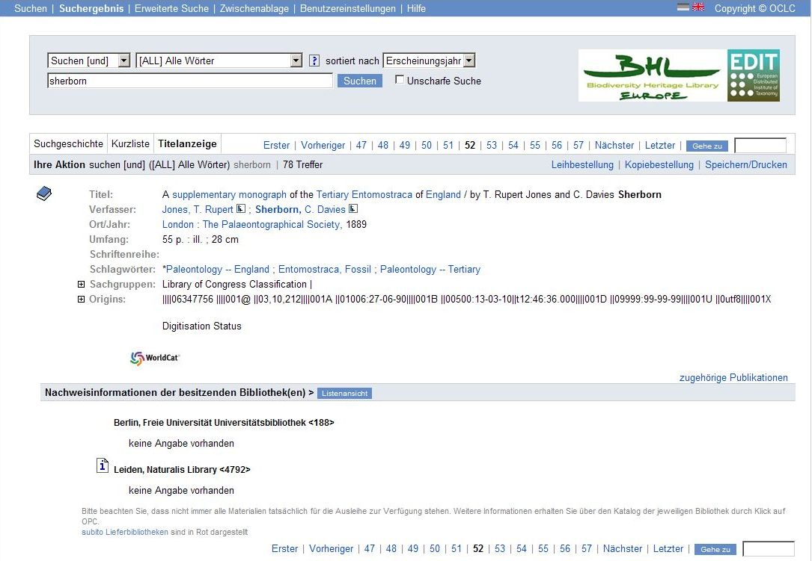

Example for de-duplication in the GRIB: the above title is available in two different libraries, but one record (i.e. master record) is shown in the list of results.

Pre-Ingest Tool
It was previously reported that a decision had been made to develop the Pre-Ingest tool further. This is mainly as a result of user feedback received after testing the tool, which highlighted the fact that some modification would be required in order to provide a best practice approach for users to upload their data.
The Pre-Ingest tool was completely re-written in order to provide a PHP based solution. To clearly identify the tasks of the Pre-Ingest tool, the workflow was documented and a specification of the tool has been started.
In addition, the File Submission Guidelines were re-written to conform to the requirements of the Pre-Ingest tool. Many content provider questions have been solved by clearly specifying the upload requirements.
In parallel the ingest process was modified to conform to the new Pre-Ingest component. A first version of the tool has since been deployed and tested by the development team. The current status of the Pre-Ingest tool was demonstrated during the last BHL-Europe Portal & Ingest Review Meeting in Helsinki on 9 February 2012.

Collaboration on OCR improvements (IMPACT) – Ground Truthing
BHL-Europe is collaborating with the IMPACT project to analyse workflows to improve the quality of the OCR text. After the ground-truth pre-production in the last reporting period, we have worked on the ground truthing itself in this period. Altogether 10 batches of page images were OCRed and re-typed by a service provider. The XML-files were sent to the BHL-Europe QA team for quality check. Errors were reported back to IMPACT and the service provider for improvements. An error rate of 0.05 was chosen based on previous experiences of IMPACT. If the error rate was higher, the batch was rejected, reworked and sent again for quality checks. With an error rate of 0.05 the batch was accepted for final processing by IMPACT. After final acceptance, the batch is ready for the experiments with the IMPACT toolkit to evaluate the potential improvement of OCR quality. Even after the end of the IMPACT project, we continue the collaboration with the new competence centre for digitisation. By the end of January, most of the batches are completed and first experiments with the IMPACT tools are in progress.

Further Development of the Portal System
Over the past couple of months our developers have made continuous improvements to the BHL-Europe system as well as implementing new features for the Portal. Many of these tasks consist of configuration changes and maintenance of the overall performance of the system. This involved the following:
- Installing and configuring the Apache solr server. This server is responsible for indexing the whole content stored in the BHL-Europe system and thus is the technological base for making the content accessible from the Portal via search and browse functionalities.
- Finalization of the connection of the Portal to the solr search index which is now updated by a special component of the Fedora system, called gsearch. By this means the index is updated every time when new documents have been ingested or when existing documents have been updated.
- Creating new and maintaining existing automated deployment jobs in the continuous integration server. This system is dedicated to build install and test any changes which have been applied by developers to the whole BHL-E system.
- Configuring the transformation process which is responsible for converting the data objects stored in the archival storage of the Fedora system into the special document format which can be indexed by the central search index, lucene.
- Bug Fixes, code refactoring and documentation: our team of developers have been busy correcting any bugs that were found by the testing team and reported in GitHub. As well as refactoring the Book Viewer to make it more configurable and easier to maintain. The version of Islandora has been upgraded to 11.2.
- Finally, all components have been documented on the internal wiki which shows good software development practice: https://bhl.wikispaces.com/Developer_Information

Implementation of BHL-Europe features in preparation of the January 2012 Milestone Release
During this period the development team have mainly focused on the Portal development and its integrated functionality in order to ensure that we have in place appropriate core feature functionality on a stable testing platform.
Development has focused on the integration of Simple and Advanced search within the BHL-Europe theme, followed by Browse, Bibliography and the Content Viewer to bring the components to a testable state.
The search module for the Portal was further enhanced. The search amplification modules (VIAF, CoL, PESI, etc.) were integrated into the search workflow in order to provide more accurate results. In addition the search module was also extended to support Drupal-Block support which was required for simple search integration. The ZDB was integrated in order to further amplify the search based on normalized journal titles. This also allows one to search for journal entries using acronyms only.
There has also been further development to major parts of the search facility of the Portal which includes: Implementing and configuring the auto-suggestion functionality of the simple search; Solving problems with searching for terms containing wild-cards and Umlauts as well as with diacritic characters in general; Implementing the search result page in which the results are ordered by their relevance for the search terms entered, just like in the result lists of Google and other search providers; Fixing problems which occurred in the interaction of the faceted search and the solr/lucene search engine.

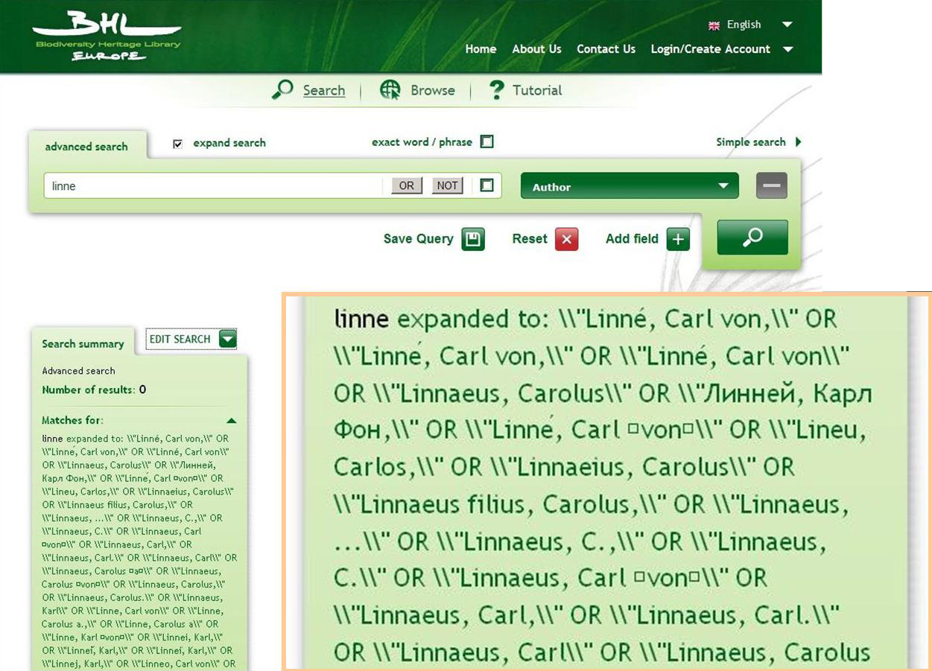

Name finding with the BHL-Europe portal in action: the implementation of the VIAF webservice enables the search term expansion on all varieties of the name available in the VIAF database. Similar functionalities are available for scientific and common names (through CoL and PESI) and serial names (through ZDB).

Biodiversity Library Exhibition (BLE)
BLE currently shows two virtual exhibitions. The one on spices was finished before and now also the second topic on expedtitions is finished. It includes 17 expeditions including Darwin, Scott, Amundsen and Livingstone. BLE was presented during the Life and Literature Conference in November 2011 and well received from the participants. BLE was identified during the education track as an excellent example of education tools. Therefore, it was concluded during the breakout session to maintain and expand the BLE in the future. BLE eventually was launched on 14 February 2012.

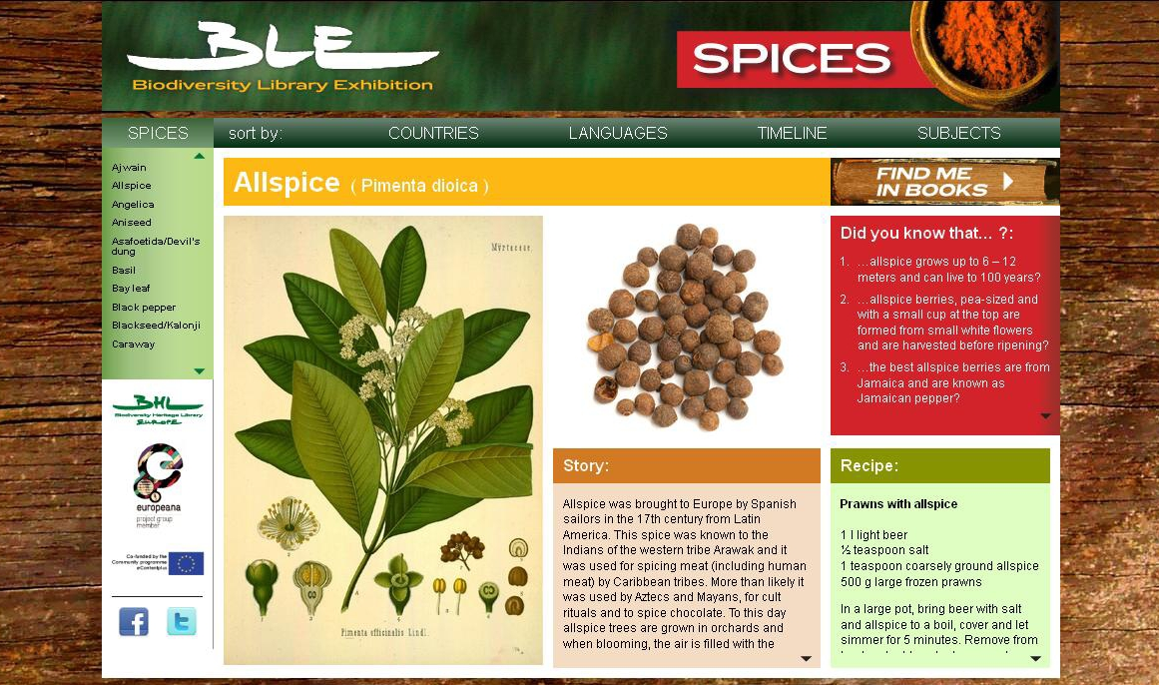

Example of a spice card in the BLE exhibition on spices.

- Website Statistics
BHL-Europe is currently not monitoring usage of content through BHL-Europe as the portal is not online. However, BHL-Europe drives usage of BHL content through two products, the Biodiversity Library Exhibition and Europeana. BLE was not launched in the last three month, but still brought a few visitors to the BHL-US portal: 66 visits, 3.3 pages per visit, 8:12 min time on site, 43.9% bounce rate.
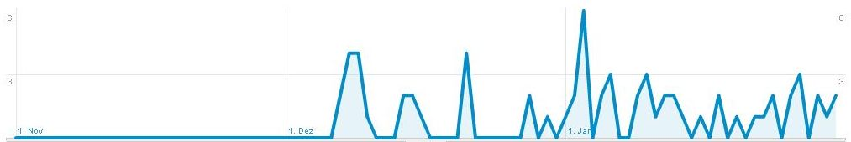
Usage of BHL-US through BLE.
Europeana was not among the top 10 referring sites in the last quarter. It brought 1,479 visits to the US portal (4.14 pages per visit, 5:17 min time on site, 48.6% bounce rate).

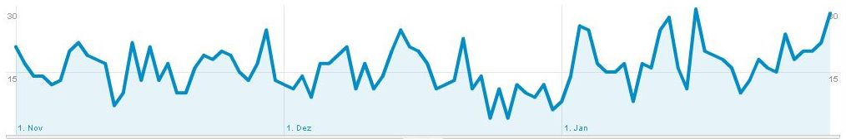
Usage of BHL-US through Europeana.
- Social Media Statistics
In December 2011, Nicolas Van Audenhove from the Royal Belgian Institute of Natural Sciences joined Work Package 5 of BHL-Europe to revitalize the social media channels and help to increase the use of social media. At the end of January 2012, we had 154 ‘likers’ of the BHL-Europe Facebook page and 138 Twitter followers. The BHL-Europe Blog had 953 all time hits, of which 348 were from January 2012. 36 hits occurred between 1 and 2 February 2012. These numbers indicate the increased publication activity on the blog: before December 2011 altogether 3 articles were posted, but 9 articles between December 2011 and February 2012. In December we published two conference reports, in January and February we published three articles on BLE and two on our portal development.
- Anecdotes and Testimonials
Nothing here.
- About BHL
This section is a standard couple of paragraphs describing the project, including information about Global BHL activity. The content in this section is basically the same throughout each report, and is only updated when major events (i.e. new partners) occur.

http://www.facebook.com/pages/BHL-Europe/151086001600041
http://twitter.com/BHLEurope
http://bhleurope.blogspot.com/

