**Gemini Quick and Dirty’**

1. **Login with your credentials @** [**http://biodiversitylibrary.countersoft.net/Main.aspx**](http://biodiversitylibrary.countersoft.net/Main.aspx)
2. **Click on BHL-Feedback [BHLFEED] to get to the project dashboard.**

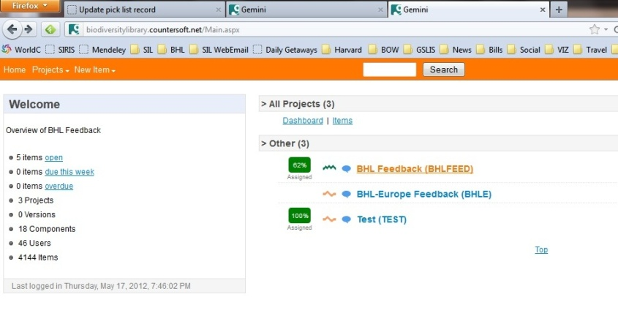

1. **This is the dashboard. Check out the pointers for a Gemini grand tour.**

95% of the time you will be going straight for the search box. Each Gemini issue is given a unique ID. Searching on the ID # will take you to the specific issue you are working on.

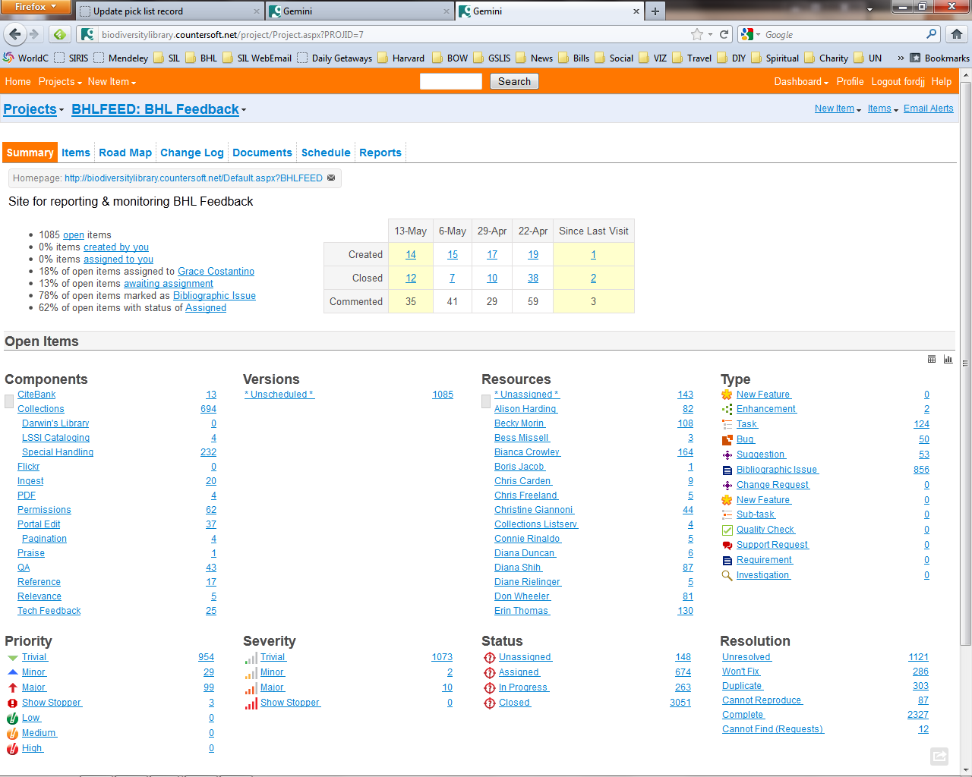

VERY important: Set up your email alerts so, that you get updates @ your email address. These emails tell you when you:

a) have been assigned to a new issue

b) when actions have been taken on an issue that you are assigned to or

c) when the issue has been closed.

Congrats, you are now a BHL resource! Here you will find your name. Click on it to see your assigned Gemini issues. Or you can click up **here** to the left as well.

Each Gemini issue is assigned a priority level. High priority items should be attended to first. (Yeah, kind of intuitive.)

1. **A typical Gemini issue, similar to ones you will be working on. Here’s the breakdown:**

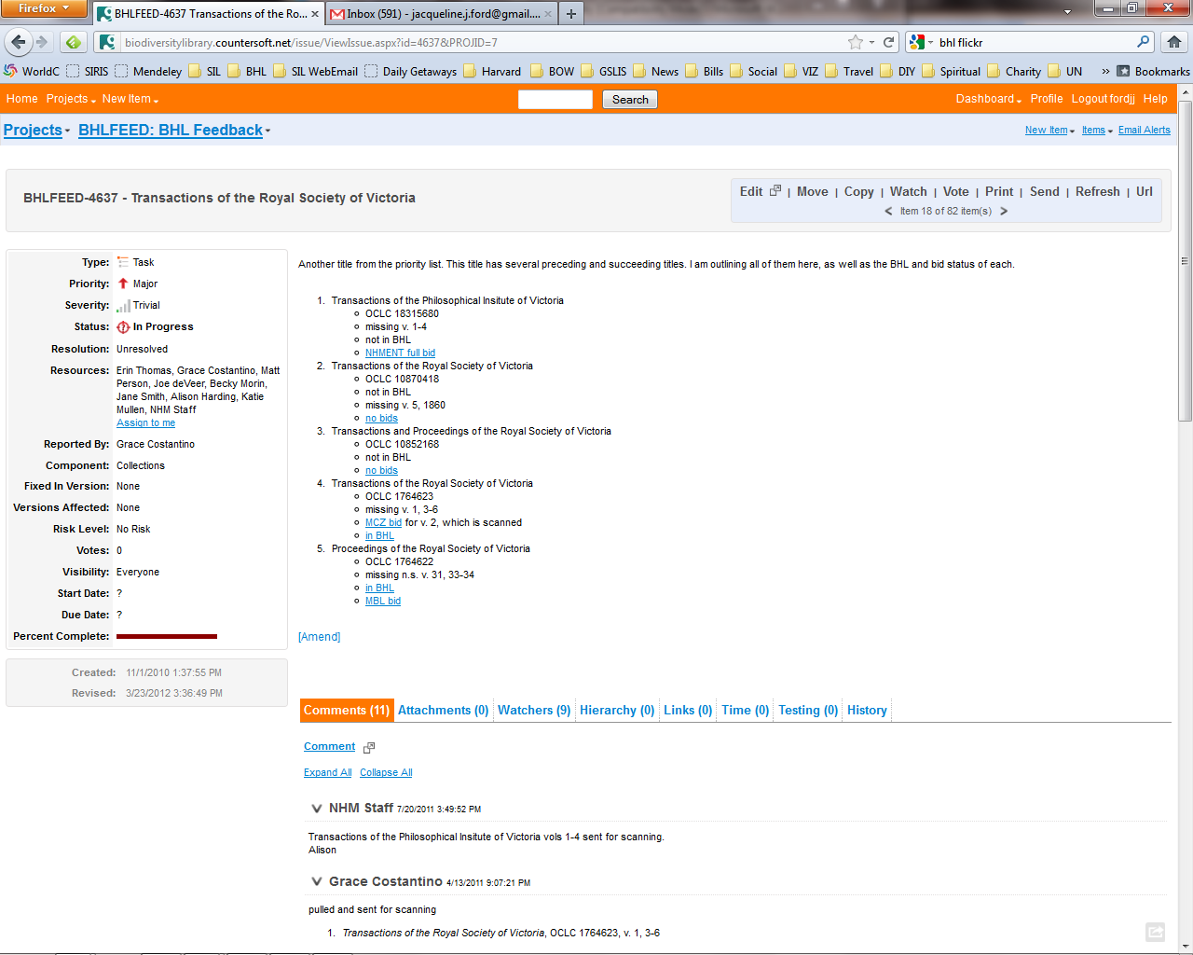

This is the staff comments section. This is the bread and butter of Gemini and how we “collaborate, communicate, cooperate.” The three C’s. Here you can add notes that update global partners. You always want to update “people” with the following info:

1. Can you scan the item? If it’s a series of some sort indicate which volumes you will be scanning.
2. Was the item rejected on your end? If so, we will reassign it to another partner.
3. Has the item been scanned? Indicate this and remove yourself from the issue. If you are the only or last responsible party for the issue then you should close the issue. (see above for instructions) Don’t forget to mark your bid in the bidlist complete as well.

To add a note just click on “comment;” Just like on an internet forum. You then enter your comment and submit it.

This area tells you issue’s pertinent details. This is where you can close issues, add yourself and others to an issue, and see the priority level of the issue. To close an issue, click on **“Status”** and select *close*; then click **“Resolution”** and mark it *complete*. Same deal for adding yourself to an issue. Just look for your name under the **Resources** section. Hold ***–ctrl*** and select your name, to add yourself to an issue.

This area is where info about the title being requested goes. It might be a serial it might be a monograph, there’s always an element of surprise at BHL! But whoever creates the issue will *usually* include 4 elements here. :

The **Title, the OCLC #, the volumes** being requested and if it’s a serial, a **link to the bidlist** where you can place your bid.

**Hints**

**Tips and Tricks: From experience.**

1. Gemini Search: Typically I search #’s not words unless, you have a very weird or specific word that you know will only pull up a few records. In my experience searching on the gemini # is primo. I’ve also searched on OCLC #’s, local bib #’s and even call #’s if for some reason I can’t remember the Gemini #.
2. Set up your email alerts to these settings:

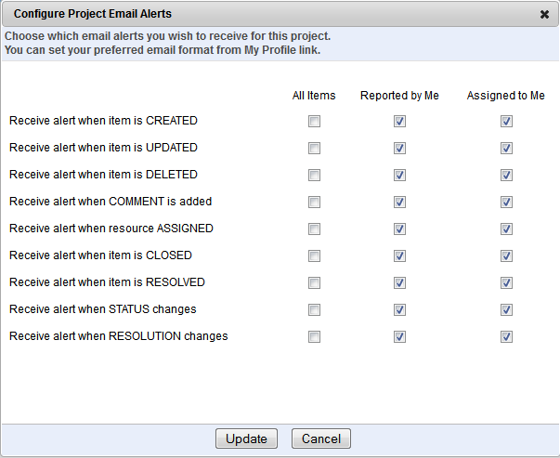

1. It is important to close issues and bids assigned to your institution after the scanning is complete. This prevents clogging up the system with falsely “open” items.
2. And that’s it. Have fun with it and remember you are now part of a global club that is committed to making taxonomic and natural history literature available globally. We are doing an immense good for the world!