Description of the Shipping Contents

Contained inside this Case you will find six (6) external Hard Drives, with the appropriate USB 2.0 Cable, Power Cord, and User Manual, as pictured below:

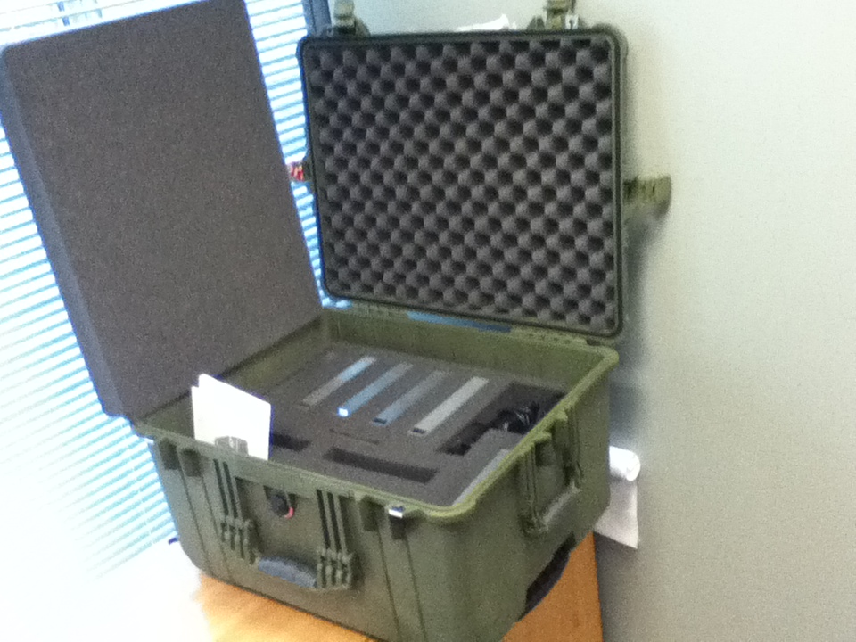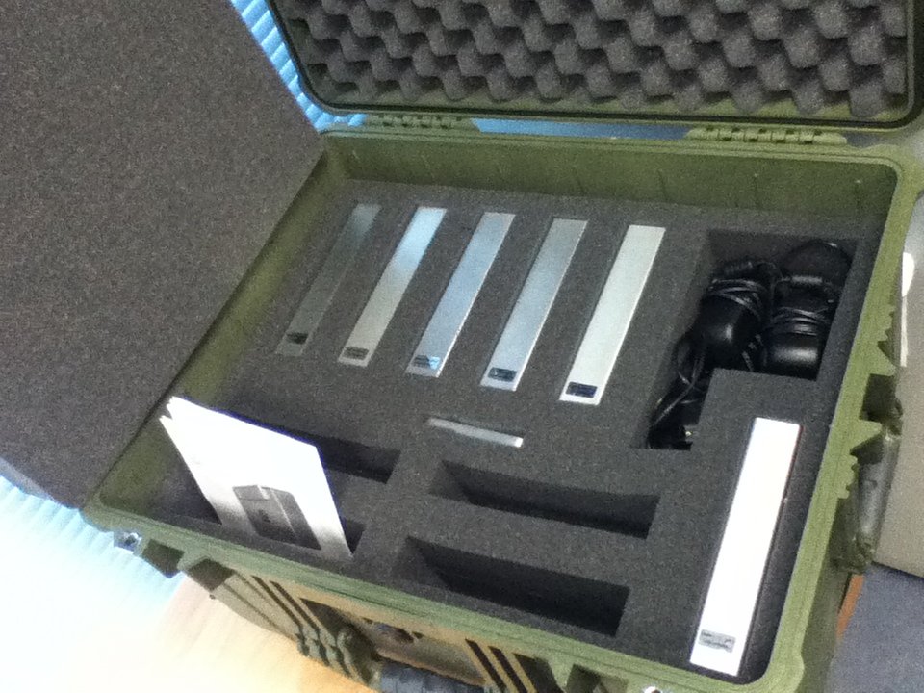

Each of the 6 external Hard Drives has the following specifications:
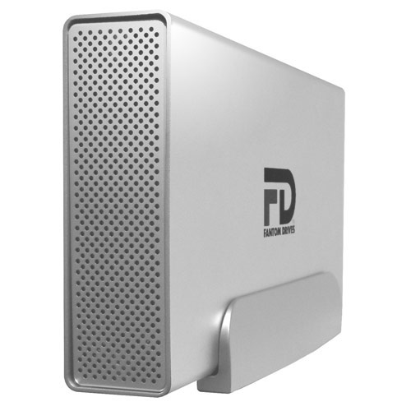
Model: Fantom 2TB G-Force
Storage Capacity: 2 Terabytes (TB)
Manufacturer: Micronet Technology
Product Type: External Hard Drive
Product Model: GF200EU
Manufacturer Part Number: GF2000EU
Product Line: G-Force
Product Name: G-Force GF2000EU Hard Drive
Manufacturer Website Address: www.micronet.com
Package Contents: eSATA/USB 2.0 Hard Drive, USB 2.0 Cable, Power Cord, User Manual
Product Dimensions: 7.75” x 4.5” x 1.375” (19.7cm x 11.4 x 3.5cm)
Product Weight: 2.4 lbs. (1.01 Kg)
Box Dimensions: 10.5” x 9” x 3 ¼” (26.7cm x 22.9cm x 8.3cm)
Box We ight: 5 lbs.(2.27 Kg)
UPC: 749656136335
Price: $50.00 USD each drive x 6 = $300.00 USD, no commercial value

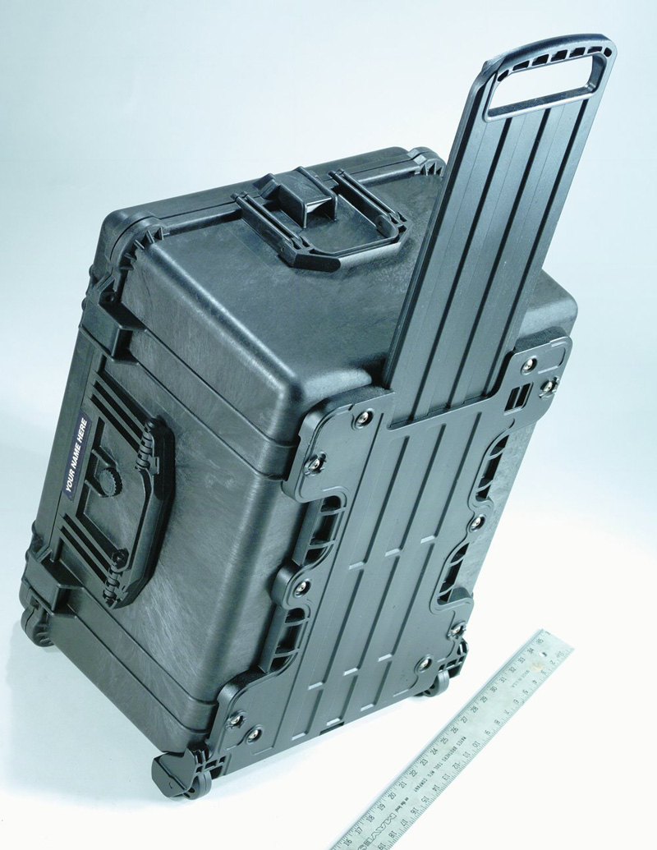
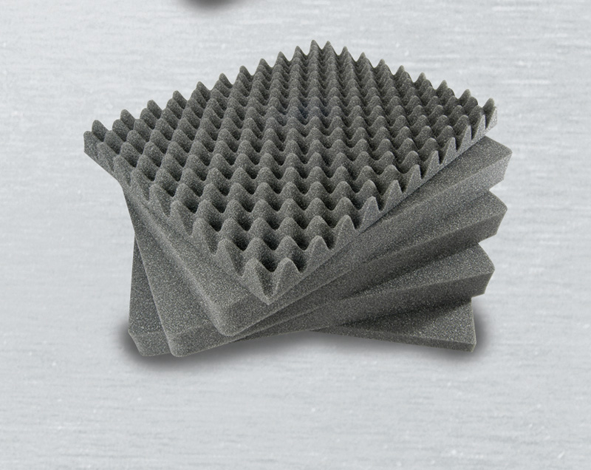
The six external drives are contained within a Peli 1620 case, color Olive of size 24.64” x 19.39” x 13.78” (62.6cm x 49.2cm x 35cm) with a weight of 24.62 lbs. (11.17 Kg) and whose market value is $310.49 USD, no commercial value.

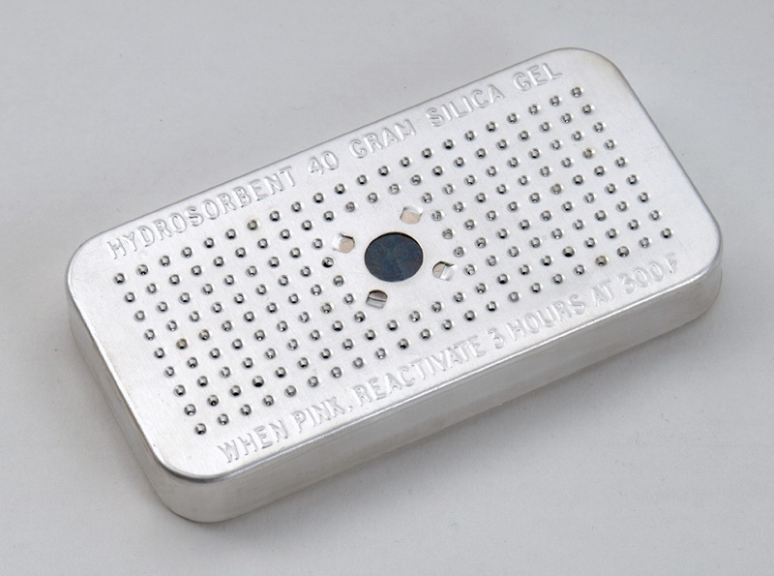
This case is a watertight, airtight, dustproof and chemical resistant case that has a retractable handle and comes with foam to avoid damage to the drives and includes a desiccant gel that absorbs dampness, prevents condensation from trapped air when cases are opened in damp, high humidity climates.

