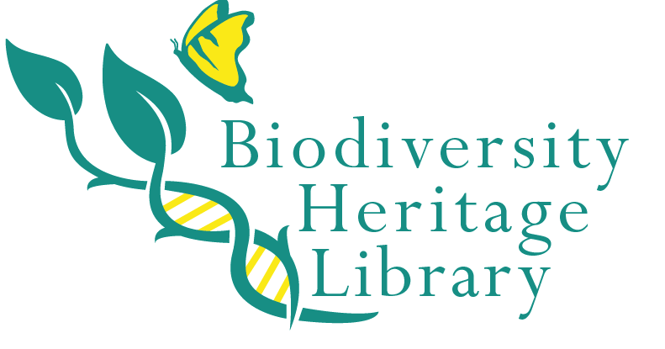
Biodiversity Heritage Library
Membership Application

Institution name: Cornell University Library – Albert R. Mann Library
Individual completing application: Mary Ochs, Director, Albert R. Mann Library
Address: Mann Library, Tower Rd., Cornell University, Ithaca, NY 14853
Phone number: 607-255-2285
Fax number: 607-255-0318
E-mail address: mao4@cornell.edu

Institutional and Library Information

Library Profile: (Submit a statement addressing the following areas. No more than four pages total)

- Academic Overview
As part of the Cornell University Library, the Albert R. Mann Library (http://www.mannlib.cornell.edu) supports the research, extension and instructional needs of the Cornell community in fields related to agriculture, life sciences and human ecology. In August 2007, a completely renovated Mann Library building opened to the public, offering an expanded footprint of 127,505 square feet and a state-of-the-art library building fully equipped for high-speed computing, collaborative learning, and efficient research and study by students and faculty. Mann Library stewards exceptionally strong, growing collections in agriculture and life sciences, with particular strengths in the literature that documents and analyzes issues of biodiversity in entomology, ornithology, and botany. Our collection of approximately 750,000 volumes is located on site in the Mann building and also in the Cornell University Library Annex storage facility just off campus. Along with these print collections, the Library provides a wealth of electronic resources and has long been noted for its technology innovations that connect researchers to the information they seek in ever more efficient ways. Mann Library also manages a collection of over 40,000 volumes housed in the Comstock Memorial Library of Entomology in Comstock Hall on the Cornell campus. The Comstock Library will be consolidated with Mann Library in 1-2 years after sufficient digitization of the collection has taken place so that taxonomy researchers can count on seamless online access to the entomology literature needed for their work with the large insect specimen collection that will continue to be housed in Comstock Hall.

- Library Operating Statistics:
A compilation of statistics for 2008/2009 for the Cornell University Library is available at http://ecommons.library.cornell.edu/bitstream/1813/14665/2/2008_2009_ASR_3_1_10.pdf . A “Libraries at a Glance” table is available on p. 1 of this pdf file.
Mann Library statistics:
Volumes on site in Mann Library | 423,036
Mann volumes at the Annex storage facility | 347,499
Electronic resources in Cornell University Library | 598,791
Total current serial titles in Cornell University Library | 94,000

- Library Personnel:
Mann Library has 14 professional librarians, 10 IT professionals, 20 support staff and approximately 100 student workers. If our membership application is accepted, the staff who will work on projects related to the Biodiversity Heritage Library include Mary Ochs, Director of Mann Library, Marty Schlabach, Mann Library Head of Collection Development, and Joy Paulson, Mann Library Digital Collections Librarian. Support staff and IT professionals will be included as needed. Mann Library is the second largest of the libraries in the Cornell University Library system, and the Director reports to Janet McCue, Associate University Librarian for Teaching, Research, Outreach and Learning Services.

- Expenditures:
Mann Library has an acquisitions budget of approximately $2.2 million. It is part of the larger Cornell University Library acquisitions budget of over $17 million. The Mann budget includes funds allocated from Cornell University, as well as significant endowment funding for subject specific acquisitions. We also have several preservation endowments which have been used to fund our previous digitization efforts and technology endowments that fund innovations in information technology.

- Institutional Organization chart (specifically where the library is in the org structure). A copy of our organization chart is attached, and our Vision and Mission Statements are below.
Vision: To be the preeminent library supporting research, teaching, learning, and outreach in agriculture, life sciences, applied social sciences and human ecology through our services, scholarly resources, innovation and leadership
Mission Statement: Albert R. Mann library supports the faculty, staff and students of Cornell University. In particular, our resources and staff support learning and research in agriculture, life sciences, applied social sciences and human ecology. As a land grant library, Mann also supports the research needs of citizens of the state of New York and the wider U.S. research community. In support of the university’s international mission, Mann Library supports innovations in information systems and services for international development. Mann Library is committed to providing outstanding information and research services in the areas of importance to its constituents through expert staff, scholarly resources, state of the art information technology, strategic partnerships and continuous innovation.
- Institutional Data (see http://www.library.cornell.edu/aboutus/inside/annrep for the annual reports of the Cornell University Library.)

- Facilities: Beginning in 1996, Mann underwent an expansion and complete refurbishment of the original 1952 building, re-opening as unified renovated building in fall 2007. The refurbished library offers 277 computers, 4 computer teaching labs, thirty-six individual and group study rooms, a gallery for public exhibitions on science and art, study seating for c. 1100 patrons, and a collaborative learning center equipped with moveable LCDs, whiteboards, and loaner laptops. We have a climate controlled storage facility for our special collections materials.

- Collections: Mann Library is noted for the remarkable strength of its collections in agriculture, life sciences, human ecology and the applied social sciences. The Library’s specific strengths in biodiversity include all areas of agriculture, botany, entomology, and ornithology. The Library Annex houses almost 3 million of the over 7 million volumes in the Cornell University Library. Mann has an active digitizing program, and Cornell has been a leader and innovator in the development of digital collections for the past 15 years. Cornell is a member of a number of collaborative library networks including Association of Research Libraries, Center for Research Libraries, NERL, and a variety of interlibrary loan networks.

- Technical Services: Cornell University Library provides technical services support for Mann Library. Records for print and electronic resources appear in our own Voyager online catalog as well as in our OCLC WorldCat local catalog. Electronic resources are fully cataloged. We rely on Serials Solutions for individual e-journal records for package products.

- Technology Infrastructure: The Cornell University Library runs the Voyager online catalog system as well as WorldCat Local for patrons to locate materials in the library and beyond. All libraries provide standard and wireless Internet access. Library resources are also available off-campus using a Cornell Net ID, so users have full access to the library databases and other electronic resources from anywhere in the world. Mann has a strong information technology staff which works closely with librarians to develop innovative information systems. Mann Library has been instrumental in the development of several digital library collections including: 1) Core Historical Literature of Agriculture http://chla.library.cornell.edu; 2) HEARTH (Home Economics Archive: Research, Tradition, History) http://hearth.library.cornell.edu ; and 3) USDA Economics, Statistics and Market Information Service http://usda.mannlib.cornell.edu. Mann Library Information Technology staff also are responsible for the development and operation of the VIVO portal http://vivo.library.cornell.edu which links researchers across multiple departments at Cornell, and now has received funding from NIH to develop a cross-institutional VIVO portal. Cornell University Library is participating in the Google Books project. The CUL project has focused on the agriculture and life sciences collection in the first round of the project. Approximately 200,000 volumes from Mann and related life science collections will be scanned by September 2010. Mann Library’s IT group works closely with the Cornell University Library central IT staff, see http://www.library.cornell.edu/dlit/ .

- Grantsmanship: Mann Library has a strong record in grants received to develop information systems and services. The Library currently has a grant from National Institutes of Health for the development of a national VIVO portal to link health researchers across the United States (see news story http://www.news.cornell.edu/stories/Oct09/VIVOweb.ws.html ); a National Science Foundation grant to develop the DataStaR data staging repository http://datastar.mannlib.cornell.edu/ for Cornell faculty to use to store, manage and share their research data; and a grant from the Bill & Melinda Gates Foundation to expand access to scientific literature for agricultural researchers in sub-Saharan Africa through Mann’s program, TEEAL (The Essential Electronic Agricultural Library) http://www.teeal.org. In the past, we received a grant from IMLS to fund the creation of the HEARTH digital library on the history of home economics.

