www.citebank.org

Citebank Purpose
- a domain-specific repository of citations and content files about biodiversity
- a “safe harbor” model for content distribution
- a tool for disambiguation and reconciliation of natural history bibliographic citations
- an environment for community building and sharing of research
- a persistent URL for researcher’s content that can be reliably referenced

Citebank History
In existence since December of 2010, Citebank evolved out of a need to access content from the Biodiversity Heritage Library (BHL) http://www.biodiversitylibrary.org/ at a more granular level than the existing functionality of the BHL interface allows. Citebank and BHL were developed by the same technical team within the BHL organization but manage and serve their content via different software applications.

Citebank Content
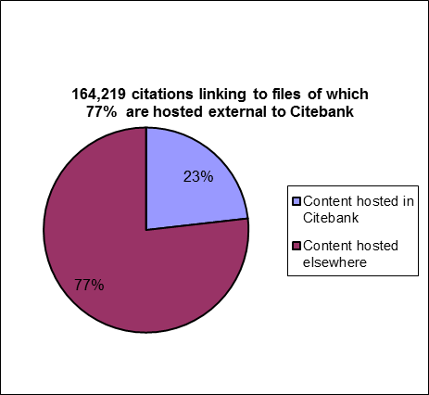
Citations and Content Files in Citebank
- Content from publishers/societies
- e.g. The American Mosquito Control Association http://citebank.org/node/102856
- © Citebank is given permission to host by publisher and content is provided under a Creative Commons license http://creativecommons.org/licenses/by-nc-sa/3.0/

- BHL article-ized content - articles/chapters created from the digitized books and journals in the BHL by end users who select specific pages and create the citation
  - e.g. http://citebank.org/node/39423
  - © All content from BHL is either in the public domain or has been licensed
Citations in Citebank but content files hosted elsewhere
- Aggregated citations - Citebank ingests citations via OAI, content is hosted elsewhere
- e.g. SciELO http://citebank.org/node/44871

- BHL Title records – Citebank ingests citations via OAI, content is hosted elsewhere
  - Journal of Shellfish Research: http://citebank.org/node/56354

Citebank Future

Citebank is evolving to serve a new and important role as the primary article repository for biodiversity as part of the Global Names Architecture (GNA). GNA is a 2 year innovation proof of concept project funded by NSF that began July 2011. The goal is to bring together the information in thousands of online resources that deal with biodiversity and aid the efforts of taxonomists, nomenclaturalists and managers of biodiversity information. GNA will be a virtual data and service layer that capitalizes on the almost universal use of latinized scientific names that annotate almost all information related to organisms, allowing them to be used as pivot points to cross-link on-line datasets. Citebank’s role in GNA is as a safe harbor citation repository. (i.e. backfiles of reprint collections contributed by users)

New types of content in Citebank
- user-contributed citations without a corresponding content file - currently all of our citations go to a content file either hosted locally or externally.
- user-contributed content files – currently we don’t allow end users to upload their own content files because of copyright concerns. In the future we will allow it under “safe harbor” principles.
- canonical citations – users will inevitably upload duplicate records to Citebank and the system will need to disambiguate and reconcile these.
- unpublished literature - eventually we’ll have primary source material, such as Field Notebooks, in BHL and this type of content will eventually make its way into Citebank.
- born-digital works - available only electronically; they must have editorial control & peer review

In addition, the BHL is in the process of expanding the data model for the BHL portal to be able to accommodate citations, such as those found at citebank.org and biostor.org, directly within the portal itself. This will be highly beneficial to end users as it will allow them to search for articles, alongside books and journals, within a single search interface at http://www.biodiversitylibrary.org instead of having to search each of these siloes separately.

Unique challenges for managing natural history citations

The inconsistent way in which natural history materials have been cited over 250 years of scholarship creates challenges for providers of biodiversity data and services. Scientists often use abbreviated methods for citation references that would not be readily understood outside the field. For example, a citation for Lotus corniculatus as first mentioned in Carl von Linneaus’ Species Plantarum from 1753 may be found as:

Lotus corniculatus (Linneaus 1753),
Lotus corniculatus (L. 1753),
L. corniculatus L., Sp. P1. 2: 775, 1753
Lotus corniculatus Linn., Sp. Pl. 775. 1753
Lotus corniculatus L. y tenuifolia L., Sp. Pl. (1753) 776

These cryptic citations are sufficient for knowledgeable human consumers who would be familiar with and can easily disambiguate what the citation represents but they are problematic for computer-automated processes trying to reconcile these text-string citations with a more standardized and parsed library catalog record.

