Sean Bryant
Biodiversity Informatics
December 12, 2006
Building the Biodiversity Commons: The Biodiversity Heritage Library
In the field of biodiversity, books and the information within them reign supreme. In March 1922, Charles Davies Sherborn wrote in his Epilogue to Index Animalium,
“In any well-appointed Natural History Library there should be found every book and every edition of every book dealing in the remotest way with the subjects concerned” (Kalfatovic, 2006, Slide 2). Taxonomists and others in the field rely heavily on published literature describing species and their characteristics to identify unknown specimens. In an April 1927 Science article on “The Limitations of Taxonomy,” J.M. Aldrich agreed, writing, “The beginner must now be prepared to spend liberally, or else must establish himself in an institution where a large library exists; if he work by himself with only a few books, he will have to confine himself to a very narrow specialty indeed” (Kalfatovic, 2006, Slide 3). The half life of taxonomic works is longer than that of the works in any other branch of science (Kalfatovic, 2006). While the information in some disciplines becomes dated very quickly as new discoveries are made, taxonomic information can retain its accuracy for hundreds of years. This glut of literature and the age and subsequent scarcity of large portions of it have led to calls for it to be placed online in a forum where the world can freely use it. Thus the Biodiversity Heritage Library was created to digitize the collections of the top institutions of the world and create a global Biodiversity Information Commons.
The amount of literature in the field is vast. The libraries that are combining their efforts on the Biodiversity Heritage Library have, collectively, more than 2 million volumes, the results of what, for some institutions, has been more than 200 years of collecting taxonomic materials (The Biodiversity Heritage Library project, 2005). This material comprises some 1.3 million records, 981,000 of them monographs, of which 757,000 are distinct, non-duplicates, and 616,000 are unique to just one of the institutions. Of this material, about 30% was published prior to 1923, putting it, under US copyright law, in the public domain (Thomson, 2006). Not only is this a vast amount of literature, but as is shown by the number of records unique to one institution, not even the top institutions in the world have the “well-appointed Natural History Library” envisioned by Charles Sherborn, increasing the chances that species could be misidentified.
In addition to the concerns of the over the amount of biodiversity literature available, its distribution is also a concern. Thomas Moritz, of the American Museum of Natural History, noted in an article, entitled “Building the Biodiversity Commons,” that “There has long been an ‘information gradient’ that runs North to South and prevents most peoples in the South (as well as many in the North) from equitable, direct access to biodiversity information” (2002). In other words, collections of biodiversity information are mainly in the North, on the shelves of university and museum libraries and other institutions, where people in the South cannot get access to them without traveling long distances. The collections are in the North, but even then, they are only in certain areas of the North, mainly in Western Europe and North America.
Another concern is the usage of biodiversity literature. For the remaining 70% of the available biodiversity material published post 1923, as well as material published today and in the future, the issue of intellectual property rights looms. Moritz notes, “The past decade has seen the emergence of a “second enclosure” movement as information has increasingly been treated as a commodity subject to new proprietary restrictions” (2002). Even non-profit organizations are reluctant to share their data “for fear that they will be taken advantage of” (Moritz, 2002). In addition to the fear of embarrassment, if the data is shared, it could be exploited inappropriately by companies seeking to make a profit or used in violation of copyright. While a combined biodiversity heritage library could include works published by its own members, rights for other works would have to be negotiated for with their publishers, who may have other concerns. Professional organizations, in particular, are reluctant to agree to open content for fear that it will decrease the revenue they gain by selling subscriptions to their journals, and thus adversely affect their ability to fund conferences, internships, research and other activities (P. Heidorn, class discussion, December 5, 2006).
With these concerns in mind Moritz proposed the creation of biodiversity information commons. Moritz defined an information commons a “community of use” which assured “free unhindered access to for that community within a defined information space” (2006). An information commons combines both freely available and copyright protected data for which certain rights have been ceded in a common database, while preserving the copyright for the commercial arena (Moritz, 2006). Moritz’s vision would become reality in the form of the Biodiversity Heritage Library, partnership among several institutions with the goal “to digitize the published literature of biodiversity held in their respective collections and to make that literature available for open access and responsible use” (The Biodiversity Heritage Library project, 2005).
The Biodiversity Heritage Library did not come around overnight. Meetings on the Encyclopedia of Life in Telluride, CO, in 2003 and “Library and Laboratory: the Marriage of Research, Data and Taxonomic Literature,” in London, in February 2005, in which librarians, taxonomists and other experts met to discuss access to taxonomic materials, led to a May 2005 meeting in which the representatives of several major natural history and botany libraries developed plans for the new partnership (Kalfatovic, 2006; Thomson, 2006). These institutions, the American Museum of Natural History in New York, Harvard University’s Botany Libraries and Ernst Mayr Library of the Museum of Comparative Zoology, the Missouri Botanical Garden, the Natural History Museum of London, the New York Botanical Garden, the Royal Botanical Gardens, Kew and the Smithsonian Institution, laid the foundation for the library and were later joined by the Field Museum of Chicago and the Marine Biological Laboratory/ Woods Hole Oceanographic Institute Library (Biodiversity Heritage Library, 2006). In addition, OCLC and the Internet Archive became associate members and the Biodiversity Heritage Library itself became a founding member of the Open Content Alliance (Thomson, 2006).
The plan that the representatives came up with had several steps. The group needed a business plan to assure the long-term validity of their plan. They also needed to merge the bibliographic records of their holdings into one common union catalog and create a website to allow users to access that catalog. Another component of the plan was to identify which works in each collection should be scanned and in what order the scanning should be done. Then, with the assistance of the Internet Archive, scanning centers could be set up to process the works. At least three scanning centers were planned for, each with ten books scanners. It was estimated that around 400 volumes could be processed per day, per center, or about 1200 per day in all. The process would include scanning, optical character recognition and metadata association for all works, down to the level of journal articles. All of this was to be done while employing the most up to date standards of book conservation, to preserve the works themselves. The representatives agreed that efforts should be made to negotiate with other publishers, and especially other research institutions to include their material. Once the scanning was complete, the planners decided they would need to clean up the optical character recognition, determine what in the way of expanded search capabilities users wanted and develop and implement them. Finally, the library needed plans to maintain access to the collection once it was online, which entailed preserving the digital files in some way. In addition, particularly interested in collections in languages other than English, the representatives planned to set up a framework by which, eventually, other institutions could join (The Biodiversity Heritage Library project, 2005). Another way to contribute to the collection would be through the Open Content Alliance, as materials placed there could be added to the Biodiversity Heritage Library catalog as well (P. Heidorn, conversation, December 5, 2006).
A model was created envisioning the system the planners hoped to build. Figure one shows the merging of records from the participating institutions and any others that agree to participate with metadata to create a searchable data repository for the participating libraries, researchers and the general public.
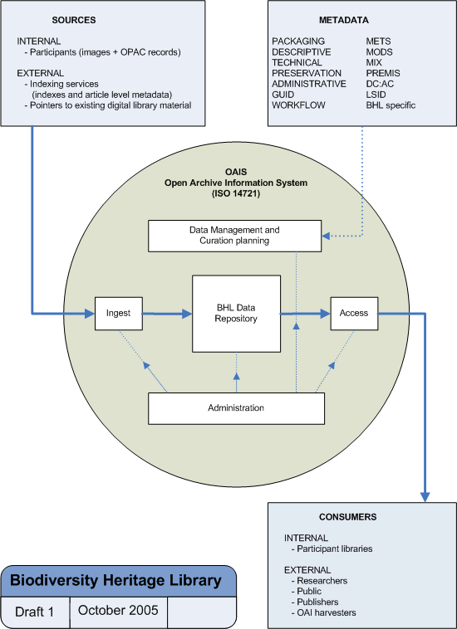
Figure 1: Biodiversity Heritage Library concept diagram showing components of the planned system. https://bhl.wikispaces.com/BHL+Concept+Diagram

The ten partner libraries have pooled their catalogs into a single aggregation and are preparing to scan material (Thomson, 2006). However, none of that material is yet online. The material that is currently available from the Biodiversity Heritage Library is simply links to material that has been compiled by the individual institutions and so varies in scope between them. For example, the American Museum of Natural History has links to its American Museum Novitates, Anthropological Papers of the American Museum of Natural History, Bulletin of the American Museum of Natural History and Memoirs of the American Museum of Natural History publications in their entirety as well as to digital libraries on evolution and a 1909 expedition to the Congo. On the other hand, the Ernst Mayr Library of the Museum of Comparative Zoology at Harvard has made available a very different collection; their collection of artwork, a collection of watercolors and drawings from the library’s special collections (Biodiversity Heritage Library, 2006).
One of these individual projects is Botanicus, an online database of the digitized holdings of the Missouri Botanical Garden. As of December 12, 2006, the database contained 139 titles comprising 878 volumes and 461,654 pages (Botanicus.org, 2006). The goals of the Botanicus project were to develop a model for digitizing scientific literature, including a data structure and a metadata format, create a computerized reference system for natural history, digitize a set of botanical literature, and create an interactive web portal to allow for better access to the material. In addition, the images of the works were to be scanned with optical character recognition software to create text so that XML markup protocols could be used to link to other data sets (Botanicus.org, 2006).

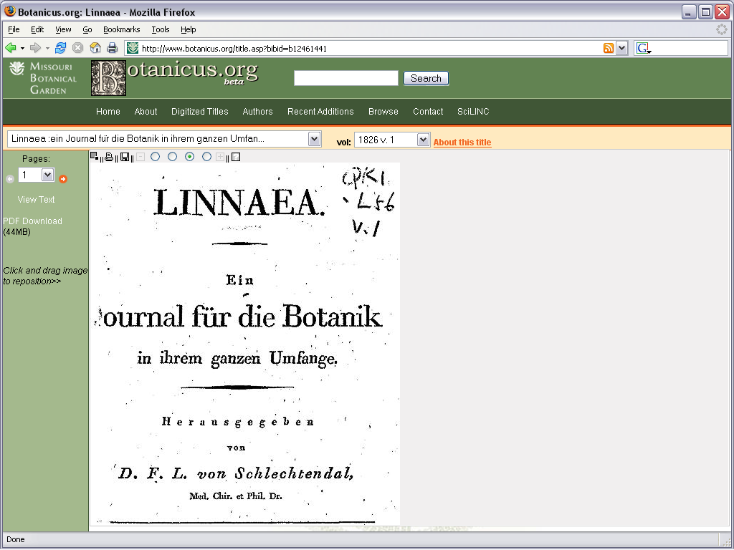 Figure 2a
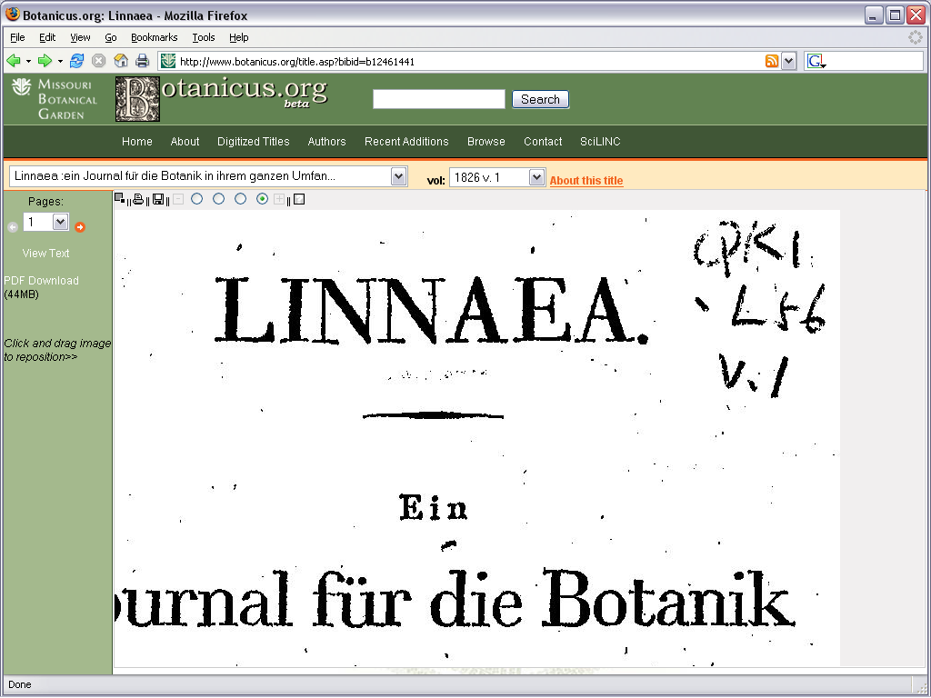 Figure 2b
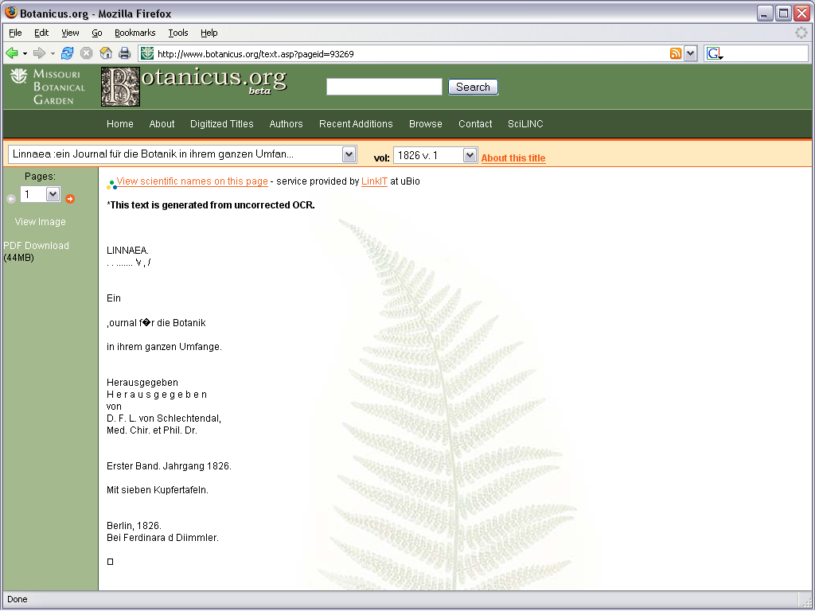Figure 2c
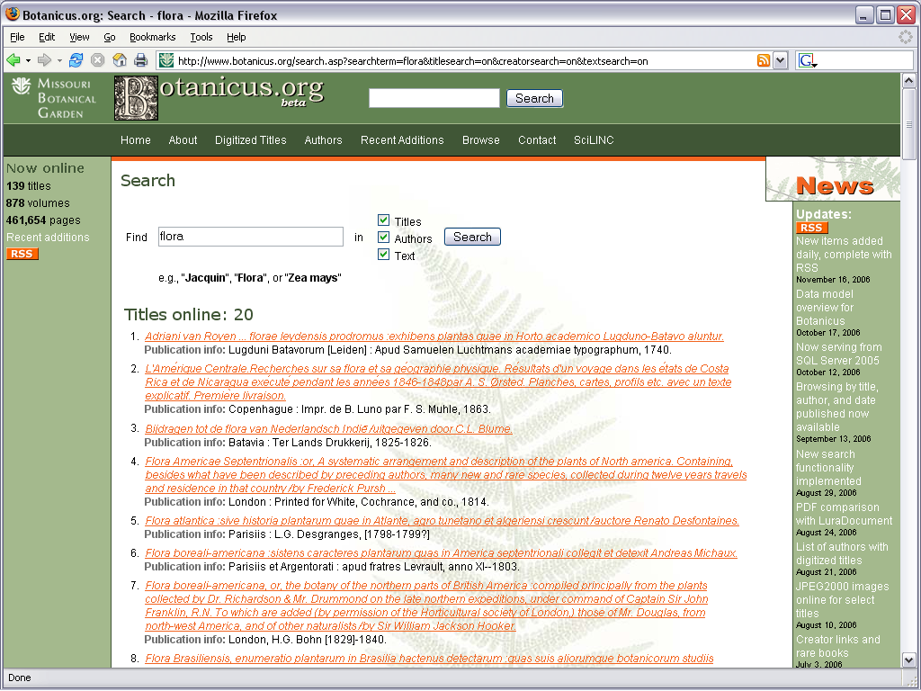Figure 2d

Figure 2a shows the Botanicus Interface. The interface is capable of zooming in and out (Figure 2b), displaying text (Figure 2c), and searching (Figure 2d). www.botanicus.org

The Botanicus interface includes the ability to search titles, authors, and the text of works, although in the beta version of Botanicus online currently, much of the text is uncorrected material, which still contains errors caused by the optical character recognition software (Botanicus.org, 2006). The interface allows the user to browse pages, grab and drag them around the screen, zoom in and out, save, print, download material and view the text as determined by the optical recognition software. Within the text window there is even a link to a tool, provided by uBio, the Marine Biological Laboratory/ Woods Hole Oceanographic Institute Library’s Universal Biological Indexer and Organizer, which allows the user to identify all of the scientific names on the page (LinkIT, 2004). The tool highlights scientific names it finds and creates links to records in the uBio database and other external databases uBio has information for.
What makes this prototype interface important for the Biodiversity Heritage Library is that it is not just for Botanicus, but a prototype for the Biodiversity Heritage Library as well. Chris Freeland, of the Missouri Botanical Garden, has proposed the system to use a system like that of Botanicus, but with even more features added (Freeland, 2006a & 2006b). The proposed system, shown in figure 3, would allow users to search text normally, but also to search for specific pages if necessary. Once the user found the work they were looking for, they could browse the pages using a slider, thumbnails, or text links, in addition to the drop down menus of the prototype. Once the user found the page they were looking for, a more precise zoom function and a thumbnail in the lower right hand corner of the screen would allow users to have better control over what area and how much of the image they saw. Buttons would allow for switching between black and white and color images and the text. The user would be able to edit the text to correct any mistakes in the optical character recognition from either the text window or from the image itself. As in the prototype, the user would be able to search for scientific names within the text and with links being generated to records in other databases for any results that are found, but the proposed system would also highlight multiple instances of the same name (Freeland 2006b). This would allow the user to find all references which might concern the same species or genus.
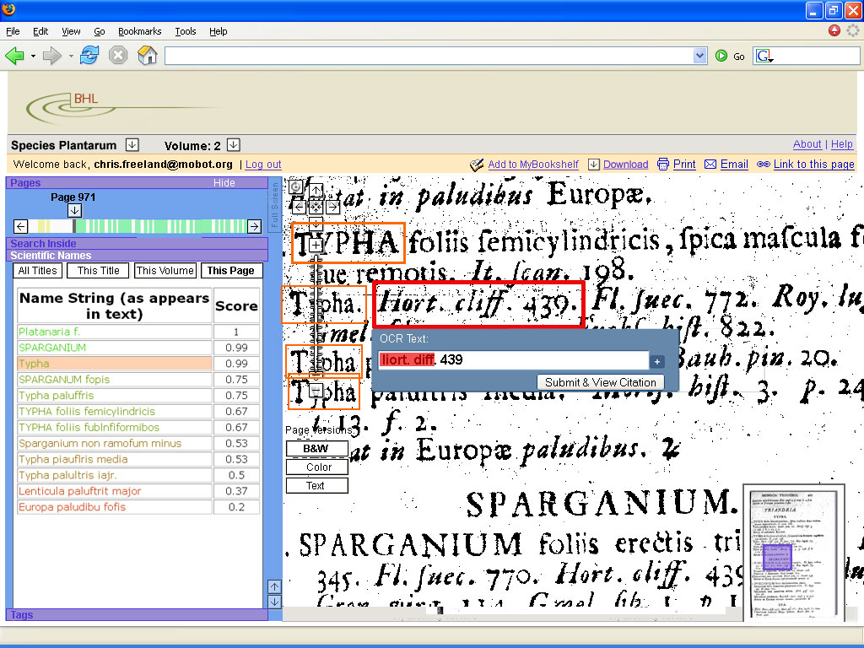

Figure 3: A screenshot of the proposed interface, in the process of changing the optical character recognition text while viewing the image. The scientific name search has found several names and instances of the selected name are shown on the screen. http://www.bhl.si.edu/Presentations/Interface4.ppt (Slide 24)

In addition to developing the web interface, other aspects of the Biodiversity Heritage Library are under development as well. The union catalog is one such area. The precursor to the union catalog currently exists as the aggregate collection of all of the records that has been created (Thomson, 2006). However to make it into a true union catalog, useful for the interface it needs to have several functions, including the ability to add, change, store and import records, detect and link duplicates, analyze records for collection strengths, assign records to institutions for digitization and track their status in a system open enough to work with the Biodiversity Heritage Library interface (Jackson, 2005). The catalog will need to store the bibliographic records obtained from the catalogs of the partner institutions, but it will also need to store links to any duplicate records, unique keys, the responsibility for digitization and the status of that digitization, among other things (Jackson, 2005). When it is fully built, the union catalog will aid users in finding out the status of the digitization process.
Metadata is another aspect of the project that is in flux. Several formats are under consideration for various aspects of the library project. The BHL metadata requirements page recommends several different schemes for these aspects, all of them based, for the purpose of standardization, on XML. For example, each volume in the collection will have associated with it images and text files for each page and metadata, all which must be kept together as a “package” (Thomson, 2005). The metadata encoding and transmission standard (METS) is designed to do just that. Unique identifiers are needed for each page digitized. The digital object identifier (DOI) and life science identifier (LSID) are two standards which do that (Thomson, 2005, 2006; LSID, 2006; The digital object identifier system, 2006). Other types of metadata that will be needed include bibliographic metadata, which can be taken from the catalogs of the participating institutions, technical metadata, much of which can be derived in house as it concerns information such as file formats, viewing requirements, and related matters dependant on how the material is digitized and administrative metadata, concerning copyright issues. Schema for these purposes include MODS, for the bibliographic metadata, PREMIS, for technical metadata, and Dublin Core Admin Core (DC:AC) for administrative metadata (Thomson, 2005). Though the final metadata standards have yet to be agreed upon, they are necessary to ensure that the participating institutions and who wish to participate in the future will be able to share meaningful information with each other.
The digitization of hundreds of thousands of works is a monumental undertaking. The Botanicus database contains only 139 titles and yet includes close to a half million pages. The digitization of even just significant portions of the collections of the ten institutions of the Biodiversity Heritage project will result in tens, or hundreds, of millions or potentially more pages of high quality images, as well as the text they contain and the metadata describing them, a wealth of information for the world to share.

Bibliography
BHL concept diagram. (October 2005). Retrieved December 5, 2006 from https://bhl.wikispaces.com/BHL+Concept+Diagram
Biodiversity Heritage Library. (2006). Retrieved December 12, 2006 from http://www.bhl.si.edu
The Biodiversity Heritage Library project. (2005). Retrieved December 12, 2006 from http://www.sil.si.edu/bhl/supportdocuments/BHLP-prospectus10-05.pdf
Botanicus.org. (2006). Retrieved December 12, 2006 from http://www.botanicus.org/
The digital object identifier system. (2006) Retrieved December 12, 2006 from http://www.doi.org/
Freeland, Chris. (2006a) Botanicus.org: Prototyping a web 2.0 interface to digitized taxonomic literature. PowerPoint Presentation presented October 17, 2006 at TDWG Conference, St. Louis, MO.
Freeland, Chris. (2006b) Web User Interface for Taxonomic Literature. PowerPoint presentation retrieved December 12, 2006 from http://www.bhl.si.edu/Presentations/Interface4.ppt
Jackson, Mark. (November 21, 2005) BHL requirements straw man. Retrieved December 4, 2006 from https://bhl.wikispaces.com/StrawMan
Kalfatovic, Martin R. (2006). Open access to legacy taxonomic literature: The Biodiversity Heritage Library. PowerPoint Presentation presented April 17 and 18, 2006 at the University of Illinois, Urbana-Champaign
LSID (life sciences identifier) resolution project. (2006). Retrieved December 12, 2006 from http://lsid.sourceforge.net/
LinkIT. (2004). Retrieved December 12, 2006 from http://names.mbl.edu/tools/linkit.php
Moritz, Thomas. (June 2002) Building the biodiversity commons. D-Lib magazine. 8 (6). Retrieved December 4, 2006 from http://www.dlib.org/dlib/june02/moritz/06moritz.html
Thomson, Neil. (2005). BHL metadata requirements. Retrieved December 12, 2006 from https://bhl.wikispaces.com/BHL+Metadata+Requirements
Thomson, Neil. (2006). Digitizing the legacy literature of biodiversity: An introduction to the Biodiversity Heritage Library. PowerPoint Presentation presented October 17, 2006 at TDWG Conference, St. Louis, MO.

