“Bound With” Procedures for BHL Project
(rev.2/10/09 lea)

The Biodiversity Heritage Library project at the Smithsonian has come across materials that are bound together. Some of the material has proper records in SIL’s ILS system and can be processed for scanning. Some titles are being found that cataloging work needs to be done. The procedures for “bound with” at SIL have a few options.
This document is to clarify how the SIL BHL project will go forward in creating “bound with” records.

Two or more titles bound together in one volume subsequent to publication are processed in the following manner. These guidelines are applied according to cataloger’s judgment. They do not apply to rare material:

I. If the titles are numerous and have a logical relationship (e.g., all of them are about the same subject), the volume may be cataloged as a collection. For example, a volume of 35 off-prints about Oceania could be cataloged as a collection. The volume has one bibliographic record and one barcode. One item record is attached to the bibliographic record, using the barcode number. If there is a binder's title, it may be used as the title proper on the bibliographic record (according to cataloger's judgment); otherwise, trace the binder's title in a 246 field.

II. Separate bibliographic records may be provided for each publication in a volume of "bound withs." Separate cataloging should always be provided when the publications are substantial and/or the titles are not numerous (in general, a dozen or fewer). When separate records are provided, process in the following manner:

A. The volume has one call number, usually assigned according to the classification for the first title. This same call number is used for each title in the volume.

B. The volume has one barcode, and the item record for the first title in the volume uses this barcode number.

C. All titles in the volume following the first have item records with a system-generated "barcode" number. In Horizon, this number begins with "mq". A 949 field may be formulated to create a system generated item record on import by omitting the $i barcode number in the 949 field. Such an item record also may be entered manually by supplying a unique barcode number that would not conflict with an existing number. After the item is saved, re-enter the number in the barcode number area by entering the letters "mq" followed by the system-generated item record number that appears at the top of the item record. In the item note area, enter: "bound with [barcode]" using the barcode number for the first title. Re-save the record.
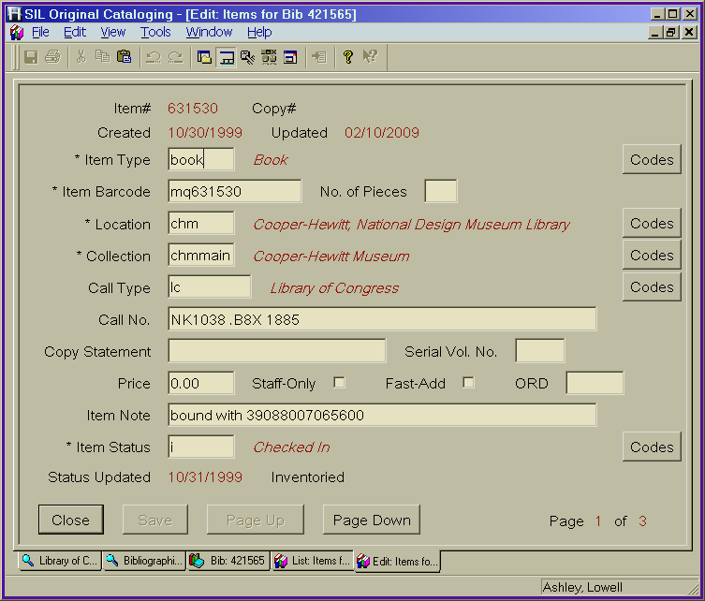

D. If there is a binder's title, trace it in a 246 field on each bibliographic record.

E. Each record has a local 590 "with" note that indicates the title is bound with one or more additional titles.

Examples:

Volume with 2 titles:
1st title
590 ENT copy [barcode] is no. 1 in a vol. with 1 other title. Bound together subsequent to publication.

2nd title
590 ENT copy [barcode] is no. 2 in a vol. with 1 other title. Bound together subsequent to publication.

Volume with 5 titles:
1st title
590 ENT copy [barcode] is no. 1 in a vol. with 4 other titles. Bound together subsequent to publication.

3rd title
590 ENT copy [barcode] is no. 3 in a vol. with 4 other titles. Bound together subsequent to publication.

