ECP-2008-DILI-518001

BHL-Europe

Business plan for long-term sustainability

Deliverable number | D1.9
Dissemination level | Restricted
Delivery date | 30 April 2012
Status | Draft
Author | Henning Scholz


eContentplus

This project is funded under the eContentplus programme,
a multiannual Community programme to make digital content in Europe more accessible, usable and exploitable.

Document History

Contributors
Person | Partner
Henning Scholz | MfN
Graham Higley | NHM
Thomas Garnett | SIL
Patricia Mergen | RMCA
Lizzy Komen, Annette Friberg, Harry Verweyen | EDLF
Graham Hardy, Lesa Ng | RGBE

Revision History
Revision Date | Author | Version | Change Reference & Summary
8 Feb 2011 | Henning Scholz | 0.1 | First draft of D1.5
9 Feb 2011 | Graham Higley | 0.2 | Review of first draft of D1.5
10 Feb 2011 | Henning Scholz | 0.3 | Second draft of D1.5
13 Feb 2011 | Thomas Garnett | 0.4 | Review and amendment second draft of D1.5
26 Feb 2011 | Patricia Mergen | 0.5 | Review second draft of D1.5
8 Mar 2011 | Henning Scholz | 0.6 | Review of D1.5 including feedback from Europeana Office
26 April 2011 | Henning Scholz | 1.0 | Final version of D1.5
20 June 2012 | Henning Scholz | 1.1 | Draft including outcomes of business development workshop from 9 June 2011 in Tervuren (RMCA)

Reviewers
This document requires the following reviews and approvals.
Name | Date | Version
BHL-Europe consortium | 21 April 2011 | 0.6
Financial/Sustainability WG of CCPA | 21 April 2011 | 0.6

Distribution
This document has been distributed to:
Group | Date of issue | Version
Reviewer and BHL-Europe consortium | 8 March 2011 | 0.6
BHL-Europe consortium | 29 April 2011 | 1.0

Table of Contents

1 Document History 2
1.1 Contributors 2
1.2 Revision History 2
1.3 Reviewers 2
1.4 Distribution 2
2 Table of Contents 4
3 Introduction 5
4 Strategic analysis 5
4.1 Strategic directions overview 5
4.2 SWOT analysis of strategic directions 5
4.3 Strategic directions details 9
4.4 Environmental Scan 9
5 Business strategy 11
5.1 Vision statement 11
5.2 Mission statement 11
5.3 Objectives 11
5.3.1 Objectives for maintenance only 11
5.3.2 Objectives for maintenance and incremental growth 11
5.3.3 Objectives for all strategic directions 12
5.4 Value proposition 12
5.4.1 Value proposition for maintenance only 12
5.4.2 Value proposition for maintenance and incremental growth 14
5.4.3 Value proposition for all strategic directions 14
6 Business plan 15
6.1 BHL-Europe preservation and archive system and portal 16
6.2 Global References Index to Biodiversity (GRIB) 17
6.3 Europeana 17
6.4 Global BHL 18
7 Proposals for follow-up projects 19
8 BHL-Europe Organisation and Governance 19
9 Appendix and reference documents 20

Introduction
This is the further development on the first overview business plan for a sustainable BHL-Europe service beyond the Best Practice Network of the EC eContentplus programme after 30 April 2012. This draft document will eventually lead to the Business Plan for long-term sustainability (D1.9) in M36 of BHL-Europe.

Strategic analysis

Strategic directions overview
In D1.5 we identified five potential strategic directions for BHL-Europe beyond the end of the project in April 2012:
- Stop all: This strategy implies BHL-Europe will not continue any of the services established after the project terminates. This is our least favoured option, and as long as we are achieving the goals we have set for the project, there is no reason to follow this strategy.
- Maintain: This strategy aims to keep the content that is already digitised and aggregated online on a long-term basis. This requires the technical maintenance of the systems on NHM servers in London.
- Incremental growth: This strategy aims to continue the work with a significant part of the existing content provider network to some extent in order to improve quantity and quality of the content available through BHL-Europe. It is not intended to extend the network of content providers significantly. The improvement of the functionality of the BHL-Europe system is not foreseen. As the BHL-Europe system is based on open source software components and the BHL-Europe community portal is set up in Drupal, the community itself can help to add new features and improve the functionality of the components.
- Keep going and growing: This strategy aims to continue all activities started within the BHL-Europe project beyond the project duration. This includes the content acquisition, the extension of the content provider network, the technology development, the preservation and archiving, the dissemination, the IPR work and the work as an advisor for the digital library community in order to promote best practices.
- Scale up: This strategy aims to extend the scope of the existing BHL-Europe project and collect much more content, invest more time in quality control and also develop technology solutions to cope with these requirements.

SWOT analysis of strategic directions
The abbreviation SWOT stands for Strengths – Weaknesses – Opportunities – Threats. Strengths and Weaknesses refer to the project itself. It is the analysis of the situation within BHL-Europe and our characteristics. The Strengths and Weaknesses are the results of our own performance. Opportunities and Threats refer to the environment. We have to understand the environment or “market”, our “competitors” or alternative sources, technological innovations, the structure and behaviour of our users. Simply put Strengths and Weaknesses are the internal issues or factors, whereas Opportunities and Threats are the external issues or factors. Strenghts and Opportunities represent the positive factors, whereas Weaknesses and Threats are the negative factors.
The results of a SWOT analysis of the strategic directions of BHL-Europe is provided below. We analysed every option against the following main criteria: Content, Services, Funding, Stakeholders, Human resources, Technology. In more detail, these criteria cover Content quality, Content quantity, Service quality, Number of services, Network, Knowledge transfer, Partnership diversity, Funding, Governance, Scope, Staff expertise, Capacity building, Usability, Marketing. For every option, the results are summarised in a matrix.

Stop all
Strengths  - not worry about funding, content, services, technology, human resources and stakeholders |  | Weaknesses  - lose content, services, technology, human resources and stakeholders  - lose learning from Best Practice Network
Opportunities  - none |  | Threats  - dissolution of the network  - losing the brand positioning  - repositioning of market existence if we decide to restart

Maintain
Strengths  - content preserved & available  - established a brand  - little human resources, low costs |  | Weaknesses  - lose control of content development  - no way of improving quality & quantity of content  - lose learning from Best Practice Network

Opportunities  - we can restart  - attractive for other key players in the market to add value to their business |  | Threats  - overtaken by other partners or competitors  - dissolution of the network  - not flexible to market/technology changes  - lose partner interest  - losing the brand positioning  - incremental decrease in usage

Incremental growth
Strengths  - capability to improve content & services  - maintenance of partnership, network and users  - develop brand visibility following key market needs  - continue to provide data to Europeana |  | Weaknesses  - tight funding  - slow reaction & inflexibility  - slight content & branding weaknesses  - not be able to keep up with new developments  - no increase in partnership diversity  - difficulty maintaining critical mass
Opportunities  - this is fundable  - we can grow  - continue to exploit new resources & partners  - focus on best practices in technologies provided by the market |  | Threats  - overtake by other partners & competitors  - eroding partner interest  - marginalisation

Keep going and growing
Strengths  - we know how to do it  - capability to improve content & services  - develop partnership  - develop brand visibility  - continue to provide data to Europeana  - sexy |  | Weaknesses  - difficulty to mobilise partner engagement  - conflict of stakeholder interest

Opportunities  - improve content quality & quantity  - improve service quality & quantity  - keep up with technology developments  - extension of partnership incl. diversification of partnership  - funding from other projects  - capacity building & knowledge transfer maintained  - be a significant global partner  - adapt to new user needs |  | Threats  - requesting a larger amount of funding  - losing financial support  - lose reputation as reliable partner because expectations are not met  - completion of scanning is slow (high dependency on partner progress)

Scale up
Strengths  - capability to be a leading global player  - critical mass will be reached  - complete content ingestion fast  - very sexy  - continue to provide data to Europeana |  | Weaknesses  - difficulty obtaining a level of funding to do it
Opportunities  - step change in the improvement of content & service quality & quantity  - step change in the improvement of networking & integration  - partner with giants  - integrate European commercial / industrial partners  - adapt to new user needs  - provide additional value to Europeana  - providing best practices to Europeana  - potential to become a leader in technology and market |  | Threats  - overreach & collapse  - stir up the giants (Google, etc.)  - requesting a very large amount of funding  - losing financial support  - significant loss of reputation as reliable partner because expectations are not met  - completion of scanning is slow (high dependency on partner progress)  - no human resources  - lose core business and identity (to broad, less focussed)  - less service and nurturing (facilitating, engage) for partners

Strategic directions details
Based on the outcomes of the above SWOT analysis and further discussions in the BHL-Europe consortium, we are able to consider three of the strategic directions for further evaluation:
- Maintain: This strategy requires the technical maintenance of the systems on NHM servers in London.
- Incremental growth: This strategy requires the technical maintenance of the systems on NHM servers in London and the maintenance of the content provider network (incl. ingestion of new content).
- Keep going and growing: This strategy requires the technical maintenance of the systems on NHM servers in London, the maintenance and extension of the content provider network (incl. ingestion of new content) and the continuation of the technology development (e.g. new portal features, improvement of the preservation and archive system) and dissemination.

The two first alternatives are foreseen to work without additional project funding. Option three is not feasible without project funding so additional work is necessary to identify relevant funding options.

Environmental Scan
In order to narrow down the strategic directions and to identify and specify the objectives of the alternative strategies, we need to better understand the various aspects of the environment of BHL-Europe. The trends will show us future areas for work and help us to identify options for future projects based on the BHL-Europe project results. We need to consider technology factors, the economic climate and political factors to plan for the future. Potential allies and competitor need to be identified to investigate options for collaboration. We need to review the needs of our customers and understand the uncertainties to minimise the risks of a operational BHL-Europe service. The below list is a draft based on the discussions in Tervuren and more ideas and input is very much necessary and appreciated:
- Trends: Open Access, Mobile applications, Sharing / social media, User generated content, E-learning, Gaming, Semantic web
- Technology factors: API, Decreasing storage cost, Data speed increase, Semantic web
- Potential allies / competitors: Wikipedia, Google, JSTOR, GBIF, National digital libraries
- Economic climate: Recession / cutback, Public Private Partnerships
- Political factors: Visibility, Return on investment, European directions, Europeana, Funding for digitisation, Role of biodiversity/taxonomy research
- Customer needs: Free access to information, Quick and correct access to data, Re-use data, Bring information into the user workflow, User interaction / feedback
- Uncertainties: Copyright / IPR, Legal issues (terms of use), Definition of metadata

Below is a graphical representation of the environmental scan.
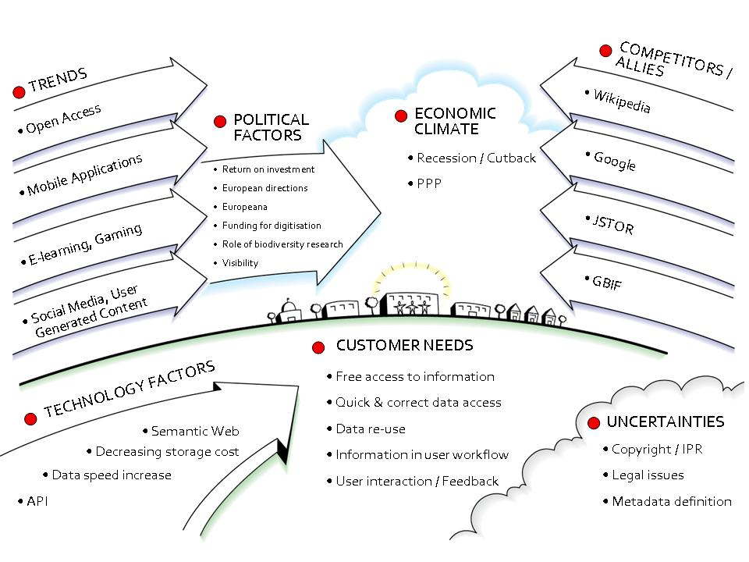

Business strategy

Vision statement
European biodiversity knowledge freely available globally to everyone.

Mission statement
Mobilising and preserving digital European biodiversity heritage literature and facilitating the open access to this literature through a multilingual community portal, the Global Reference Index to Biodiversity, and Europeana.

Objectives
Above we have analysed the strategic directions for an operational BHL-Europe service. Below the objectives for every individual business strategy are listed. This list is not comprehensive yet and your ideas and input are still necessary.

Objectives for maintenance only
- Maintenance of the BHL-Europe multilingual biodiversity digital library.
- Provide a multilingual access point for the search and retrieval of biodiversity content through BHL-Europe and Europeana.
- Long-term preservation and sustainability of the content and metadata produced by national biodiversity digitisation programmes.

Objectives for maintenance and incremental growth
All of the above objectives are applicable as well, but below are the additional objectives.
- Facilitate the open access to taxonomic literature for a large number of target users including the general public.
- Improve the interoperability of European biodiversity digital libraries by the application of tools and technologies developed with the BHL-Europe Best Practice Network.
- Promote the adoption of best practice, standards and specifications for the large-scale implementation of such repositories.
- Collaborate with content providers to ingest metadata and content in a standardised way.
- Building a strong brand associated with BHL-Europe
- Disseminate best practice guidelines, standards and policy papers to potential content providers and the community.
- Facilitate IPR management.

Objectives for all strategic directions
All of the above objectives are applicable as well, but below are the additional objectives.
- Further development of the BHL-Europe multilingual biodiversity digital library.
- Collaborate with aggregators and content providers to automate and simplify the ingestion process, accumulate digitised content, standardise the data that describes it, enrich the data and promote persistent identifiers.
- Raise awareness and ensure that the services are known and used by the target users and that the proposed approach directly addresses user needs.
- Facilitate and enable the initiation of scanning initiatives in European countries not yet involved in digitisation programmes and improve the infrastructure for digital libraries in all EU countries.
- Negotiate with Rights Holders to enable access to in-copyright content.

Value proposition
BHL-Europe delivers the following values to content providers and user and helps them to solve the following problems. The value proposition is made for every individual business strategy analysed above. This list is not comprehensive yet and your ideas and input are still necessary. I also feel that my distribution across the three strategies is not quite appropriate and need some more work.

Value proposition for maintenance only
Value proposition for content providers:
- BHL-Europe enriches the metadata of all partners so that every content provider can retrieve and re-use the enhanced data.
- BHL-Europe helps to create good quality OCR text from the scanned page images for further data analysis and metadata enrichment.
- BHL-Europe provides (open source) tools and technologies to cost-effectively present the digital content and manage digitisation projects in the biodiversity domain.
- BHL-Europe establishes a sustainable preservation and archive system to store, curate, manage, and migrate our partners’ data. Thus BHL-Europe will have strategies and processes in place for long-term preservation of the data produced by biodiversity digitisation programmes.
- BHL-Europe provides multilingual access to the content of all partners, thus saving partners the cost of creating a multilingual portal.
- BHL-Europe increases the visibility of the content of all partners, thus increases the visibility of the partner institutions.
- BHL-Europe is changing the library strategies for physical collections.
- BHL-Europe is facilitating and changing the interlibrary loan process.
- BHL-Europe makes all the content available through Europeana – a search platform to a collection of European digital libraries. This will increase the visibility of BHL-Europe content, and it will also increase the visibility of BHL-Europe content provider data. A sustainable Europeana will also support the sustainability of BHL-Europe.
- BHL-Europe provides access to the complete content through the Global Biodiversity Heritage Library (see section 6.4 for details). The content will be globally mirrored and backed-up for preservation and access.
Value proposition for users:
- BHL-Europe is accumulating a trustworthy and authoritative digital collection of Europe’s biodiversity heritage literature for research, education and a number of other applications.
- BHL-Europe establishes a sustainable preservation and archive system to store, curate, manage, and migrate our partners’ data. This strengthens our position as a long-term trusted source.
- BHL-Europe provides free and direct online access to comprehensive information not currently publicly accessible through different access routes, thus facilitating the access for a large number of target users (see also more specific values proposed below).
- BHL-Europe provides a multilingual community portal to search or browse the digital archive, read the literature online, download all relevant data (bibliographic information, page images, pdf of the publication or parts of the publication, OCR) and print the literature.
- BHL-Europe provides access to Taxonomic Intelligence services to facilitate the search for taxon specific information. This does not only include the search for the scientific name of a species but also the search for vernacular names.
- BHL-Europe makes research in the biodiversity domain more efficient (time and budget) as identification of biological species takes less time, and thus research based on historical taxonomic works is easier and quicker, as time and costs involved in visiting libraries is significantly reduced.
- BHL-Europe improves the quality of research in the biodiversity domain as the accuracy of citations will be improved, and thus the possibility of “reinventing the wheel” is avoided where new research inadvertently repeats older research, as biodiversity information is shared with a very large community.
- BHL-Europe is repatriating biodiversity knowledge.
- BHL-Europe facilitates sharing books with other countries, e.g. third world countries.
- BHL-Europe facilitates library management by reducing the handling time for librarians and by reducing the wear and tear of special (rare) collections.
- BHL-Europe facilitates the production of high quality paper copies of rare or precious books.
- BHL-Europe provides high quality images (artwork) of animals and plants.
- BHL-Europe is an extensive resource for teaching material as a complement to textbooks used in schools.
- BHL-Europe provides access to the digital archive through Europeana thus making a major corpus of science material available to every European citizen to help raise the awareness and appreciation of biodiversity heritage. The access through Europeana also facilitates the cross-domain search and retrieval of content for all users.
- BHL-Europe provides information to users about the distribution of heritage material still to be digitised and offers mechanisms to place requests for scanning such material through the Global References Index to Biodiversity.
- BHL-Europe helps libraries and digitisation programmes to manage their scanning activities through the Global References Index to Biodiversity.
- In making all the content available through the Global Biodiversity Heritage Library, BHL-Europe is also incorporating content that is made available by the global partners (see section 6.4 for details). This is also bringing digital copies of European heritage literature that is not available in Europe anymore back to Europe.

Value proposition for maintenance and incremental growth
All of the above objectives are applicable as well, but below are the additional objectives.
Value proposition for content providers:
- BHL-Europe will facilitate funding for scanning
- BHL-Europe provides access to an important up-to-date and cost-effective pool of information and network of collaboration to help partners use best practice approaches.
- BHL-Europe is creating a collaborative spirit: working together on a common goal.
- BHL-Europe facilitates collaboration between partners beyond project goals.
- BHL-Europe dissemination activities will reach a large group of target users to increase the use of all data and content. Thus, BHL-Europe gives a cost-effective way to multiply the impact of partners’ editorial activities and build a presence with users, the professional community, and other organisations including national governments.
- BHL-Europe makes all the content available through Europeana – a search platform to a collection of European digital libraries. This will increase the visibility of BHL-Europe content, and it will also increase the visibility of BHL-Europe content provider data. As Europeana enriches the metadata, this new metadata can be retrieved through BHL-Europe too. BHL-Europe benefits from the network and knowledge building capacity of Europeana, thus increasing the access to state-of-the-art research and technologies. A sustainable Europeana will also support the sustainability of BHL-Europe.
Value proposition for users:
- BHL-Europe welcomes user feedback and interacts with users to effectively improve the service quality and the addition of further digital collections.
- BHL-Europe continues to add more content to the existing corpus through the implementation of the collecction development policy
- BHL-Europe facilitates the grow of open access journals for taxonomists. One recent example is the European Journal of Taxonomy (EJT).

Value proposition for all strategic directions
All of the above objectives are applicable as well, but below are the additional objectives.
Value proposition for content providers:
- BHL-Europe will facilitate funding for scanning
Value proposition for users:
- BHL-Europe welcomes user feedback and interacts with users to effectively improve the service quality and the addition of further digital collections.
- BHL-Europe facilitates the grow of open access journals for taxonomists. One recent example is the European Journal of Taxonomy (EJT).

Business plan
BHL-Europe offers the user four routes to access the digital biodiversity literature– three European and one global (Fig. 1):
- BHL-Europe portal and preservation and archive system
- The Global Reference Index to Biodiversity (GRIB)
- Europeana
- Global BHL – partners include Atlas of Living Australia, Chinese Academy of Science, BHL USA, Bibliotheca Alexandrina, etc.
All these routes provide access to our digital library, but are self-contained applications working along-side the BHL-Europe preservation and archive system for the European digital literature. Therefore, a sustainability plan for all these service options is required. The BHL-Europe system and portal is the core product and outcome of the BHL-Europe project. Thus, this is the core focus of our sustainability plan. The GRIB is a second major outcome of BHL-Europe, developed in collaboration with the EDIT project. For this system, a sustainability plan was developed that is independent from the future of BHL-Europe. Europeana is a major partner of BHL-Europe with its own products and agendas. Europeana itself has a business plan and a strategic plan that is highly independent from BHL-Europe. As Europeana is very important for BHL-Europe, a summary of their future strategies is also provided below.

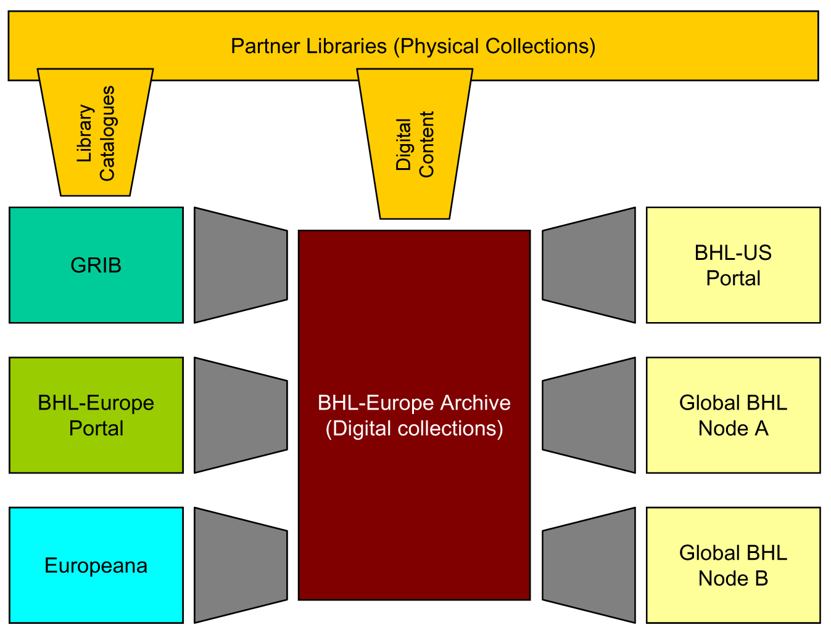

Fig. 1. The access routes to the digital biodiversity literature provided by BHL-Europe. Our partner libraries will provide catalogue data and digital content to the GRIB and the BHL-Europe archive. The content in the archive is accessible through the GRIB, the BHL-Europe Portal, Europeana and any Global BHL Node including the BHL-US Portal. The library catalogues are only accessible through the GRIB to facilitate the digitisation management.

BHL-Europe preservation and archive system and portal
For the sustainability of the BHL-Europe preservation and archive system and portal, we identified six business components, which need development for the strategies discussed and analysed in 4.1 above:
- Long-term sustainability of the content already digitised and aggregated
- Long-term sustainability of the network, including Europeana
- European participation/leadership in Global BHL
- Easy method for current/future partners to add content to corpus, including IT development
- Helpdesk in managing user feedback on data/content quality and follow up data/ content QA management
- Lobbying and high level strategic network management
Estimated resources (given in approximate FTE = full-time equivalents) for all these options are summarised in the table below. This does not include the work of each content provider. Every institution interested in contributing content to BHL-Europe is expected to provide the collaborative work with BHL-Europe as in-kind contribution of that institution (part of the existing scanning programme / project or library activity). Depending on the scenario, the process for adding content to the corpus will range from very simple (low-value added, low quality control) to a fully managed process. Parallel with the increase in content, an increase in IT development work is necessary to take new software developments into account and manage scale-related issues. The increase in content also requires organisation of the network of content providers, even though the content providers are funded themselves.

 | Stop all | Maintain | Incremental growth | Keep going and growing | Scale up
Long-term sustainability of the content already digitised and aggregated | No costs | NHM¹ commitment (1.0 FTE) | NHM¹ commitment (1.0 FTE) | NHM¹ commitment (1.5 FTE) | NHM¹ commitment (2.0 FTE)
Long-term sustainability of the network, incl. Europeana | No costs | No costs | Partner A² commitment (0.4 FTE) | Partner A² commitment (1.3 FTE) | Partner A² commitment (1.7 FTE)
European participation/ leadership in Global BHL | No costs | No costs | Partner A² commitment (0.1 FTE) | Partner A² commitment (0.2 FTE) | Partner A² commitment (0.3 FTE)
Easy method for current/ future partners to add content to corpus, incl. IT development | No costs | No costs | Partner B² commitment (0.5 FTE) | Partner B / C² commitment (2.0 FTE) | Partner B / C² commitment (3.0 FTE)
Helpdesk in managing user feedback on data/content quality and follow up data/ content QA management | No costs | Partner A² commitment (0.1 FTE) | Partner A, B² commitment (0.2 FTE) | Partner A, B² commitment (0.3 FTE) | Partner A, B² commitment (0.5 FTE)
Lobbying and high level strategic network management | No costs | CETAF³ commitment | CETAF³ commitment | CETAF³ commitment | CETAF³ commitment
Total FTE | 0.0 | 1.1 | 2.2 | 5.3 | 7.5

¹ NHM is the Natural History Museum London, UK
² BHL-Europe is discussing with the consortium partners the option for commiting staff time to support BHL-Europe services to secure a project independent funding of BHL-Europe business components. Additional (external) funding through new or follow-up projects would then help the partners to do more work to fulfill the anticipated business strategy (depending on the funding level). It still needs to be decided what the future BHL-Europe business strategy will be, which is based on the commitments of partner institutions. As NHM have committed already to maintain the infrastructure and thus the access to and preservation of the content aggregated during the BHL-Europe project, long-term sustainability of the content already digitised and aggregated is secured. Three additional partners are considered to be sufficient in order to extend the services and deliver the business described above. The roles of the three partners are defined in the table based on the expertise required to fulfill the taks.
³ CETAF is the Consortium of European Taxonomic Facilities. It has agreed to build an office to take up some tasks for all the European natural history museums and botanical gardens. Among these tasks is the lobbying and the high level strategic management of the network of taxonomic facilities in Europe to also support the initiation and management of projects.

Global References Index to Biodiversity (GRIB)
The GRIB is build by the head office of the common library network GBV (VZG) for BHL-Europe. The Gemeinsamer Bibliotheksverbund (GBV) is the common library network of the seven German federal states with more than 400 member libraries. It’s head office in Göttingen is responsible for the development of new library specific services.
After the end of the BHL-Europe project in April 2012, the VZG will further host and maintain the GRIB at least until February 2020 according to a bilateral agreement. This service also includes the import of data from partner libraries as well as free and open access to the data via standard interfaces (WWW, Z39.50, SRU, internal XML, and OAI). The Museum für Naturkunde Berlin will act as the formal liaison between the BHL-Europe partner libraries providing the data and the VZG. A governance structure for the time after the end of the BHL-Europe project needs to be defined and will be provided with D1.9 in M36 of BHL-Europe.

Europeana
The Europeana Strategic Plan 2011-2015 sets out a clear vision for the future direction of Europeana - Europe's digital library, archive and museum. It focuses on four strategic tracks - aggregate, facilitate, distribute and engage - that will enable Europeana to generate real value for its stakeholders. The plan complements the release of ‘The New Renaissance, the Comité des Sages’ report on digital cultural heritage to the Commission, which recommends ‘a clear vision and plan for the future development of Europeana.’
The plan sets out to continue to aggregate the material from across Europe and become THE trusted source of cultural heritage. Europeana should also be a facilitator and support the cultural heritage sector through knowledge transfer, innovation and advocacy. To distribute the data and make heritage available to users wherever they are, whenever they want it; through APIs and search widgets, in teaching resources, on blogs, college sites and social networks. Europeana will also explore new ways of actively engaging users in the development of the site and making creative reuse of its content.
Europeana will be one of the access points via which the BHL-Europe material will be made available. Europeana aims to continue its service in the future and reach the goals it has set out in the strategic plan. The Europeana Foundation receives funding from the European Commission, with matching funds supplied by the Member States to carry out its activities. Europeana Foundation competes for project funding from the EU. It has one project run entirely by the Europeana Foundation, Europeana v1.0 and it is a partner or subcontractor in 20 other projects. Without this matching funding, Europeana cannot participate in the projects and would therefore not have been able to progress beyond the prototype phase of 2008 and leading directly to increased material being available from the countries and establishing improvements of the site for the end user.
Europeana v2.0 is a project under the ICT PSP programme starting summer 2011, with the aim to provide the majority of the funding required to ensure the continued running and development of Europeana from August 2011 to December 2013. Activities will include the enhancement of content, increase and facilitate the re-use of content, develop a sustainable finance and provision model, create centralised repositories of linguistic resources, release new versions and maintain the service and its APIs, develop features and functionalities, improve the user experience and coordinate the network of contributing organisations.

Global BHL
The Global Biodiversity Heritage Library (Global BHL) is a cooperative network of autonomous decentralised members operating programs and projects to make digitised biodiversity literature available through open access to all. The goals of the Global BHL are:
  - Digitise and make available as much legacy biodiversity literature as funding and copyright law allows through the member programs and projects.
  - Maintain repositories for the storage, preservation, and serving of this digitised literature.
  - Develop services to make this digital content widely and easily available for use by biodiversity research projects and others.
  - Share data, technologies and knowledge between nodes. Especially important in this regard is the redundant storing of BHL content in multiple, geographically distributed, independently administered sites. This will avoid the “monoculture” problem common to many large digital library projects and set the framework for long-term preservation of the digital assets.
The principles of the Global BHL are:
  - Open access: The digital content served by Global BHL members is available without cost and can be reused by other projects and users in general.
  - Collaboration: Each Global BHL member will actively coordinate and converge its activities with other BHL partners to achieve agreed-to objectives.
  - Decentralisation: Each Global BHL is self-governing and funded.
  - Interoperability: Each Global BHL member will deploy technologies enabling sharing of contents and services with other Global BHL members.
  - Transparency: The processes of the Global BHL will be transparent, public and clear to all members.
  - Respect and solidarity: The Global BHL will operate within the legal statutory frameworks of its members.
The Global BHL Partner Projects are:
  - BHL
  - BHL-Europe
  - BHL-China, which includes the Chinese Academy of Science – Institute of Botany, Chinese Academy of Science – Institute of Zoology, Chinese Academy of Science – Institute of Microbiology, and Chinese Academy Science - Institute of Oceanography
  - BHL-Australia, which includes the Atlas of Living Australia (ALA), Museum Victoria, and several Australian digitisation projects
  - BHL-South America, which includes BIREME/SciElo (Scientific Electronic Library Online), Museum of Zoology, University of São Paulo, National Biodiversity Program, Ministry of Environment, and several museum and herbaria libraries.
  - Arab Language BHL organised by the Bibliotheca Alexandrina.
The Global BHL partners are in different stages of project implementation and are establishing a Global BHL Coordinating Committee to better align the project's strategies. The hope is that by sharing digitised biodiversity literature content, by mirroring content, and by sharing technologies and best practices the global partners will reduce the resource burden required by each separate project.

Proposals for follow-up projects

BHL-Europe Organisation and Governance
Current positions and functions we may need to have for the incremental growth option (more work necessary here):
- BHL-Europe Director and Network Manager
- BHL-Europe Technical Director
- BHL-Europe Technical Support
- BHL-Europe Helpdesk Administrator
- BHL-Europe Dissemination Officer

Appendix and reference documents
The Business Plan for long-term sustainability (D1.9) in M36 of BHL-Europe will further include as annex the following documents or refer to them:
- D3.8 – Sustainability policy for continuation of service e.g. hosting, future development, helpdesk provision for service users/content providers etc.
- D4.3 – Deliver IPR framework to support long-term access and sustainability of the digitised material
- BHL-Europe in a nutshell including BHL-Europe Memorandum of Understanding
- BHL-Europe collection development policy
- Future objectives for development based on the user survey and usability tests (D5.9)

OJ L 79, 24.3.2005, p. 1.
The CCPA WG members have received the document for revision. A formal feedback/review was never provided by the date of submission.
GBV homepage: http://www.gbv.de/vgm/
VZG homepage: http://www.gbv.de/vgm/info/biblio/01VZG/index?lang=en
Europeanav1.0 project website: http://version1.europeana.eu/web/europeana-project/documents
European Commission website: http://ec.europa.eu/culture/pdf/report_Comite_des_Sages.pdf

