

**Metadata Clean-up Workflow**

Biodiversity Heritage Library (BHL)’s Cataloging Group works to provide and maintain quality metadata that will help users to search, discover, and identify the resources they want. As of January 2016, the Cataloging Group utilizes two different web interfaces to enhance cataloging metadata with issues – both interfaces require a User ID and Password obtained through BHL.

* **Gemini Issue Tracker**: <http://biodiversitylibrary.countersoft.net/>
* **BHL Administrative Dashboard**: <http://admin.biodiversitylibrary.org>

All metadata clean-up work starts in the Gemini Issue Tracker.

1. **Gemini Issue Tracker**

Whenever there is a new Issue, it is added in the Gemini Issue Tracker. In the Gemini Issue Tracker, you can view only cataloging related issues (as seen below). The Issue page includes Issue ID, Type, Priority, Title, Status, Resolution, and Revised date information.

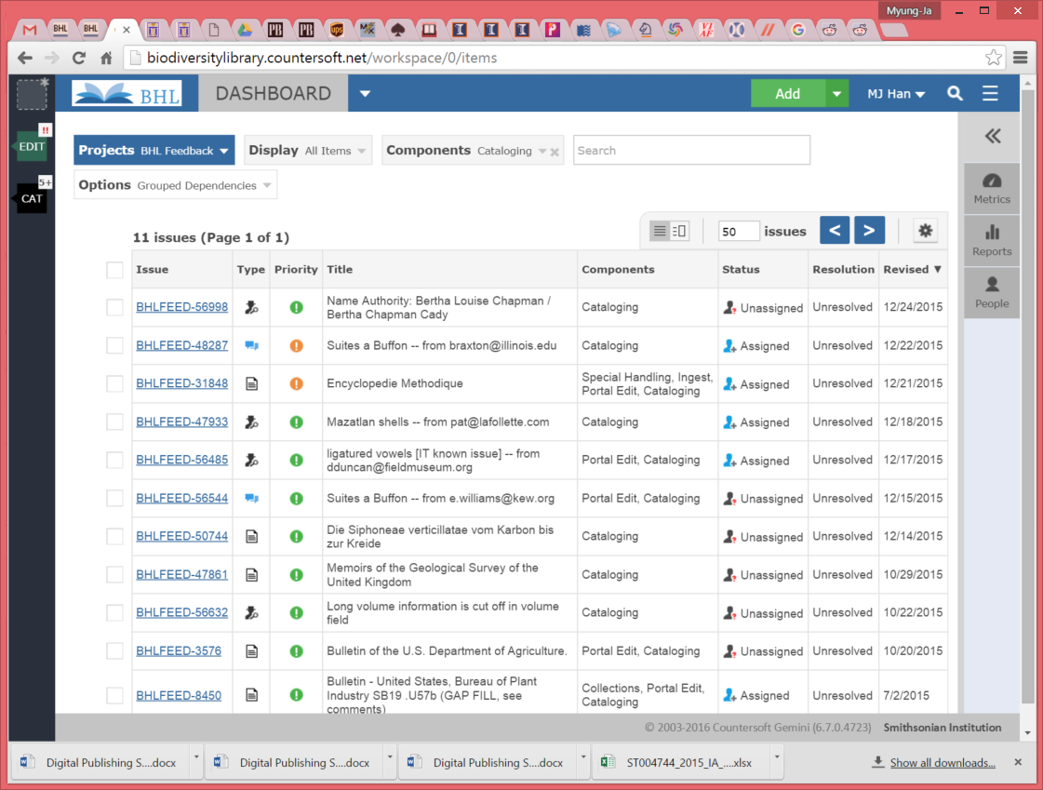

After the new issue is created, an email is sent out to all Cataloging Group members. If you want to work on the issue, you can click the ‘Unassigned’ box and change it to ‘Assigned’ and (or) add your ID.

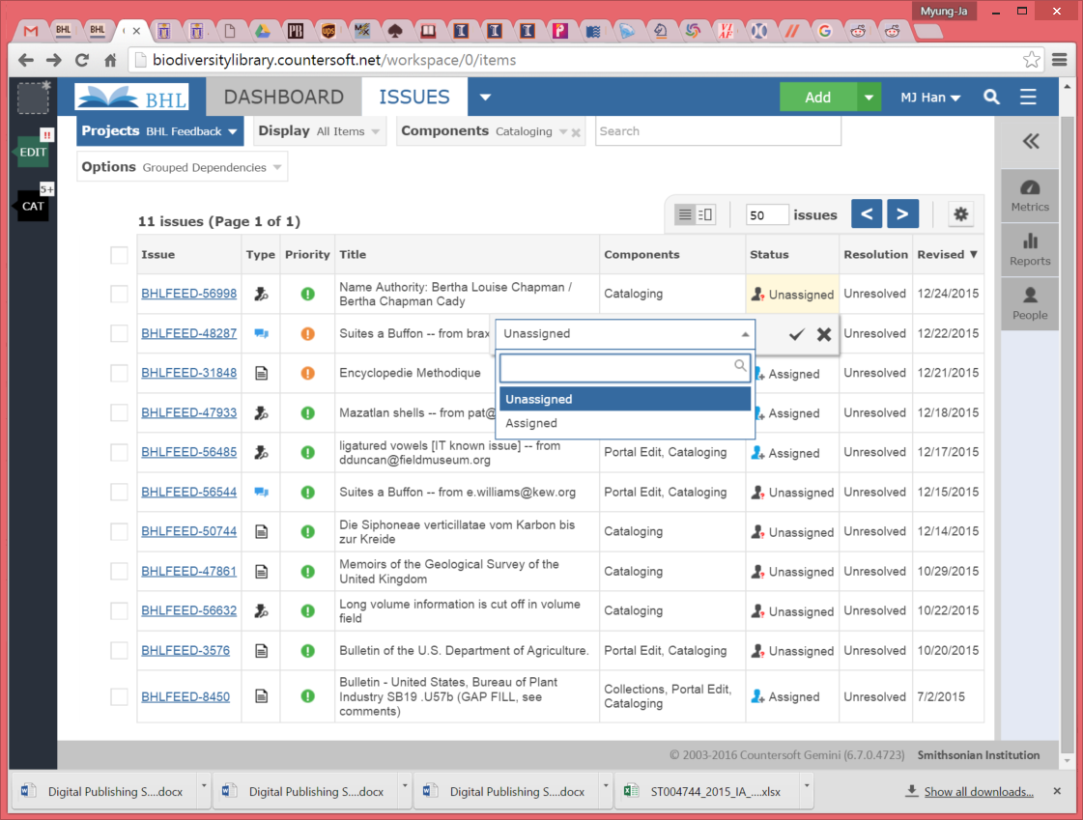

When you click the Issue ID ‘BHLFEED-56998,’ you will see all detailed information about the issue.

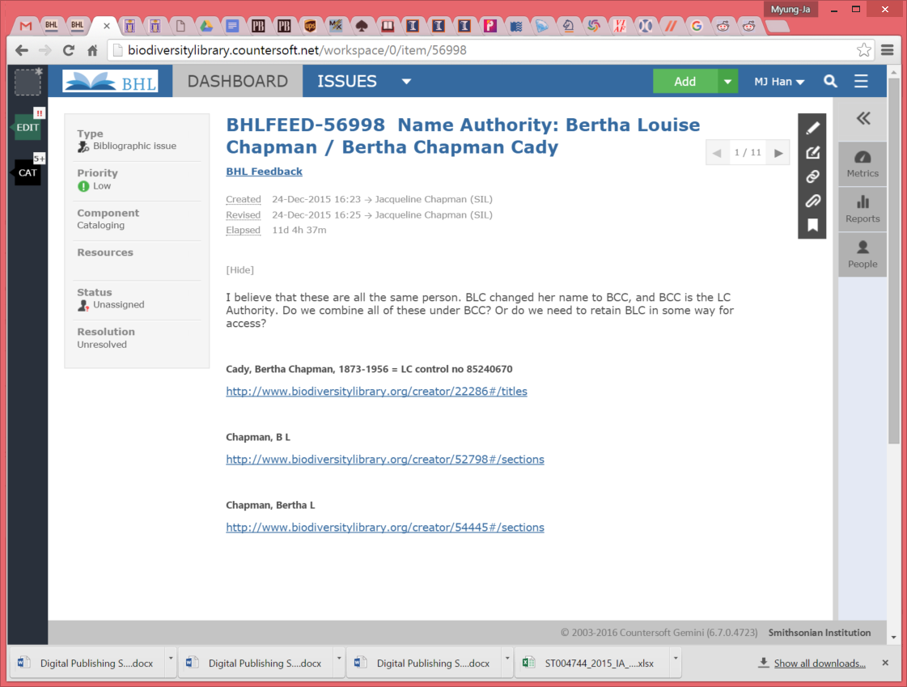

By clicking the first link (<http://www.biodiversitylibrary.org/creator/22286#/titles>), you can see detailed information about the item, including title information. Descriptive metadata in MODS format, and citations in BibTeX and Endnote can be seen by choosing the appropriate tab at the top.

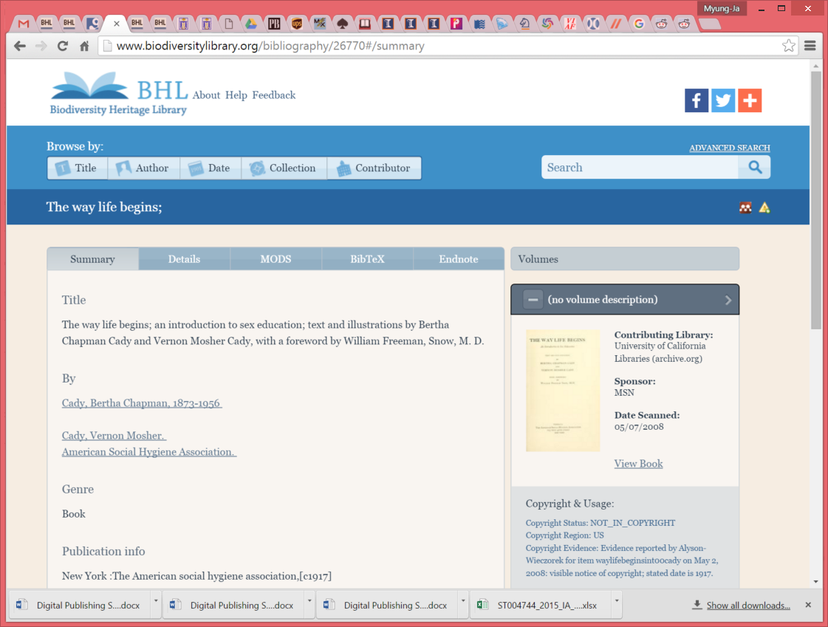

1. **BHL Administrative Dashboard**

Once the detailed title information has been reviewed, and any changes have been decided on, you can search the book metadata from the **BHL Administrative Dashboard.** The *titles* link ([http://www.biodiversitylibrary.org/creator/**22286**#/titles](http://www.biodiversitylibrary.org/creator/22286#/titles)) includes the ‘Title ID’ and this can be used to search the actual metadata in the BHL. You can also search the system by MARC Bib ID, full title of the item, or Item ID when it is available.

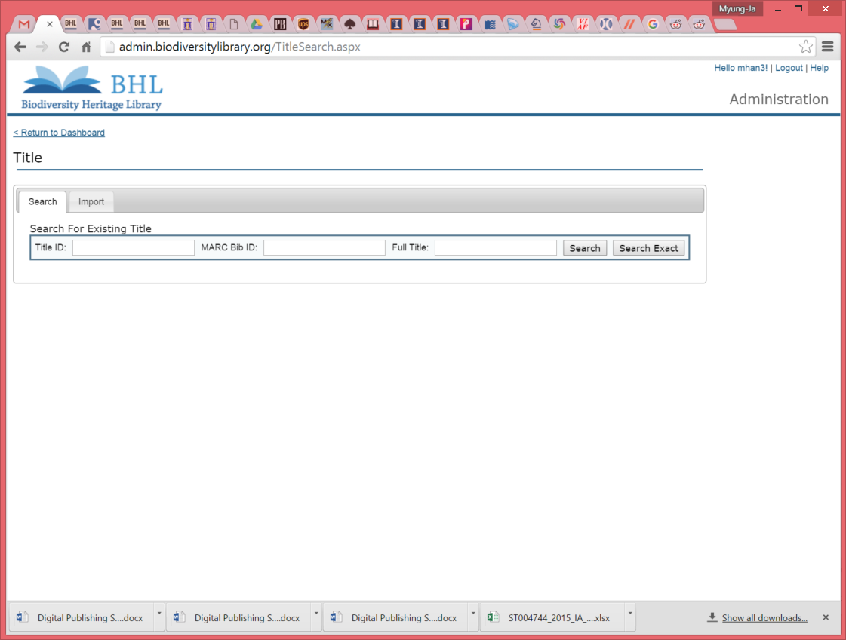

When the search is done, you can see the full catalog record of this title (Title ID 22286) on your screen as below.

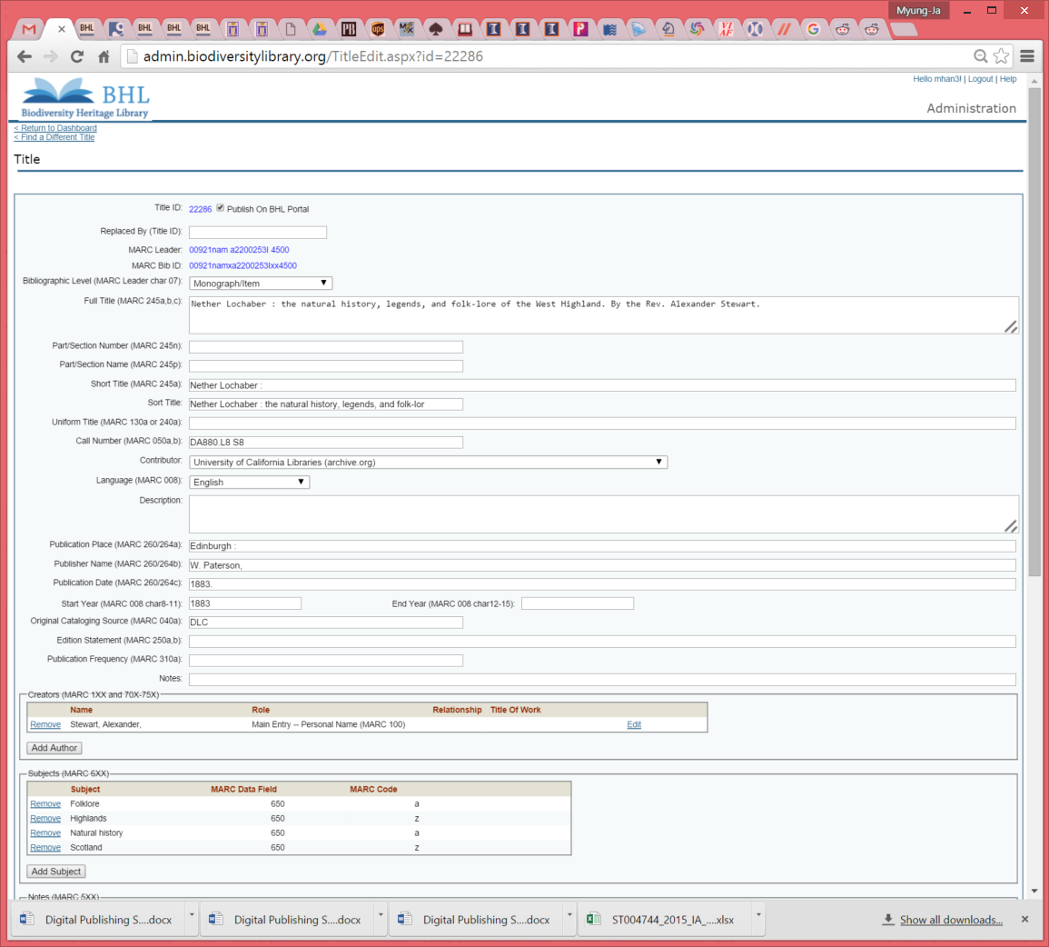

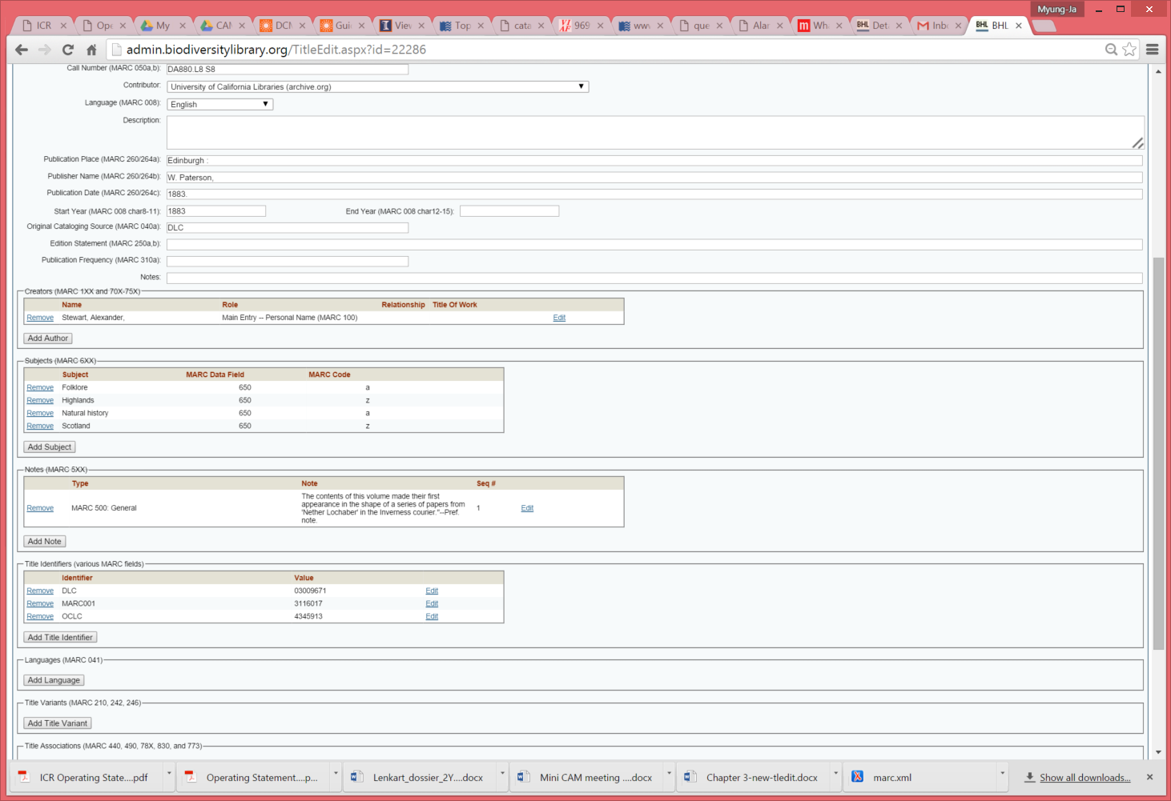

Depending on the issue, make any appropriate changes on this screen. For each catalog field, you can remove, add, or edit the value.

If there are multiple titles that require changes in their metadata, keep searching the system with the Title ID or Item ID (available on the top left corner of the screen), and update the metadata.

Once all changes are made, save the record by clicking the ‘***Save***’ button at the end of the screen.

After the catalog record is updated and saved appropriately, you can go back to the **Gemini Issue Tracker**.

1. **Gemini Issue Tracker**

In the Gemini Issue Tracker page, please add any changes you have made to the metadata as a *Comment* available in the Detailed Issue page so other people can use it as a reference for further discussion.

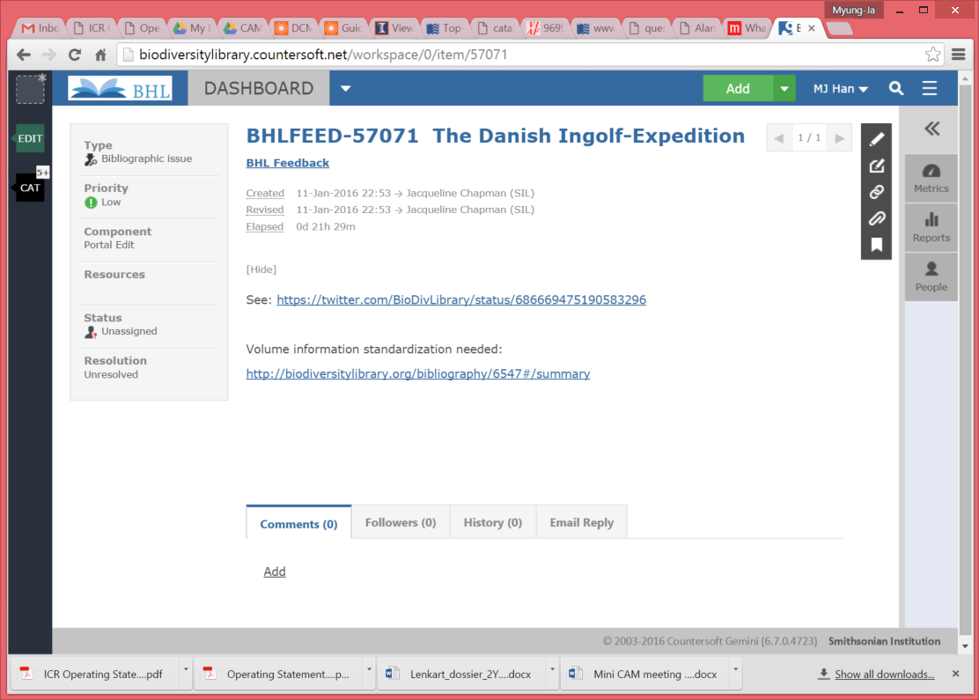

You can also change the ***Resolution*** section. Depending on the Issue, you can choose from *Unresolved, Duplicate, Cannot Reproduce, Won’t Fix, Wishlist, and Complete*.

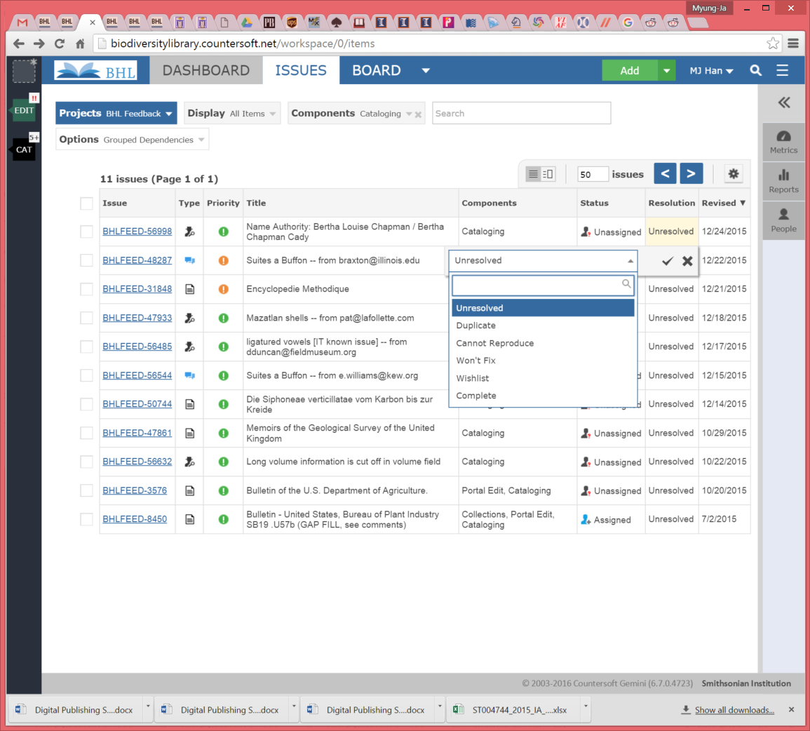

All other documents on BHL are available on BHL’s Wiki (https://bhl.wikispaces.com/help).