ECP-2008-DILI-518001

BHL-Europe

Key components documented for output of D3.5

Deliverable number | D3.7
Dissemination level | Public
Delivery date | M24
Status | Draft
Author(s) | AIT


eContentplus
This project is funded under the eContentplus programme,
a multiannual Community programme to make digital content in Europe more accessible, usable and exploitable.

Table of contents
1 Document History 3
1.1 Contributors 3
1.2 Revision History 3
1.3 Reviewers and Approvals 3
1.4 Distribution 3
2 Introduction 4
2.1 Overview – The BHL-Europe Key Components 4
3 Interdependencies between Key Components 5
4 Key Components 6
4.1 Pre-Ingest 6
4.2 Ingest 6
4.3 Archival Storage 6
4.4 Data Management 6
4.5 Access 6
4.6 Portal 6
I Acronyms 7
II Figures 8

Document History
This chapter describes the document’s creation events and contributors.

Contributors
This document is based on the meeting of the technical team in Egypt with the following members contributing to this document.
Person | Partner
Walter Koch, Bernd Sproger | AIT

Revision History
Revision Date | Author | Version | Change Reference & Summary
2011-03-08 | AIT | 0.1 | Final

Reviewers and Approvals
This document requires the following reviews and approvals. Signed approved forms are kept in the project file.
Name | Position | Signature on approval | Date | Version
Walter Koch |  |  | 2011-03-08 | 0.1

Distribution
This document has been distributed to:
Group | Date of issue | Version
Adrian Smales | 2011-03-08 | 0.1

Introduction

Overview – The BHL-Europe Key Components
BHL-Europe Technical Architecture
- Pre-Ingest
- Ingest
- Archival Storage
- Data Management
- Access
- Portal

The BHL-Europe data workflow is based on systems to separate roles and responsibilities and to effectively manage the data. The outcome of every individual system is feeding the Pre-Ingest module of the BHL-Europe system. The Pre-Ingest module thus collects all the data produced in these systems and prepares the SIP to be ingested into BHL-Europe. Among these systems are the scanning system and the mapping system (called schema mapping in the architecture). The scanning system on the content provider side will provide the page images. The mapping system will provide the metadata mapped to the OLEF (Open Literature Exchange Format). No metadata other than data in the OLEF schema is allowed to enter the Pre-Ingest module. It is of special importance that the archived information can reconstruct exactly the same output OLEF as the one which was submitted to the Pre-Ingest module.
BHL-Europe is offering the metadata mapping to the OLEF schema as a service for all content providers (for details on this process see section XYZ below). This does not disengage content providers to be responsible for the quality of their metadata, as we don’t have the resources to fix all quality issues. To start the process, every content provider is uploading metadata and scans via FTPS to the NHM servers in London.
Content Provider first upload test content to the NHM server including the scanned images and the corresponding metadata according to the file submission guidelines. The test content will then be checked on the one hand by AIT and on the other hand by NHMW. AIT verifies if the file submission guidelines have been followed and NHMW will start with the data mapping to the OLEF schema creating a configuration for every content provider to accommodate for the characteristics of the content provider data. The mapping configuration is defined for every content provider individually once and will remain the same as long as the content provider does not change the structure of the provided metadata. However, standard mappings (for e.g. MARC21, DC) are available and only partners with non-standard data need more work to map the data properly. According to our preliminary analysis, this is only true for a low number of partners. The mapping process is accompanied by a QA process to negotiate and verify the result of the mappings in collaboration with the content providers. After quality is approved, the content provider can upload the bulk of the material to be ingested into the BHL-Europe system. Once the upload is finished, the content provider log into the Pre-Ingest module to trigger the conversion of all metadata into the OLEF schema based on the previously defined configuration. NHMW provides the command to convert the metadata for each content provider which is then executed by the Pre-Ingest module. The content provider then selects the folder(s) for procession via the Pre-Ingest interface. The data handling in the Pre-Ingest module will be managed by AIT.
In case content provider have the expertise and resources to work on the mapping configuration themselves, we can offer this options and provide all the necessary tools for the content providers. The Schema Mapping Tool is open source and a documentation will be available before the end of the project. This also is a sustainable solution to distribute the responsibility and offer future content providers tools to map their data to our data schema after the end of the project.
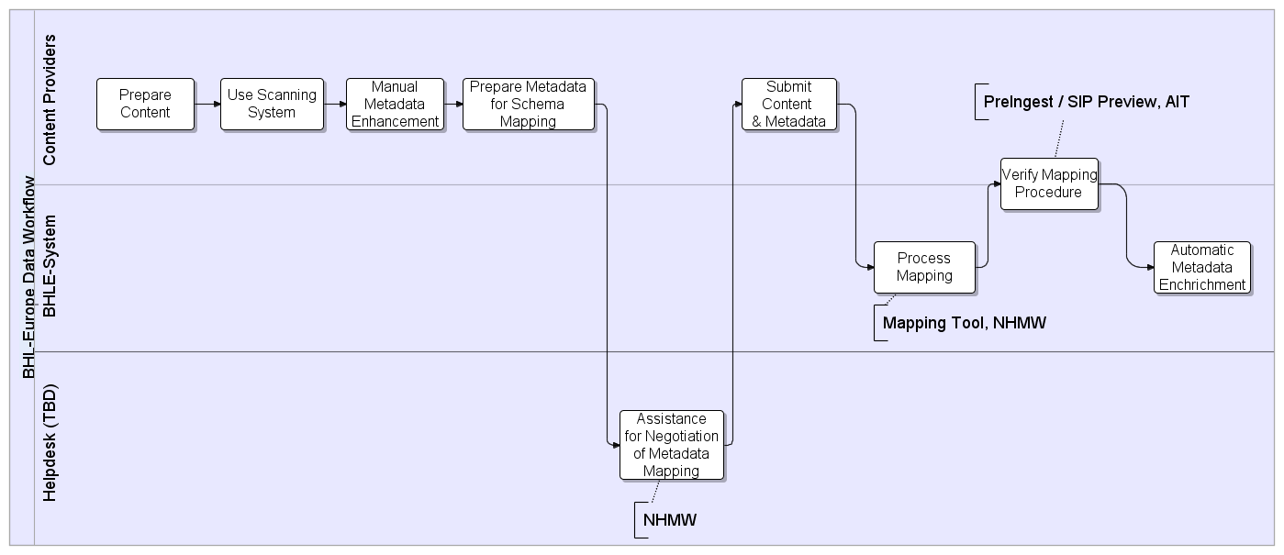
Figure 2-1 SIP Preparation Workflow
The Schema Mapping Tool is also able to deal with enriched metadata of our content providers and include this information in the OLEF schema. Manual data enrichment ideally happens at time of scanning and during quality control on the content provider side. This may include taxonomic information in high quality. It needs to be investigated, if workflow management tools like Goobi are able to support the data enrichment procedure.
If one content provider, for example, is able to provide good quality taxonomic metadata for the page images or scans, BHL-Europe is able to use these data to facilitate search and retrieval of these items. In any case an automatic enrichment of the metadata will be done during Pre-Ingest using live Web-Services. Pre-processing of the data is required to facilitate the automatic data enrichment. OCR is necessary, for example, to apply the TaxonFinder and identify taxon names in the documents provided to BHL-Europe. Within the Pre-Ingest module, METS files are generated as a transport container (encapsulating the OLEF metadata) for Fedora. Also the mapping to the Europeana schema (ESE, EDM) is part of the Pre-Ingest and is done by AIT. For more details on the Pre-Ingest component, please see section xyz below.

Interdependencies between Key Components
Aims to describe the data flows through the system and in between the key components, comparable to the OAIS data flow diagram. Here we can also use our workflow diagrams and data flow diagrams (such as using Pentaho mapping for Europeana).

Key Components

Metadata mapping to OLEF
As content providers use different metadata for their exports it was necessary to introduce an additional processing step for harmonizing the metadata. In order to provide a common input format to all further processing steps it was decided to use OLEF (Open Literature Exchange Format). The format will be explained more in detail later on.
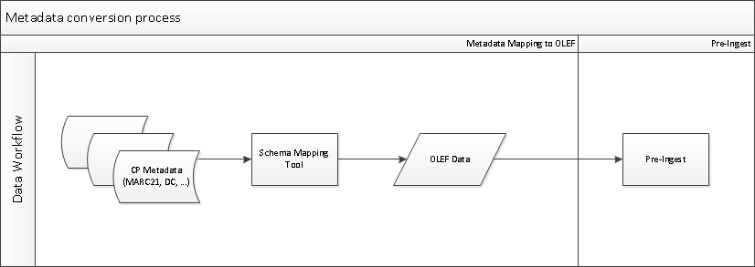
Figure 4-2 Metadata Mapping to OLEF
As outlined in Figure 4-2 all incoming metadata will be pre-processed using the SMT (Schema Mapping Tool). The SMT has several built in conversion templates for processing standard input formats (like MARC21, DC, MODS, etc.). Some content providers may provide their metadata using a special format. Therefore the SMT is also able to process custom mappings which can be pre-defined using a graphical user interface.
The metadata mapping to OLEF is a preparation phase for the Pre-Ingest module which however is directly invoked by the Pre-Ingest itself. The conversion of the metadata can be actively triggered by the Content Provider itself when accessing the Pre-Ingest interface. Therefore the metadata mapping to OLEF is more a conceptual step than a physically separated process.
As a first step we defined our requirements involving all of our content providers. In order to allow communication between all of our partners we started a Google group (BHLE-Metadata) which primary task it was to create a simple list of requirements for our metadata including a comparison to existing standards. During the gathering of the requirements for the metadata it was discovered that no existing standard can fulfill all desired requirements on its own. Therefore we decided to create an own schema which encapsulates several domain specific standards into a single exchange and storage format which satisfies all of our requirements.
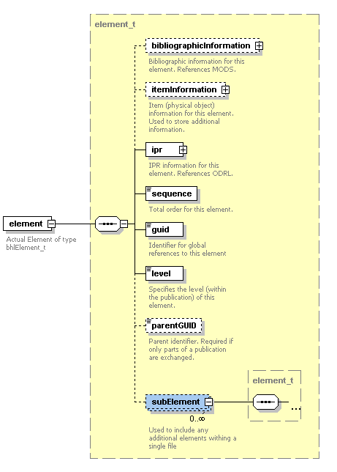
Figure 4-3 Schematic outline of OLEF structure
As shown in Figure 4-3 the OLEF schema uses a simple yet effective approach for storing literature related metadata in a single file. The main problem for all existing standards is the lack of ability to store metadata at any given level within the hierarchy of a publication. The OLEF schema tackles that limitation by introducing a recursive element (called “element” and “subElement” in Figure 4-3) which is able to reference itself within the same structure. Using that technique it is now possible to store metadata at any given level of information (monographs, serials, articles, pages, …). Even only parts of a publication can be exchanged as the OLEF schema offers fields for storing and referencing GUIDs which are used for each item within the BHL-Europe architecture.
As mentioned above the OLEF schema incorporates several other standards and creates a relation between them. The standards used are:
- MODS – bibliographic metadata (author, title, publication date, etc.)
- MIX – Image (scans) metadata (resolution, size, acquisition device, etc.)
- ODRL – IPR information
- DWC – Taxon Name information
The combination of those standards has proven to satisfy all of our requirements. As of OLEF version 0.3, a stable namespace for the schema has been established using the BHL-Europe Web site. The current version of the schema can be found at http://www.bhl-europe.eu/bhl-schema/v0.3/ (which is equal to the namespace).
The conversion process is already established at the servers provided by NHM London and is actively tested using the first uploads by our content providers. The integration into the Pre-Ingest module workflow is outlined in the next chapter.

Pre-Ingest
[AIT]

Ingest
[Atos/AIT]

Archival Storage
[Atos/NHM]

Data Management
[Atos/NHM]

Access
[Atos/AIT]

Portal
[MfN/AIT/Atos]

- Acronyms

- Figures

OJ L 79, 24.3.2005, p. 1.
page 4-17 http://public.ccsds.org/publications/archive/650x0b1.PDF
Metadata Object Description Schema: http://www.loc.gov/standards/mods/
Metadata for Images in XML Schema: http://www.loc.gov/standards/mix/
Open Digital Rights Language: http://odrl.net/
Darwin Core: http://rs.tdwg.org/dwc/

