ECP-2008-DILI-518001

BHL-Europe

BHL-Europe multimedia presentation,
final version

Deliverable number | D5.10
Dissemination level | Public
Delivery date | 30 April 2012
Status | Draft
Author(s) | Jiří Kvaček, Jiří Frank, Nicolas Van Audenhove


eContentplus

This project is funded under the eContentplus programme,
a multiannual Community programme to make digital content in Europe more accessible, usable and exploitable.

Table of contents

0 Document History 3
0.1 Contributors 3
0.2 Revision History 3
0.3 Reviewers and Approvals 3
0.4 Distribution 3
1 Purpose 4
2 Background and context 4
2.1 Introduction 4
3 Movie – BHL-Europe 4
4 Biodiversity Library Exhibition 4

Document History

Contributors

Person | Partner
Jiří Kvaček, Jiří Frank NMP
Nicolas Van Audenhove RBINS

Revision History

Revision Date | Author | Version | Change Reference & Summary
20 April, 2012 | NMP, | 0.1 | First draft of deliverable document
23 April, 2012 | NMP, | 0.2 | Second draft of deliverable document
02 May 2012 | RBINS | 0.3 | Revised version
xx, 2012 | NMP | 1.0 | Final version after approval by CWG and PMG

Reviewers and Approvals
This document requires the following approvals.

Name | Position | Date | Version
Henning Scholz | BHL-Europe PCO |  | 1.0

Distribution
This document has been distributed to:
Group | Date of issue | Version
BHL-Europe consortium | 02 May 2012 | 0.3
BHL-Europe consortium |  | 1.0

Purpose
This document gives an overview of the preparation and end results of multimedia presentations to inform the general public about the project. For the first version of the demonstrator, please refer to D5.1 of BHL-Europe published in July 2008.

Background and context

Introduction
BHL-Europe needs to demonstrate the main goals of the project to the general public. For this purpose we decided to go for two kinds of multimedia demonstrators.
The first is a movie explaining the hobby scientist or naturalist’s need for BHL-Europe digitised books. A short film was prepared in cooperation with our colleagues from the Museo National Ciencias Naturales, Madrid.
The second demonstration took on the form of a virtual exhibition, called the Biodiversity Library Exhibition (www.biodiversityexhibition.com). This virtual exhibition informs people on several topics. Two topics are already ready: spices (inspired by gastronomy) and expeditions (inspired by tourism).

Movie – BHL-Europe

The first demonstrator originally was a Power Point presentation. The idea was scrapped in favour of a video explaining the major goals of the project in an entertaining and retro way (Fig. 1). It was developed in cooperation with Antonio Valdecasas (who also performs the starring role) from the Museo National Ciencias Naturales, Madrid. The movie is placed on YouTube. It lasts for 3:30 minutes. It was distributed via our social media channels: the blog, Twitter and Facebook.

Biodiversity Library Exhibition

The Biodiversity Library Exhibition (BLE) was developed for dissemination purposes. This multimedia tool is which already attracted the general public and specialists during several BHL-Europe presentations and conferences.
The Biodiversity Library Exhibition (BLE) is a virtual exhibition of digital content drawn from the Biodiversity Heritage Library for Europe (BHL-Europe). Currently the BLE has two topical exhibitions in place. The first is focused on ‘Spices’: over 52 plants used as spices are featured, each with their own illustrations, story and fun trivia, and a sweet or savoury recipe people can try at home. The second exhibition is focused at major historical world explorations, with expedition summaries, diaries of the routes, “did you know”-lists, and of course illustrations. The BLE makes these interesting stories accessible to the general public. The voyage of the Beagle, the exploration of North and South America, and the conquest of Mexico, are just a few examples of the ‘Expeditions’ covered.

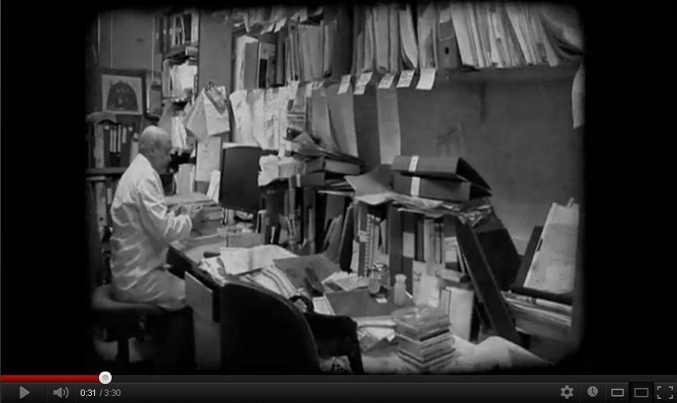

Figure 1. Screenshot of the movie with Antonio Valdecasas in the lab.

OJ L 79, 24.3.2005, p. 1.
http://www.youtube.com/watch?v=BEdtEHtw4k0
http://bhleurope.blogspot.de/2012/03/bhl-europe-in-35-minutes.html

