BHL Technical Review & Architecture Meeting Recap
BHL Institutional Council Meeting, March 20, 2009

 | 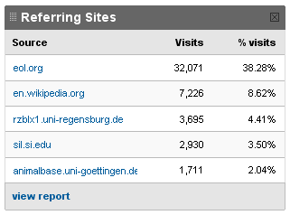

BHL Items (Volumes) Added Per Month
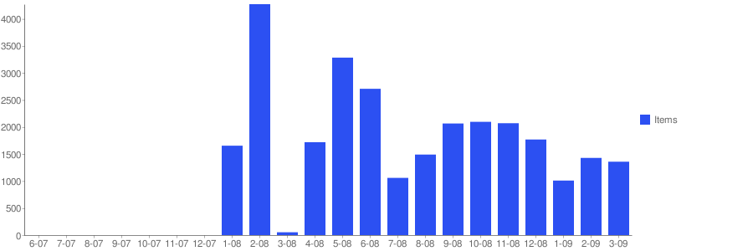

BHL Cumulative Items Added Per Month
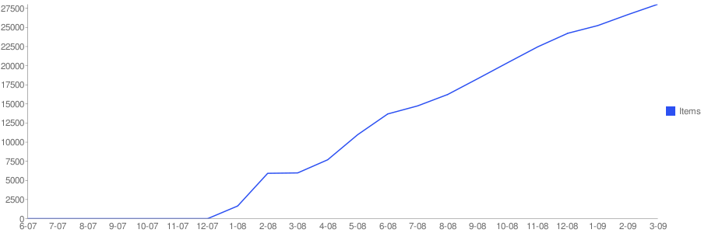

Usage in Visits (pre-EOL Launch – 15 Mar 2009)
