

Biodiversity Heritage Library

Building a Digital Open Access Library for Biodiversity Literature

Strategic Plan 2009-2013

Introduction  The published literature on biological diversity is rare or has limited global distribution and much of it is available in only a few select libraries. From a scholarly perspective, these collections are of exceptional value because the domain of systematic biology depends -- more than any other science -- upon historic literature. Yet, this wealth of knowledge is available only to those few who can gain direct access to significant library collections. Literature about the biota existing in developing countries is often not available within their borders. Biologists have long considered that access to the published literature is one of the chief impediments to the efficiency of research in the field. Among other results, free global access to digitized versions of the literature would repatriate information about the earth’s species to all parts of the world.  The Biodiversity Heritage Library (BHL) is an international library collaboration of natural history museum, botanical garden, and biological research libraries working together to digitize the published literature of biodiversity held in their respective collections and to make that literature available for open access and responsible use as a part of a global “biodiversity commons.” The BHL consortium is working with the global taxonomic community, rights holders and other interested parties to ensure that this biodiversity heritage available to all. Formed in 2007, the BHL program is one of the four cornerstones of the Encyclopedia of Life (EOL) and contributes to the International Convention on Biological Diversity (CBD) and the Global Biodiversity Information Facility (GBIF). The BHL program receives major funding from the John and Catherine D. MacArthur Foundation, the Alfred P. Sloan Foundation, and the Gordon & Betty Moore Foundation, as well as other foundations and the member institutions.  BHL member institutions are scanning their own institution’s scientific publications to contribute to the BHL. Using the Internet Archive, a non-profit partner, members are scanning other volumes from their collections that are not covered by copyright or for which permissions have been obtained to quickly add large segments of literature to the corpus. The BHL actively seeks permission from commercial publishers and learned society publishers to add their copyrighted material to the corpus.  The Missouri Botanical Garden has developed and hosts a Biodiversity Heritage Library Portal to serve the digitized literature to users worldwide. The BHL Portal incorporates an innovative research environment that will vastly accelerate research in life sciences and conservation: a freely accessible, service-based Web Service formed through coupling existing databases with digitized, searchable images and OCR text of heritage literature. The BHL Portal uses existing informatics tools to identify strengths and overlap among the participating institutions' libraries and to help solve the problems associated with the naming of organisms over time.  Membership  Membership is international. (See Appendix A). BHL partners are organizations that have substantial collections of biodiversity literature and are prepared to share that information in a collaborative, open access environment. Partners support and promote the goals of BHL and, as appropriate, offer financial or staff resources or facilities to the partnership. Contributions may be derived from existing or new projects funded from within core institutional resources or from other projects that contribute to the corpus of biodiversity literature available electronically. Membership may be extended to other institutions by the consensus of the charter members. The partners agree that it is in their common interest, and to their mutual benefit, to work cooperatively through BHL in a manner consistent with each partner’s mission and objectives.  Governance and Management  The BHL is governed by an Institutional Council composed of the Directors of the member libraries. The BHL Institutional Council has established by-laws to govern its operations. The Board elects from among its members an Executive Committee composed of a Chair, Vice-Chair, and Secretary/Treasurer. The Institutional Council members are those institutions who have signed a Memorandum of Understanding that can be reviewed, renewed, and revised as needed. (See Appendix B for MOU). The Institutional Council is responsible for selecting a Program Director, who is hosted by one of the member institutions.  Funding for BHL staff comes from a variety of sources. The Program Director and some other staff are funded by grant funding. In addition, many library staff in the various BHL libraries devotes significant hours weekly to BHL-related work. The Internet Archive staffs that scan and process the files are paid for by contracts with various BHL libraries. Therefore the total number of BHL staff varies over time because of such factors as level of scanning, competition from other work priorities, etc. The attached chart presents a good approximation as of January 2009. (See Appendix C for Program Chart).  Primary Program Goals  Below are the primary goals for the BHL. Specific objectives for 2009-2013 are listed in Appendix D. They are regularly reviewed in the light of changing circumstances and new opportunities. More specific objectives for each goal are listed in the appendix.  - Establish the major corpus of digitized biodiversity publications on the Web. Through scanning its members library collections, through sharing with partner projects, and through cooperation with content providers BHL will establish the most comprehensive collections of digitized, openly accessible, biodiversity publications available on the Web.  - Improve access to accurate, documented information about the world’s biodiversity. The BHL will create services for disambiguating the complex web of 250 years practice of citing and documenting biodiversity literature and will create a repository, Cite, for community-vetted bibliographies in support of ongoing research and data mining.  - Improve the efficiency of biological research for users. The BHL Portal will be regularly improved and further integrated with the Encyclopedia of Life and other biodiversity projects.  - Preserve the textual record of biodiversity for the future. The BHL will ensure that the corpus of biodiversity literature is available for future generations using the most effective technical and social practices.  - Sustain the project into the future. Through efficient management of resources, fund raising strategies, and appropriate partnerships, the BHL will gather the resources needed to keep the project going.  - Ensure that the BHL is widely known, understood, and used by scientists and the general public. The BHL community will communicate and promote the services, content, and uses of the BHL to multiple audiences.  - Internationalize the BHL. The BHL will seek international collaborative projects to ensure and demonstrate that the legacy of biodiversity research belongs to all of humanity and is the exclusive provenance of no one country.  Service Elements  The BHL program comprises several distinct but interconnected service elements:  - Scanning and capture operations  - BHL members send books and journals to Internet Archive scanning centres where staff create high-resolution image files, integrate metadata derived from the libraries’ catalogues, process images and files, and apply optical character recognition (OCR) software to the digitized texts.  - Ingesting  - Files from the Internet Archive are ingested into the BHL Portal for tagging, indexing, search, and display.  - Files from non-IA sources are ingested into the BHL Portal for tagging, indexing, search, and display. This often involves data analysis and some mapping operations.  3. BHL Portal Development  • Contains digitized full texts of core biodiversity literature derived from the BHL libraries’ collections and other sources with multiple search, display, and download features. It is continually upgraded in response to community needs  4. BHL Article Repository  • A digital repository where selected communities of taxonomists may deposit digital copies of key texts for their sub-disciplines. These texts will be linked to EOL species pages and other biodiversity databases by the same Taxonomic Intelligence tools used in the Portal.  - As the BHL obtains software to break-up large serial text blocks derived from member collections into individual articles, they will be deposited and served from here.  5. Copyright and Permissions Administration  • Staff approach not-for-profit learned society and commercial publishers to seek permission to digitize their copyrighted texts to add to the library  - Staff approach quasi not-for-profit digital aggregators of texts for permission to include their material in the library  - Where needed, BHL staff develop licenses to govern the use of the files.  6. Outreach  • BHL staff and members collectively promote the use of BHL by scientists, students, libraries, projects.  7. Funding  • BHL staff and members prepare proposals for projects to be submitted to funding agencies.  - BHL staff coordinate and integrate contributed resources of BHL member libraries.  Communications Plan  A formal launch of the BHL was announced in June 2007. The BHL is developing a communication plan designed to reach all potential target audiences including library staff, faculty and researchers, consumers, potential partners, and the general public. With the support of the BHL Partners’ public relations and communications offices and the office of the BHL Project Director, regular updates and information will be disseminated through a variety of channels such as on-line and print publications, conferences, workshops, and appropriate media outlets. Coordinated activity allows the members to share expertise, facilities, equipment, and data; makes most efficient use of resources; and provides consistent information to the public.  Funding  BHL is funded through 2011 from:  - The John D. and Catherine T. MacArthur Foundation through the Encyclopedia of Life  - The Gordon and Betty Moore Foundation for Fedora integration by the Missouri Botanical Gardens.  - Grants made to individual BHL members  - In-kind contributions, including staff, from the BHL member libraries.  Appendices  - Goals and Objectives 2009-2013  - List of Member Institutions and Partners  - BHL Programme – Current and Future  - BHL Portal Page | 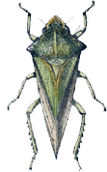
 | 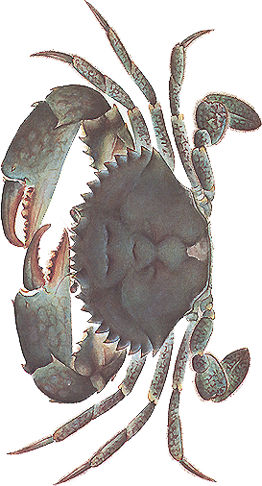
 | 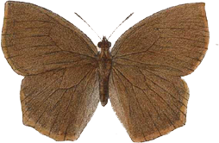
 | 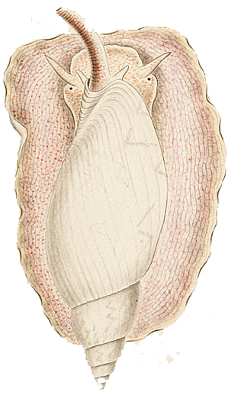
 | 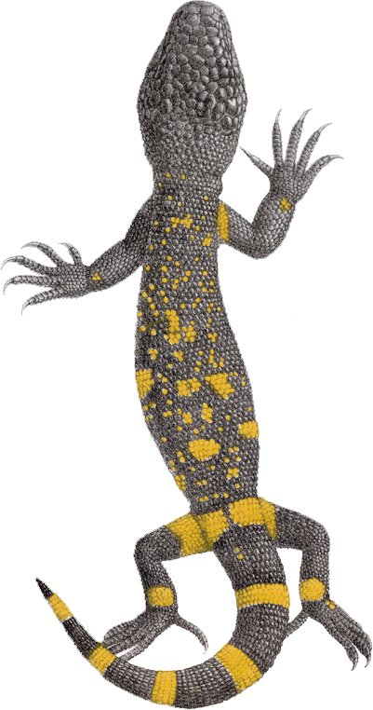
 | 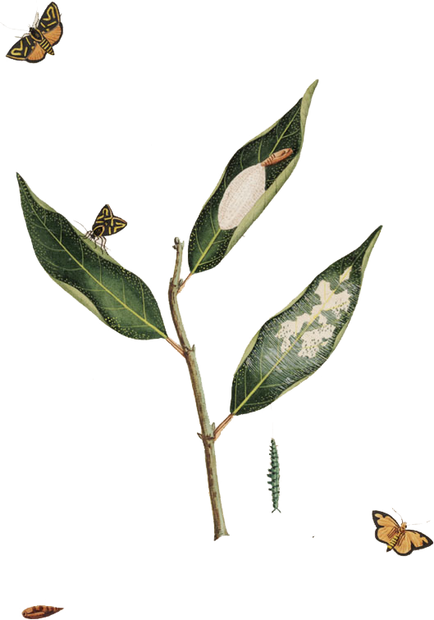
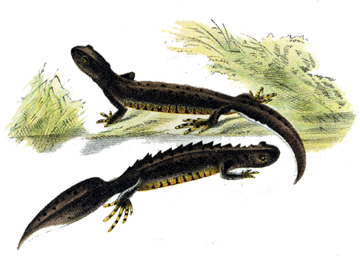

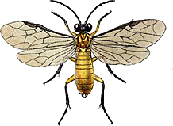

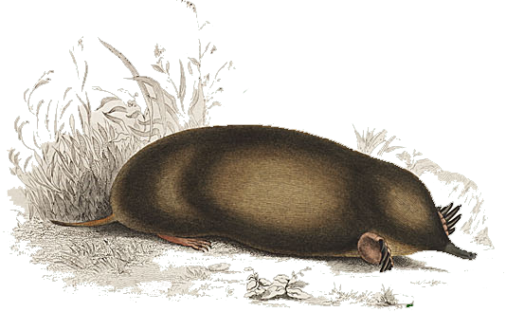

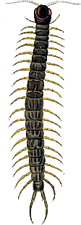
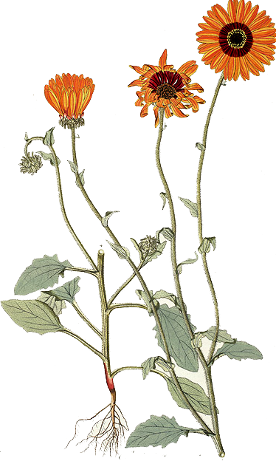

Appendix A
Goals and Objectives 2009 – 2013

- Establish the major corpus of digitized biodiversity publications on the Web
  - Increase mass scanning effort from BHL collections
    - 2009: 14 million pages added
    - 2010: 16 million pages added
    - 2011: 12 million pages added
    - 2012: 10 million pages added
    - 2013: 10 million pages added
    - Measure: number of pages added.
  - Increase ingested content from other collections by 20 million pages
    - 2009: California Digital Library
    - 2010: University of Toronto
    - Ongoing: Publishers who have digitized files of their back files
    - Measure: No. of pages added.
  - Improve de-duping tools by 2010. Measure: Rate of duplication declines.
  - Develop techniques to cut high cost of special collections, and archives scanning
    - 2011: Techniques are fully developed
    - Measure: Work plan drafted, tested, and implemented at some BHL libraries
    - Measure: Number of special collections is substantially increased.
  - Accelerate permissions from copyright holders.
    - Continuously approach non-profit publishers for permission
    - Obtain agreement with JSTOR for full linking to its relevant content
    - Obtain agreement with at least one major commercial aggregator for full linking.
    - Measure: JSTOR agreement is in place by 2010
    - Measure: 150 non-profit publishers’ titles are mounted in Portal by 2011
    - Measure: Agreement with commercial aggregator is in place by 2013.

- Improve access to accurate, documented information about the world’s biodiversity
  - Implement article repository by 2009
    - Gain cooperation of vetted taxonomic communities to direct deposit safe harbour model
      - Begin to add articles by 2009
      - Acquire/develop software, such as automated mark-up and metadata to break up large serial blocks of OCR text into individual articles and load them into repository by 2012
  - Interoperate with other major digitizing providers, especially in Europe and Asia, by 2011
  - Measure: 1,000 articles deposited by 2011
  - Measure: Links to repository from EOL species pages and major biodiversity projects are constantly increasing.
  - Measure: Software is successfully implemented and articles from one journal successfully loaded.
  - Measure: At least 3 major working relationships with large text digitizing projects are in place and substantial biodiversity content is available for and through the EOL by 2013.

- Improve the efficiency of biological research for users
  - Upgrade the functionality and services of the BHL Portal.
  - Increase the usefulness and relevance of BHL content.
    - Increase links to BHL texts from the Encyclopedia of Life and other major biodiversity projects
    - Integrate community-vetted bibliographies of key species texts as guides for selection process and as tools for collections evaluations.
    - Develop annually a list of tasks required to improve the architecture and establish priorities (see appendix)
    - Measure: Links to BHL texts increase XX% (in development)
    - Measure: 20 vetted community bibliographies are integrated
    - Measure: Workflow processes to use the data embedded in the BHL corpus are implemented by other biodiversity projects.

- Preserve the textual record of biodiversity for the future
  - Arrange for entire BHL corpus to be hosted by at least one secondary fail-over site by 2009
  - Establish multiple distributed sites for serving of BHL content by 2010.
  - Two-way content sharing is established with BHL Europe by 2011
  - Establish 2 mirror sites by 2010
  - Measure: All target dates are met.

- Sustain the project into the future
  - BHL members collectively prepare annually two significant grant proposals.
  - Develop sustainable model for long-term preservation and accountability of the corpus
  - Measure: Grant proposals are prepared on time each year and at least one is funded.
  - Measure: Sustainability Plan is prepared by 2010.

- Ensure that the BHL is widely known, understood, and used by scientists and the general public
  - Develop a communication plan that involves BHL Program Director and BHL member staffs.
  - Disseminate information through online and print publications, conferences, workshops and other appropriate media outlets.
  - Integrate BHL with wider scientific data management projects, e.g. DataNet to encourage use of the entire BHL corpus as a scientific dataset for computer science projects.
  - Measure: Communications plan is drafted by 2010.
  - Measure: At least 4 substantive articles appear in relevant journals or major news outlets.
  - Measure: presentation about BHL is given to at least 6 conferences/workshops/meetings each year.

- Internationalizing the BHL
The BHL will seek international collaborative projects to ensure and demonstrate that the legacy of biodiversity research belongs to all of humanity and is the exclusive provenance of no one country.
  - Create a plan for international cooperation on the BHL.
  - Create structures, agreements, and clear working procedures for technical, policy and communication issues with BHL-Europe.
  - Pursue ongoing discussions with the Chinese Academy of Sciences to establish a Chinese BHL.

Appendix B
List of Member Institutions and Partners

BHL Institutional Members
Directors of these libraries constitute the BHL Institutional Council:

American Museum of Natural History (New York, NY)
The Field Museum (Chicago, IL)
Harvard University Botany Libraries (Cambridge, MA)
Harvard University, Ernst Mayr Library of the Museum of Comparative Zoology (Cambridge, MA)
Marine Biological Laboratory / Woods Hole Oceanographic Institution (Woods Hole, MA)
Missouri Botanical Garden (St. Louis, MO)
Natural History Museum (London, UK)
The New York Botanical Garden (New York, NY)
Royal Botanic Gardens, Kew (Richmond, UK)
Smithsonian Institution Libraries (Washington, DC)

Recently a partner project, BHL-Europe, involving 25 European libraries with biodiversity text collections has been funded by the European Union.

BHL Contributing Members
These libraries have agreed to share content they have digitized with the Biodiversity Heritage Library:

University of Illinois at Urbana-Champaign Library
California Digital Library

The BHL serves as the Scanning and Digitizing Component of the Encyclopedia of Life, which is funded by the John D. and Catherine T. MacArthur Foundation and Alfred P. Sloan Foundation. The Encyclopedia of Life will offer a multimedia, expandable Web page for each of the 1.8 million scientifically identified species on earth and will create resources to expedite the identification and classification of the millions of species yet to be discovered.

The BHL partners with the Internet Archive, which provides scanning, processing, and storage services for the BHL. The Internet Archive is a non-profit organization “that was founded to build an Internet library, with the purpose of offering permanent access for researchers, historians, and scholars to historical collections that exist in digital format.”

The BHL partners with Fedora Commons in areas of system development. The Fedora Commons is a non-profit organization “providing sustainable technologies to create, manage, publish, share, and preserve digital content as a basis for intellectual, organizational, scientific, and cultural heritage by bringing two communities together”.

BHL Publisher Partners
Publishers of biodiversity journals and monographs that have agreed to let the BHL serve digital versions of their texts include:

American Entomological Society
American Peanut Research and Education Society
Arnold Arboretum
Botanical Research Institute of Texas
California Academy of Science
Colin Plant Associates
East Africa Natural History Society
Entomological Society of Washington
Institute of Malacology
International Society for the Study and Conservation of Amphibians
International Society of Hymenopterists
Nat. Shellfisheries Association
New England Botanical Club
Palaeontological Research Institution
Peabody Museum of Natural History
Phytologia
San Diego Natural History Museum
Society of Ethnobiology
Swedish Museum of Natural History
The Bailey-Matthews Shell Museum
Tulane University Museum of Natural History
University of Kansas
University of Michigan Herbarium
Western North American Naturalist

Appendix C
BHL Programme - Current

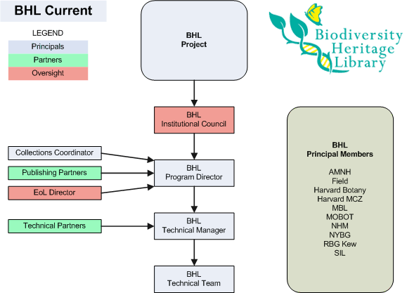

Staff from BHL libraries perform tasks involving selections, scanning workflow, documentation, and metadata creation in their libraries and serve on many BHL-wide task forces to advance the project.
BHL partners with many informatics and software projects such as the Internet Archive and the Fedora Commons.

Appendix C
BHL Programme - Future

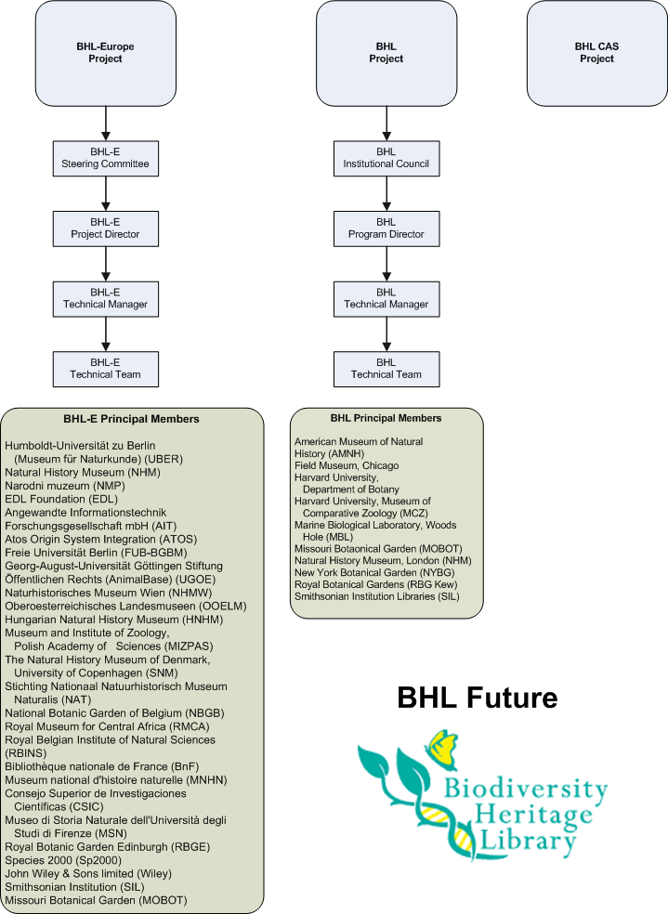

Appendix D
BHL Portal Page

