BHL Production Architecture & Infrastructure
Rev.: January 12, 2008

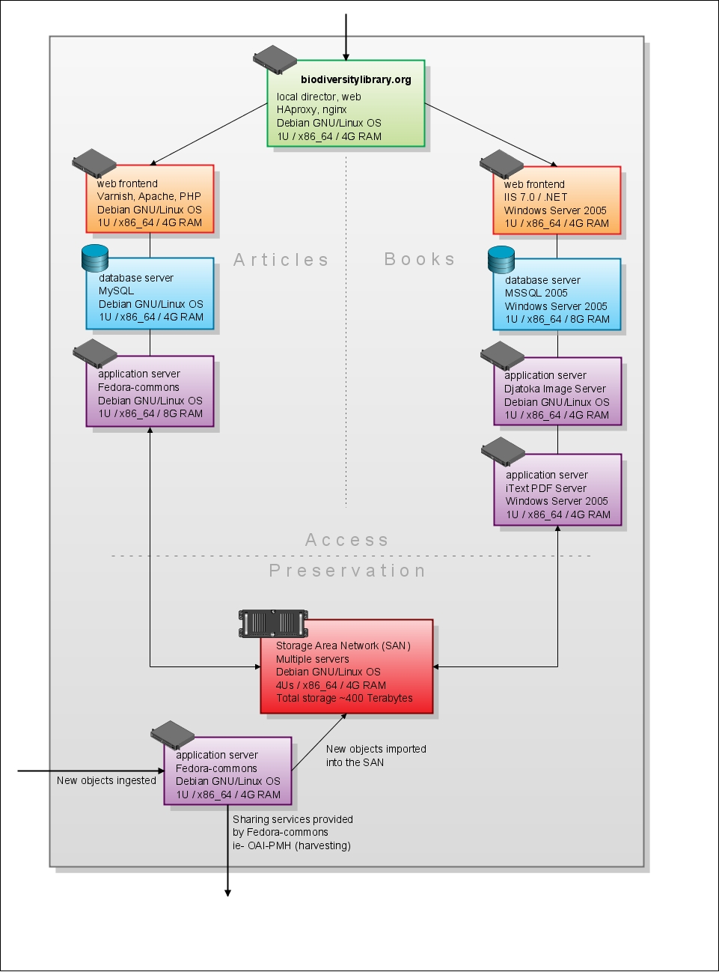

BHL infrastructure is divided into 2 components, Preservation and Access. Each component has the following characteristics as described below.

Preservation
The Preservation components of BHL consist of an expandable Storage Area Network (SAN) and an application server running Fedora Commons software for file management and services for ingest and export.

Hardware:
- SAN (Qty: 1)
Manufacturer: | TBD
OS: | Debian GNU / Linux OS
Processor/RAM: | 4Us / x86_64 / 4G RAM
Storage: | 44TB of content to date; expandable beyond 400TB by 2011.
Applications: | TBD
Use: | Storage of scanned content.

- Application Server (Qty: 1)
Manufacturer: | TBD
OS: | Debian GNU / Linux OS
Processor/RAM: | 1U / x86_64 / 4G RAM
Storage: | 36GB
Applications: | Fedora Commons, Tomcat
Use: | Fedora ingest & export utilities & services

Access
The Access components of BHL consist of the servers and applications required to deliver scanned books and digitized articles to the BHL user community. Currently the books & articles are being managed by separate systems because their methods of contribution and user requirements are distinct. These solutions use a mix of Windows and Linux software, as indicated.
Hardware
- OS Web/Applications Servers (Qty: 4)
Manufacturer: | TBD
OS: | Debian GNU / Linux OS
Processor/RAM: | 1U / x86_64 / 4G RAM
Storage: | 36GB
Applications: | Varnish, Apache, PHP, MySQL, djatoka

- OS Application Server (Qty: 1)
Manufacturer: | TBD
OS: | Debian GNU / Linux OS
Processor/RAM: | 1U / x86_64 / 8G RAM
Storage: | 36GB
Applications: | Fedora Commons

- Win Web/Applications Servers (Qty: 2)
Manufacturer: | TBD
OS: | Windows Server 2005
Processor/RAM: | 1U / x86_64 / 4G RAM
Storage: | 36GB
Applications: | IIS 7.0, .NET, iText PDF Server

- Windows Database Server (Qty: 1)
Manufacturer: | TBD
OS: | Windows Server 2005
Processor/RAM: | 1U / x86_64 / 8G RAM
Storage: | 150GB
Applications: | SQL Server 2005

Annual Site Usage/Bandwidth Requirements for www.biodiversitylibrary.org
2008
- Launch Feb 26, 2008
- Through 12/31/2008:
  - 39.4 million hits
  - 32.6 million page views
  - 362.3 GB of data distributed to users
  - Note: These figures do not include the bandwidth consumption of our scanned content currently being served from Internet Archive.

