1. ) Top request is a separation of Serial/Journals from Monographs.
Using the MARC leader we could potentially do a quick separation of those.

best example: http://bibdigital.rjb.csic.es/ing/index.php where a clear separate link exists on the opening page for periodicals

1. ) Next /tied with Top request is that the volume breakdowns include the dates of the volumes.

see” http://bibdigital.rjb.csic.es/ing/Obras.php?Libro=0 and http://bibdigital.rjb.csic.es/ing/Volumenes.php?Libro=1110

2. ) Second Top request is that the if the paging indexing takes too much man power to get up and running immediatedly for all titles – using thumbnails to give the quick look to see the title page and the table of contents... text vs image

http://www.literature.at/webinterface/library/ALO-BOOK_V01?objid=12537&page=1&zoom=3

Example: Austrian site: http://www.literature.at/webinterface/library/search/simple?query=lexikon&btnG=Search

3. ) Default when opening a title is to the Title page instead of the cover. Potential to navigate back up the chain to the preliminary pages and covers but the initial landing is the title page.

Example: could you mean http://fax.libs.uga.edu/QK1xC981/cbmmenu.html ??

4. ) Once you have all the journal up- can we launch a search inside the entire journal run? The University of Georgia seems to have that for Curits.

5. ) Once we have a volume up, can we search inside the entire volume and only that volume?

6. ) Build your own pdf by selecting pages and creating the pdf on the fly.
http://www.literature.at/webinterface/library

7. ) Example of a clean easy to navigate interface

http://bibdigital.rjb.csic.es/ing/index.php

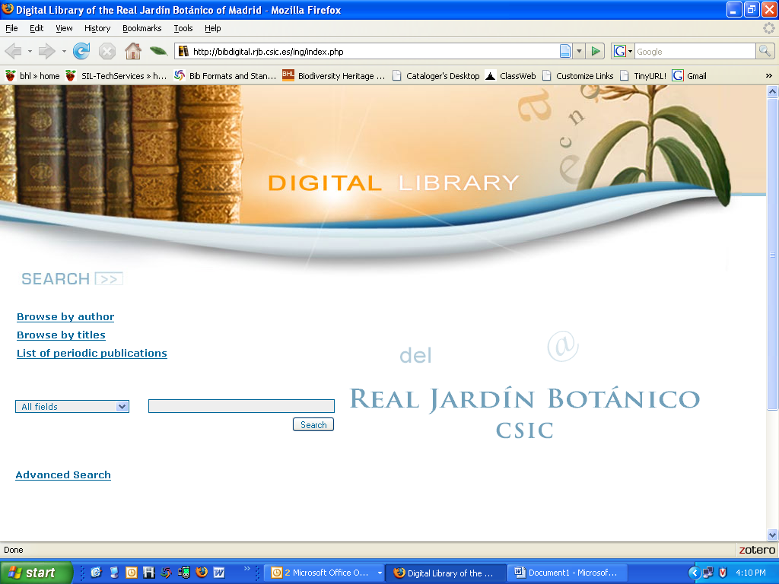

8. ) Listing periodic publications as a separate browsable list

9 . ) The result text and graphics show you clearly what to expect
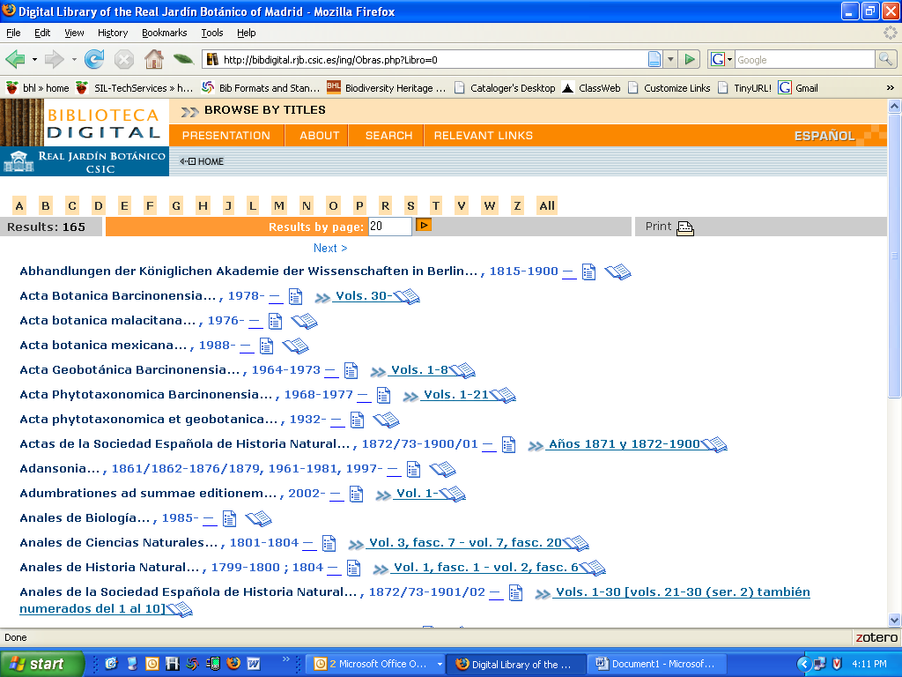

Choosing Acta Geobotanica Barcinonensia
10. ) You get a clear display of the volume and year per line.

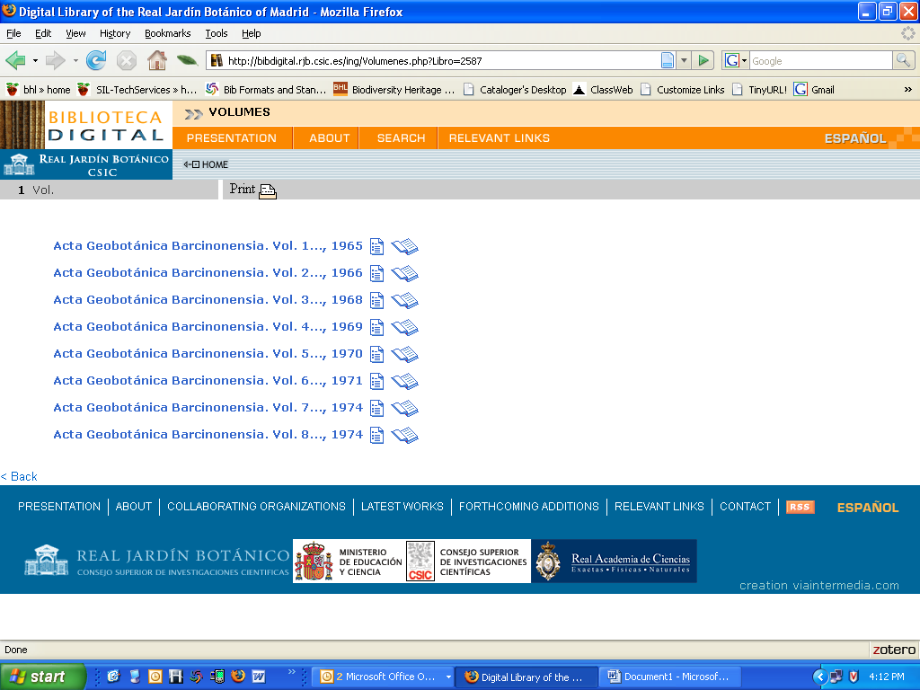

11. ) An example of a title that clearly tells you the volumes you have is the Curtis’s Botanical Magazine through the University of Georgia

http://fax.libs.uga.edu/qk1xc981/cbmmenu.html

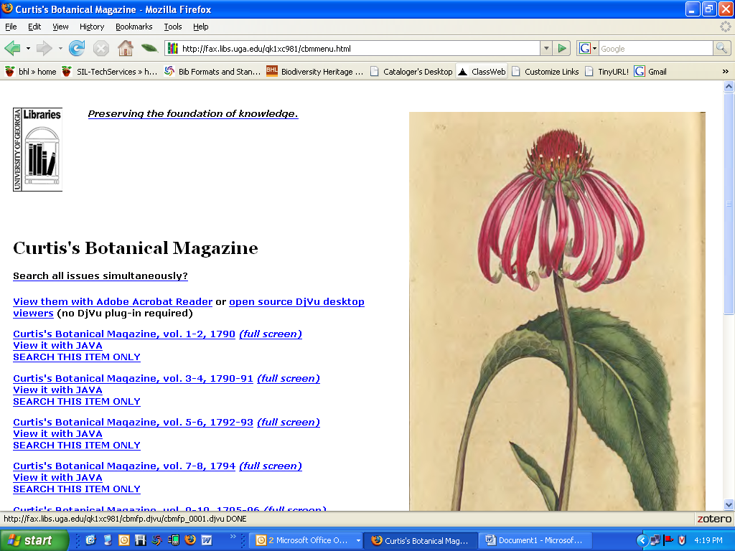

Compared to BHL’s version
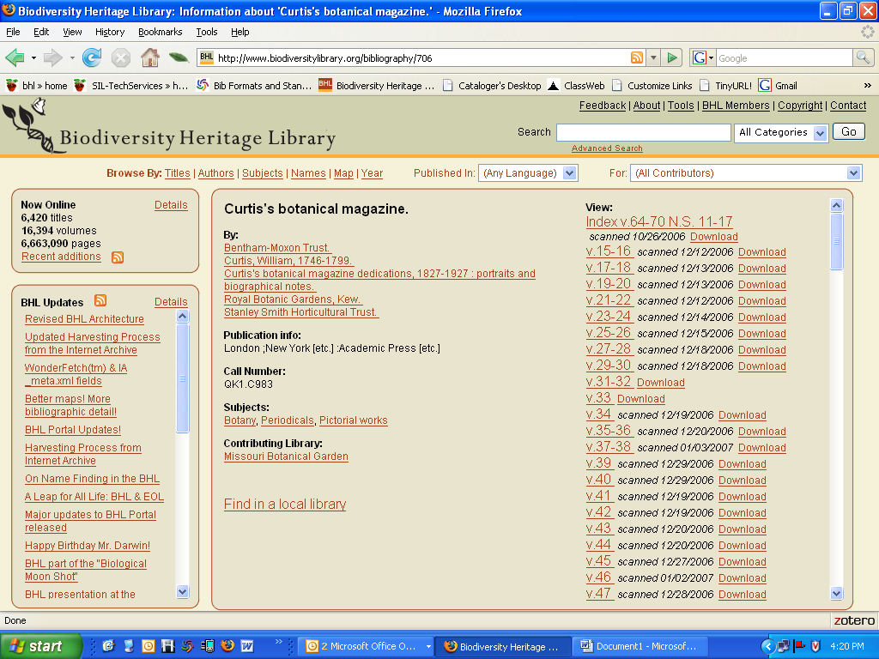

Other comments about the parts of this display:

13. ) The volumes do not have the years. The data scanned isn’t that important here. There is no information about how large the download will be once you click on it.

14. ) Interesting list of Open Access Journals - Possibly something BHL would like to participate in if they take OLD journals that are now available

http://www.doaj.org/
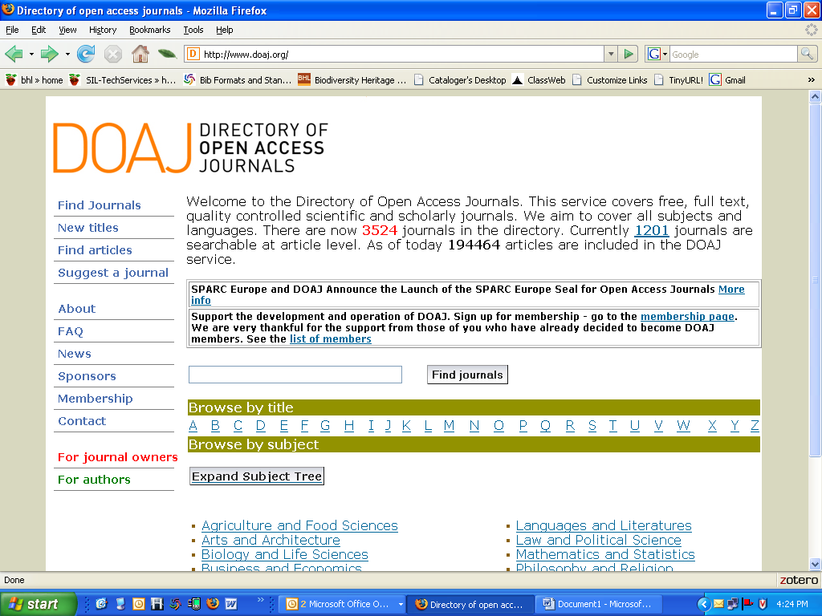

15. ) Interesting subject tree navigation with quantity of hits as you drill down. For example:
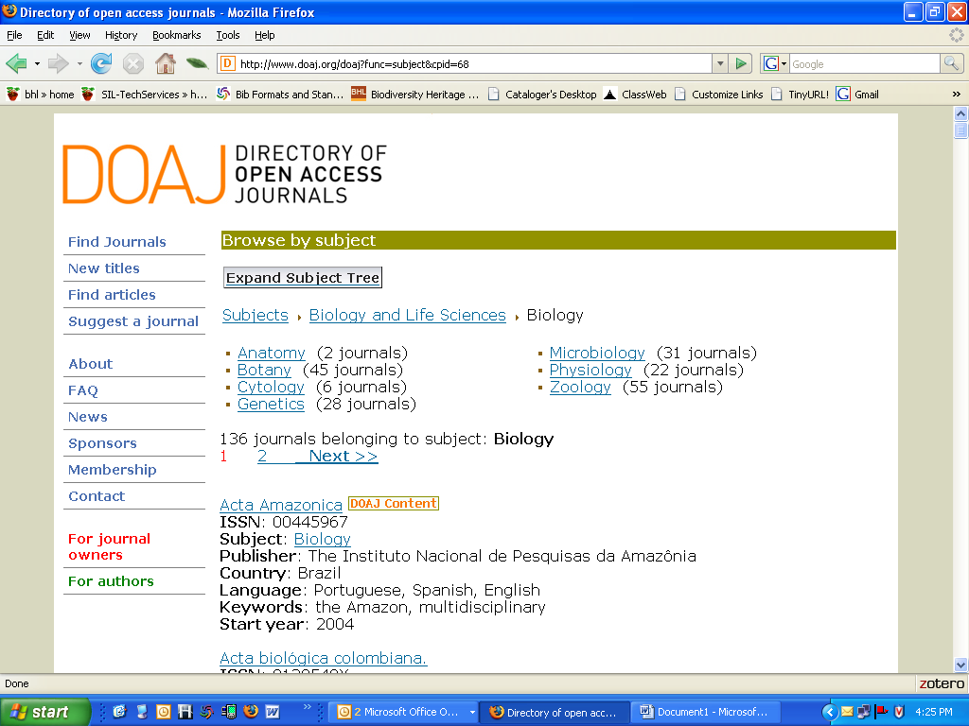

16. ) New Titles link – gives a span of time. And sorting options:
