BIODIVERSITY HERITAGE LIBRARY
INSTITUTIONAL COUNCIL

Bylaws

ARTICLE 1- Name

Section 1. This group shall be known as the Biodiversity Heritage Library (BHL) Institutional Council (hereafter known as “Council).

ARTICLE II – Purpose

Section 1. The Biodiversity Heritage Library is an international library collaboration of natural history museums, botanical gardens, and biological research libraries (“BHL Member Institutions”) whose purpose is to work together to digitize the published literature of biodiversity held in their respective collections and to make that literature available for open access and responsible use as a part of a global “biodiversity commons.” This collaboration is memorialized in a Memorandum of Understanding (BHL Memorandum of Understanding”).

Section 2. The Council will oversee and manage the BHL project.

ARTICLE III – Composition and Powers of the Institutional Council

Section 1. Composition of the Council. The Institutional Council is composed of one representative, generally the chief librarian, from each BHL Member Institution. Each representative has one vote on the Council. The BHL Program Director, the BHL Technical Director, and the Executive Director of the Encyclopedia of Life shall serve as ex-officio members of the Council, with voice but without vote. In the event of a tie vote, the Executive Director of the Encyclopedia of Life shall break the tie.

Section 2. Powers. The Council shall establish policies and procedures to manage the BHL project and expenditure of BHL funds. The Council shall have the powers and responsibilities set forth herein and in the BHL Memorandum of Understanding, including responsibility for the following:

- Advising on the hiring, evaluation, and management of the BHL Project Director;
- Strategic planning
- Reviewing budgets
- Admitting new BHL Member Institutions (see Section 4 below)
- Defining categories of membership/collaborators or associations as needed
- Policy setting in conformance with the BHL Memorandum of Understanding
- Establishing relationships with other bodies and Institutions
- Reviewing and commenting on all grant proposals and other fundraising initiatives on behalf of the BHL
- Advising on the administration of awards by the BHL Member Institutions
- Developing policies for ownership and use of intellectual property, including uses of logos and trademarks and publicity

Section 3. Core Decisions. Core decisions related to the BHL will be made collaboratively by the BHL Member Institutions acting through the Council. Core decisions will be made by majority vote of the Council. Core decisions include: Approval of the annual work plan and budget for the BHL, modifications to the approved budgets; decisions to distribute funds to BHL Member Institutions or to third parties for BHL-related purposes other than as set forth in the approved budgets; decisions regarding the type and extent of license agreements to negotiate with third parties for content, data or information for use in the BHL; making recommendations for hiring and evaluating the BHL Project Director and any other positions required by the BHL Project; contracts for services lasting longer than one year unless such services are otherwise included in an approved budget; addition of BHL Member Institutions to the MOU.

Section 4. Core Decisions Regarding BHL Membership. The BHL Member Institutions shall be institutions concerned with biodiversity education and research. Each must have a library with substantial biodiversity collections that will expand coverage of the BHL. Each must be willing to contribute personnel and other resources to support its participation in the BHL and to advance the aims of the program. After meeting these criteria for membership, institutions may become members upon approval by a two-thirds vote of the Council. No institution shall be admitted to membership until it presents evidence satisfactory to the Council that such membership has been duly authorized by that institution and that a duly authorized representative of such institution has signed the BHL Memorandum of Understanding.

Section 5. Core Decisions Regarding the Budget and Expenditures. With regard to core decisions concerning the budget and expenditures of funds, a BHL Member Institution that receives the specific grant, gift or contract for the BHL project must abide by: (a) any obligations imposed by the BHL’s financial sponsors; (b) the terms of all applicable grants, gifts and contracts made by the grantor, donor or contractor; and (c) applicable institutional policies and practices of each BHL Member Institution regarding use of grant, gift and contract funds. In the unlikely event that the majority of the Institutional Council makes a core decision regarding the budget or expenditures that conflicts with a legal or fiduciary obligation of the BHL Member Institution that has received the grant, gift or contract, such BHL Member Institution shall not be obligated to undertake such expenditure until the conflict is resolved in accordance with its legal and fiduciary obligations.

Section 6. Non-Core Decisions. Decisions relating to expenditures for the BHL that do not qualify as “core” are non-core decisions and can be made by the BHL Project Director or, where applicable to only one BHL Member Institution, by the specific Institution involved, including decisions relating to operations, hiring of staff, expenditures, etc. that are expressly included in the annual work plan and approved budget, and contracts and letters of intent with collaborators, among others.

Section 7. Delegation. The Council may, from time to time delegate any of its powers to committees, officers, attorneys or agents of the BHL, subject to such limitations as the Council may impose.

Section 8. Compensation. Council Members, and their designated representatives, shall not receive any salary for their services on the Council.

ARTICLE IV – Meetings

Section 1. Regular Meetings. Regular meetings of the Council shall be held at least annually, and may be more frequent, as the Council Members may determine and at such times and places as they may fix. A notice of the meeting including an agenda shall be distributed at least thirty days prior to each regular meeting. The BHL Program Director shall report annually on the activities of the BHL at the regular meeting. Attendance at the meetings may include professional advisors as the Council chooses to add.

Section 2. Special Meetings. Special meetings of the Council may be held at such times and places as may be determined by the President of the Council or upon written application of three or more Council Members and shall be called by the Secretary or, in the case of the death, incapacity or refusal of the Secretary, by any other officer. A notice shall be distributed at least seventy-two hours prior to each special meeting unless shorter notice is adequate under the circumstances. The notice shall specify the purpose of any special meeting. Notice of a special meeting need not be given to any Council Member, if a written waiver of notice executed by her/him before the meeting is filed with the records of the meeting.

Section 3. Quorum. A majority of the Council Members shall constitute a quorum at any meeting of the Council for the transaction of business. Any act of a majority of the Council Members present at any meeting at which there is a quorum shall be deemed the act of the Council.

Section 4. Action by Consent. Any action required or permitted to be taken at any meeting of the Council may be taken without a meeting provided that Council Members submit their votes in writing or electronic vote. Any Council Member who fails to submit a written /electronic vote will be recorded as an abstention. An action by consent shall be effective when the number of Council Members required to approve such a vote have taken action. The record of such action and the result of such vote shall be filed with the records of the meetings of the Council.

Section 5. Vacancies of Representatives. Each BHL Member Institution shall designate a representative, generally the chief librarian, to act on behalf of the institutional Council Member at all meetings. In the event of a vacancy in the position of the designated representative, the BHL Member Institution may designate an alternative representative who shall be entitled to represent that Member on the Council for all purposes including voting.

ARTICLE V – Officers and duties

Section 1. Officers. The officers shall be a President, a Vice-President/President-Elect, and a Secretary, who shall be elected by majority vote from among the members of the Council. Officers shall have the authority and perform the duties as usually pertain to their offices, such duties as provided in these bylaws, and such additional duties as may be prescribed by the Council.

Section 2. President. The President shall manage and conduct the business of the BHL and, subject to the supervision of the Council Members, shall preside at all meetings of the Council Members and of the Executive Committee at which she/he is present. The President shall represent the BHL on the Encyclopedia of Life (EOL) Steering Committee.

Section 3. Vice-President/President-Elect. The Vice-President/President-Elect shall have such powers and duties as may be designated from time to time by the Council Members or by the President. The Vice-President/President-Elect shall have the power to act in the absence or incapacity of the President.

Section 4. Secretary. The Secretary shall keep the official minutes of the Council and Executive Committee meetings. The Secretary shall also have such powers and duties as may be designated from time to time by the Council Members or by the President

Section 5. Removal. Any officer elected or appointed by the Council may be removed from office with cause at any time by an affirmative vote of two-thirds of all the Council Members.

Section 6. Resignation. Resignations by officers shall be given in writing to the President.

Section 7. Election and Terms. Election of officers will take place at the Annual Meeting of the Council. Officers shall serve two-year terms for each office held. Officers may not be re-elected to consecutive terms for the same office. Officers may, however, be elected to non-consecutive terms for the same office.

Section 8. Vacancies. A vacancy in office because of death, resignation, removal, disqualification or otherwise may be filled by a majority vote of the Council for the unexpired portion of the term.

ARTICLE VI - Executive Committee

The Officers of the Council will serve as the Executive Committee together with the Program Director (ex officio). The President shall serve as the Chair of the Executive Committee; the Vice-President/President-Elect shall serve as the Vice-Chair of the Executive Committee; and the Secretary shall serve as the Secretary/Treasurer of the Executive Committee. The Executive Committee shall manage the ordinary business of the BHL on behalf of the Council in between Council meetings and perform such other duties as the Council may authorize from time to time. Executive Committee decisions must be reviewed by the full Council at the next meeting and included in the Council minutes. The Executive Committee shall review the performance of the Program Director in accordance with the employment procedures and conditions of the Program Director’s employing institution. The Executive Committee may establish other committees as deemed necessary from time to time to carry out its duties.

ARTICLE VII – Minutes

The BHL Program Director shall keep accurate and complete minutes of any proceedings of Council meetings and committees having any of the authority of the Council.

ARTICLE VIII.- Withdrawal

Members may withdraw from the BHL upon written notice provided such written notice is given to the President of the Council six months before the end of the fiscal year. At the end of the fiscal year, if a withdrawing member has unexpended or unobligated project funds, they must be returned to the funding source or dispersed at the direction, or with the approval, of the funding source. Membership may be revoked with effect from the end of any fiscal year by two-thirds vote of the Council.

ARTICLE IX - Amendments

These bylaws may be amended, in whole or in part, at any meeting of the Council Members by a positive vote of not less than two thirds of the Council Members present and voting, provided that notice of the proposed amendment(s) shall have been given in the notice of the meeting.

ARTICLE X – Entry into Force

These bylaws will enter into effect immediately upon the positive vote of two-thirds of the Council Members present at any meeting of the Council.

As adopted by vote of the Institutional Council on____March 21, 2008___

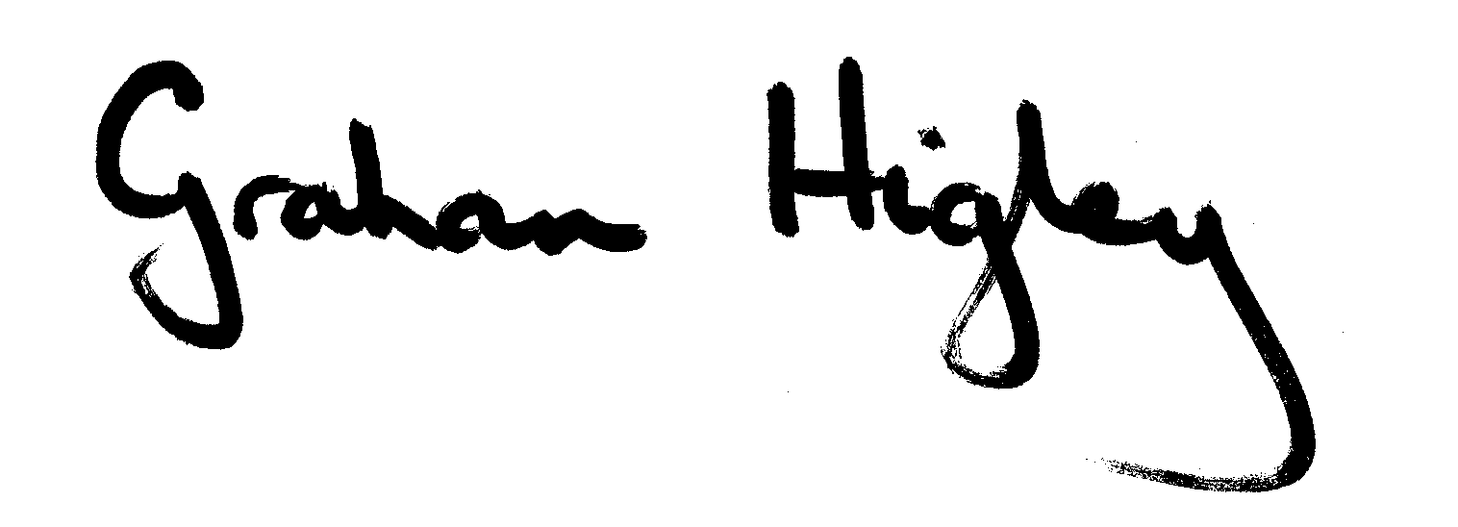
President: __________________________________________
Graham Higley

Secretary: __________________________________________
Constance Rinaldo

Revised by a vote of the Institutional Council on _________________________
(Date)

