
Scientific Electronic Library Online

BHL SciELO Network:
quarterly report
Technical Support: Fabiana Montanari, SciELO Supervisor, FapUNIFESP; Fabio Batalha, SciELO Supervisor, FapUNIFESP; Luis Gomes, SciELO Administrator, FapUNIFESP
Project Coordinators: Abel L. Packer, SciELO Operational Coordinator, Advisor on Information and Communication in Science, Foundation of the Federal University of São Paulo; Hussam Zaher, Director, Museum of Zoology, University of São Paulo

São Paulo - February 2012
Content
1 Introduction 3
2 Content Statistics 3
3 New software and functional development 5
4 Website Statistics 9
5 Social Media Statistics 9
6 Anecdotes and Testimonials 9
7 About BHL SciELO Network 9

Introduction
This report describes the implementation and operation of BHL SciELO Network has as a goal to enrich, extend and give strength and development of the national infrastructure of information and scientific knowledge on biodiversity to support research and education in the area, as well as public policies, programs, projects and processes decision-making related to biodiversity conservation and sustainable use of the environment.
Among the results achieved in the last three months, include: a) started the pilot operation of the Centers Scanners with infrastructure installed in the USP Zoology Museum, training of local staff to operate the scanner and scan 5 volumes of the Revista do Museu Paulista; b) defining and establishing technology architecture for the scanning operation, composed of storage, tape Library, LTO, storage units (NAS) External Hard Drives and Desktops; and c) release of the first version of Thesaurus in Biodiversity.
From the end of February 2012, the development and operation of the BHL SciELO Network now has the support of more than one Staff, Jose Eugenio Grillo, will perform the functions under the supervision of the Coordination SciELO Program and the support of the Administration.

Content Statistics
From the BHL SciELO Network Portal (http://www.bhlscielo.org), available of information sources result in the following:
- BHL Brazil, with 355 works about the Brazilian fauna and flora, digitized in the context of the BHL (http://www.biodiversitylibrary.org/Default.aspx);
- Global BHL, with 94.300 works about the biodiversity in the various regions of the world, already available in the BHL (http://www.biodiversitylibrary.org/Default.aspx);
- Biodiversity journals, with listing of biodiversity that are already part of SciELO Network;
- SciELO Articles in Biodiversity, with 399 articles published in journals in the SciELO Network;
- Repository BIOTA / FAPESP, with 489 articles produced in the context of the BIOTA/FAPESP Program;
- Other sources, as thesaurus, events, Online Collaborative Spaces, Biodiversity Law.
The Figure shows the home page of BHL SciELO Network Portal:
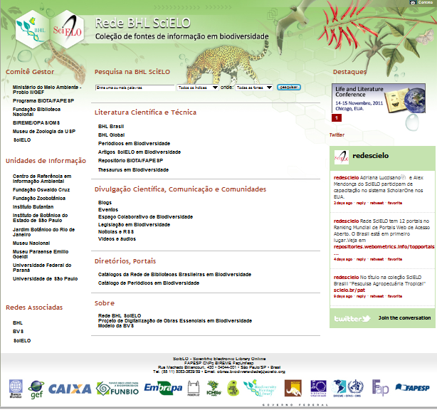
- Página principal do Portal da Rede BHL SciELO
For the digitization of essential works in biodiversity of Brazilian libraries, the BHL SciELO Network, through the support and financial aport of the Environment Ministry (by means of the Probio II/GEF), will deploy a storage structure consisting of a local infrastructure for the assembly of five Centers Scanners and an infrastructure for Storage Center, which will be allocated on the SciELO, ensuring the persistence and publication of data scanned continuously for a period of two years.
Over the past three months, started the pilot operation of the Centers Scanners with infrastructure installed in the USP Zoology Museum, training of local staff to operate the scanner and scan 5 volumes of the Revista do Museu Paulista, totaling approximately 2.000 pages of the numbers identified below:
Journal: Revista do Museu Paulista
Number: 1923 13; 1926 14; 1927 15; 1929 16; 1931 17(1); 1932 17(2)
The pilot operation of the Scanner Centre of the USP Zoology Museum will allow testing with the work plan for scanning and sending metadata to BHL and the Internet Archive.
The SciELO Unit also already has a scanner installed that will allow testing of equipment, training staff in scanner operation and technical support to the Centers Scanners.
In addition to the Centers Scanners USP Zoology Museum and the SciELO Unit, two other centers will be installed in the next three months: the first at the Butantan Institute (São Paulo - SP, Brazil) and the second at the Museum Goeldi (Belém - PA, Brazil).

New software and functional development
For the operation of activities related to digitization of works essential biodiversity, teams SciELO and BHL, after completion of the “Workshop Essential Collection Rare Works in Biodiversity: governance, operation and digitization”, the establishment of infrastructure composed of Storage, Tape Library, LTO, storage units (NAS) External Hard Drives and Desktops.
The technology architecture provides the implementation of a storage structure consisting of a local infrastructure for the Centers Scanners and a central infrastructure to ensure the existence and publication of data scanned continuously for a period of two years.
This architecture aims to empower the Centers scanners in the scanning process and also ensure the safe storage of digitized content, while it is in the process of evaluation and production centers within the scanners, as well as a guarantee from all of Central Storage resources necessary for security and availability of digitized works.
The Figure shows the technology architecture of BHL SciELO Network:

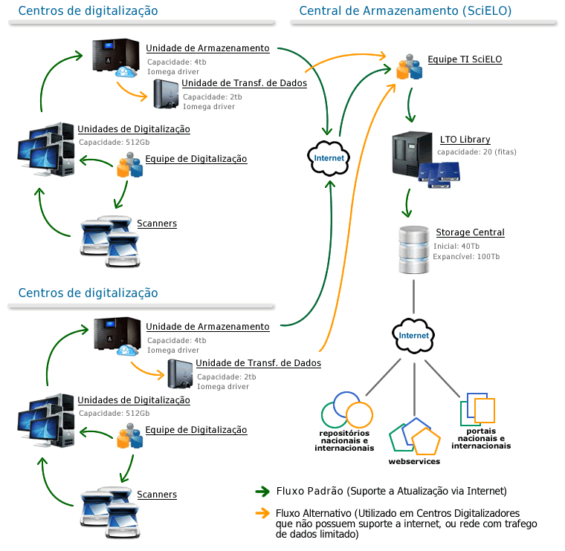
Imagem 1: Arquitetura Tecnológica

Project Applications
The second image shows the set of applications that are now part of the Project:
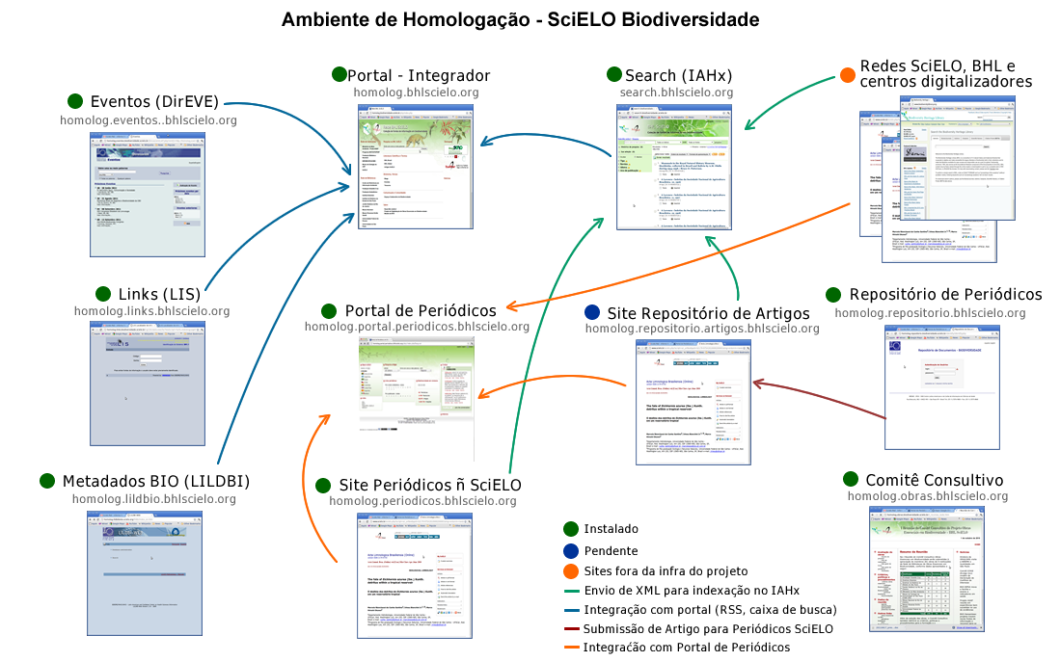Imagem 2: Aplicações do Projeto
This suite are present a tool for recording events (DIREVE), tool to record links (LIS), a tool for the bibliographic record of digitized works (LILDBI) , integrated research tool content (iAHx), a portal integrator that provides information content of the various sources of project information (BVS-Site), a portal to SciELO journals in biodiversity (BVS, SciELO Site), a repository system articles in biodiversity (Repository SciELO), SciELO a site for articles submitted to the repository (Web SciELO), a site not SciELO SciELO journals (SciELO Web), a system for managing Thesaurus biodiversity (TemaTres) and a site support for committee meetings.

Website Statistics (não precisa revisar)
The BHL SciELO Network uses Google Analytics to measure the access to the content available on the site. Considering the tool has only been included to the BHL SciELO Network site, not very long ago, the data on access will presented in the next report.

Social Media Statistics
Over the past three months, were released from the Twitter Network SciELO 9 twits related to BHL SciELO Network.

Anecdotes and Testimonials
No anecdotes or testimonials available at this point.

About BHL SciELO Network
The BHL SciELO Network has as a goal to enrich, extend and give strength to the publication and access to online relevant biodiversity scientific information.
The BHL SciELO Network operations are divided into three tiers:
- The network of institutions and individuals that take part and contribute as producers, intermediaries and users of the biodiversity scientific information;
- The network of content organized as information sources that include the products, services and events provided and maintained by the institutions and individuals in it;
- The network learning and informed environments that is based on the exchange of ideas, experiences and knowledge that strengthen the contextualization of information and knowledge in biodiversity.
The BHL SciELO Network is part of the SciELO Network and the Biodiversity Heritage Livrary (BHL) and is associated with the Virtual Health Library (VHL) that is managed by BIREME/PAHO/WHO, and uses its methodology in management and operation of the network.
The network was built on two complementary projects:
- The digitalization and publication of a collection of essential works in biodiversity of the Brasilian libraries project and;
- SciELO biodiversity project.
Both projects have the support and financial aport of the Environment Ministry (by means of the Probio II/GEF), the Fundação de Amparo à Pesquisa do Estado de São Paulo - FAPESP (by means of the SciELO project with participation of the FAPESP Virtual Library, BIOTA/FAPESP program), National Library Foundation, BIREME/PAHO/WHO, USP Zoology Museum and Brasilian Biodiversity Library network representatives.

